WESTAR Council

Technical Writing

February 9 – 10, 2027

VIRTUAL TRAINING

REGISTRATION DEADLINE
January 15, 2027

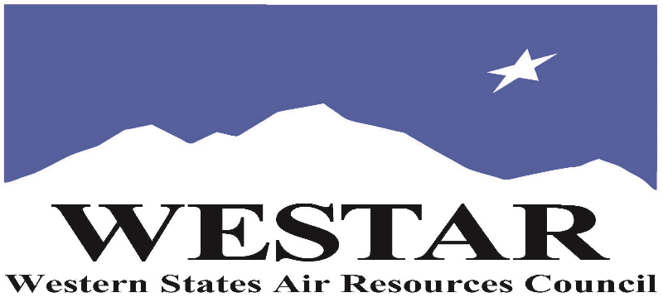

TO REGISTER
- Log onto EPA’s AirKnowledge and create a profile, or log onto your existing AirKnowledge account: EPA's AirKnowledge Website
- When you complete your profile, you will receive a confirmation e-mail to activate your new account. It may take several minutes before receiving the email.
- Once activated, log into your account.
- Click the “Instructor Lead Training Calendar” link under the “My Training” tab.
- Search the calendar for the training date(s). On the calendar you will see a course description. Hover over the text for additional information.
- To register click the course title link.
- In the lower righthand corner of the page you will see a “Request” button. Click it.
- At this point you have requested a seat in the training. Because demand for WESTAR sponsored training frequently exceeds availability all registrants are placed on a waitlist.
- You will receive an email from Jeff Gabler confirming your request.
- WESTAR attempts to accommodate all requests but at times it may be necessary to prioritize attendees.

AGENDA
WEDNESDAY, NOVEMBER 4, 2026
PACIFIC TIMES
10:00 am Introduction
10:15 am Session 1: Revisit the Writing Process
10:50 am Session 2: Tackle Writer’s Block
11:25 am Session 3: Nail Your Purpose
12:00 noon Break
1:00 pm Process and Purpose Recap and Q&A
1:15 pm Session 4: Organize for Success
2:25 pm Session 5: Be Concise and Clear
3:25 pm “Jeopardy!” Challenge and Q&A
4:00 pm Adjourn for Day
THURSDAY, NOVEMBER 5, 2026
PACIFIC TIMES
10:00 am Recap and Discussion
10:20 am Session 6: Tackle Common Problem Areas
12:00 noon Break
1:00 pm Common Problem Area Wrap-up
1:35 pm Session 7: Make the Most of Peer Review
2:25 pm Session 8: Tap Helpful Resources
3:15 pm Supplemental Exercises and “Jeopardy!” Challenge
3:45 pm Q&A and Final Wrap-up
4:00 pm Adjourn
ABOUT THE TRAINING COURSE
AUDIENCE: This course is specifically designed for staff that need to write clear concise documents involving technical information for your agency such as Planning, Ambient Monitoring, Permitting and Compliance & Enforcement staff with all levels of expertise.

COURSE DESCRIPTION: This course will help air quality staff to learn/reaffirm the best practices and principles of effective communications, identify the common personal habits that may be hampering potential, and understand how to improve communications outcomes.

COURSE DELIVERY: This is a virtual, instructor-led training course.

SPACE LIMITATION: Registration is limited to 40 attendees. Air quality staff from the fifteen western states receive registration preference.

REGISTRATION FEES: There are no registration fees for state, local or tribal air quality agency staff.

ACCESSIBILTY
WESTAR strives to host inclusive, accessible training events that enable all individuals, including individuals with disabilities, to engage fully with the instructor and course content. To request an accommodation or for inquiries about accessibility, please contact Jeff Gabler at jgabler@westar.org or 503-744-0486 by Friday, January 8, 2027.

INSTRUCTOR BIO
Susan Zummo Forney has more than 35 years of experience in the environmental consulting arena, supporting governmental and private organizations in the areas of communications and regulatory compliance. Her consulting practice specializes in training professionals seeking to improve their writing and communication skills. Ms. Forney has delivered technical writing training courses to hundreds of federal, state, and local air-quality government personnel through multi-jurisdictional organizations across the nation. She holds an M.S. in Environmental Science and Management from Duquesne University, and a B.S. in Science with minor degrees in Technical Writing and Science, Technology and Society from Penn State.

