WESTAR Council

Stationary Gas
Turbines (TOXC 224)

May 19, 2026

VIRTUAL TRAINING

REGISTRATION DEADLINE
Friday, April 17, 2026

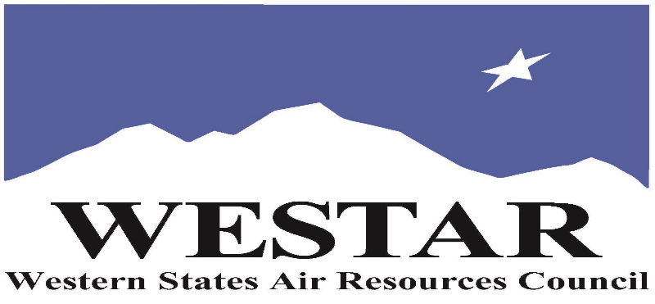

TO REGISTER
- Log onto EPA’s AirKnowledge and create a profile, or log onto your existing AirKnowledge account: EPA's AirKnowledge Website
- When you complete your profile, you will receive a confirmation e-mail to activate your new account. It may take several minutes before receiving the email.
- Once activated, log into your account.
- Click the “Instructor Lead Training Calendar” link under the “My Training” tab.
- Search the calendar for the training date(s). On the calendar you will see a course description. Hover over the text for additional information.
- To register click the course title link.
- In the lower righthand corner of the page you will see a “Request” button. Click it.
- At this point you have requested a seat in the training. Because demand for WESTAR sponsored training frequently exceeds availability all registrants are placed on a waitlist.
- You will receive an email from Jeff Gabler confirming your request.
- WESTAR attempts to accommodate all requests but at times it may be necessary to prioritize attendees.

AGENDA
TUESDAY, MAY 19, 2026
PACIFIC TIMES
9:00 am Introductions/Overview
9:30 am Terminology & Engine Types
10:00 am Break
10:10 am Turbine Sections & Components
11:00 am Break
11:10 am Power & Steam Generation
11:40 am Emissions & Control Techniques
12:00 noon Lunch
1:00 pm Emissions & Control Techniques (cont’d)
1:30 pm Combines Heat & Power (Cogeneration)
2:00 pm Break
2:10 pm Regulatory Requirements & Permits
3:10 pm Monitoring, Source Testing, Inspection & Safety
3:45 pm Adjourn

ABOUT THE TRAINING COURSE
TARGET AUDIENCE: This course is intended for new, inexperienced state, local and tribal air quality professionals.
COURSE DESCRIPTION: Stationary gas turbines are popular as combined-cycles, peaking power plants and cogeneration facilities. The course discusses the uses of gas turbines, and fundamentals of operation of modern turbines with emphasis on state-of-the-art controls to achieve some of the lowest emission concentrations for this source category. The course also discusses combined cycles with HRSG units, steam turbines and power generation. This is followed by a detailed discussion on emissions and control techniques such as Dry Low-NOx combustors with staged combustion, water or steam injection followed by SCR and CO catalysts. Applicable federal and local BACT regulations, permitting requirements, and agency inspection procedures and safety concerns are thoroughly discussed.
LEARNING OBJECTIVES: Those completing this course will gain a basic understanding of the general information associated with stationary gas turbines plants. Attendees will be able to perform regulatory reviews involving the following elements of stationary gas turbines:
- Gas turbine history, theory of operation
- Gas turbine uses
- Air pollution control devices
- Gas turbine regulations
- Typical permit conditions
- Inspection procedures
- Continuous emission monitoring
- Source testing requirements
COURSE DELIVERY: This is a virtual, instructor-led training course.

SPACE LIMITATION: Registration is limited to 40 attendees. Air quality staff from the fifteen western states receive registration preference.

REGISTRATION FEES: There are no registration fees for state, local or tribal air quality agency staff.

ACCESSIBILTY
WESTAR strives to host inclusive, accessible training events that enable all individuals, including individuals with disabilities, to engage fully with the instructor and course content. To request an accommodation or for inquiries about accessibility, please contact Jeff Gabler at jgabler@westar.org or 503-744-0486 by Friday, April 17, 2026.

