WESTAR Council

Sources & Control of
Volatile Organic
Air Pollutants

June 9-12, 2026

VIRTUAL TRAINING

REGISTRATION DEADLINE:
Friday, May 15, 2026

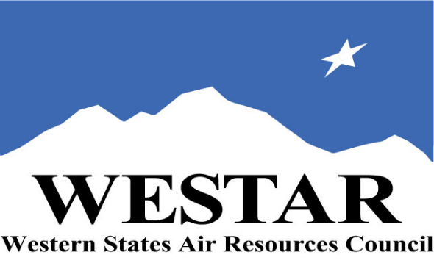

TO REGISTER
- Log onto EPA’s AirKnowledge and create a profile, or log onto your existing AirKnowledge account: EPA's AirKnowledge Website
- When you complete your profile, you will receive a confirmation e-mail to activate your new account. It may take several minutes before receiving the email.
- Once activated, log into your account.
- Click the “Instructor Lead Training Calendar” link under the “My Training” tab.
- Search the calendar for the training date(s). On the calendar you will see a course description. Hover over the text for additional information.
- To register click the course title link.
- In the lower righthand corner of the page you will see a “Request” button. Click it.
- At this point you have requested a seat in the training. Because demand for WESTAR sponsored training frequently exceeds availability all registrants are placed on a waitlist.
- You will receive an email from Jeff Gabler confirming your request.
- WESTAR attempts to accommodate all requests but at times it may be necessary to prioritize attendees.

TUESDAY, JUNE 9, 2026
PACIFIC TIMES
8:30 am Welcome & Introduction
9:00 am National Emissions
10:20 am Break
10:30 am Regulatory Approach
12:00 noon Lunch
1:00 pm Review of Organic Chemistry
2:20 pm Break
2:30 pm Review of Organic Chemistry (cont’d)
4:00 pm Adjourn for Day
WEDNESDAY, JUNE 10, 2026
PACIFIC TIMES
8:30 am Formation of Ozone and Photochemical Smog
9:15 am Properties of Organic Vapor
10:20 am Break
10:30 am Source Measurement
12:00 noon Lunch
1:00 pm Conversions & Problem Solving
2:20 pm Break
2:30 pm Surface Coating Processes
4:00 pm Adjourn for Day
THURSDAY, JUNE 11, 2026
PACIFIC TIMES
8:30 am Graphic Art Processes
9:30 am Break
9:40 am Problem Solving Coating
10:30 am Break
10:40 am Petroleum Industry
12:00 noon
1:00 pm Petroleum Refining
2:20 pm Break
2:30 pm Petroleum Products Storage & Distribution
4:00 pm Adjourn for Day

FRIDAY, JUNE 12, 2026
PACIFIC TIMES
8:30 am Degreasing
9:30 am Break
9:40 am Drying Cleaning
10:30 am Break
10:40 am Liquid Asphalt
11:30 am Lunch
12:30 pm VOC Control (Part 1)
1:50 pm Break
2:00 pm VOC Control (Part 2)
3:00 pm Adjourn

COURSE DESCRIPTION
WHO SHOULD ATTEND: This basic course is designed for individuals within a regulatory agency whose role is to evaluate volatile organic compound emission sources for permitting and to determine the ongoing compliance status of such emission sources. This class is intended for new permit and compliance engineers and scientists who are responsible for permitting and compliance activities.

LEARNING OBJECTIVES: Those completing this course will gain a basic understanding of the different types of volatile organic emission sources that are present at industrial facilities and the types of control devices that are available for certain emission sources. Attendees will be able to perform regulatory reviews involving the following elements of gaseous emissions and control:
- Basics of organic chemistry and photochemistry
- VOC properties
- National emissions and the regulatory approach
- Source measurement of VOCs
- Surface coating processes
- Graphic arts processes
- Petroleum refining and product storage and distribution
- Liquid asphalt
- Degreasing processes
- Dry cleaning processes
- VOC control methods

COURSE DESCRIPTION: This course prepares the student to evaluate techniques typically used to control volatile organic emissions from certain industrial sources. Process descriptions, emission sources and characterizations, regulatory requirements, and emission controls are discussed, along with techniques for field evaluation. Industrial sources covered include surface coating, graphic arts, petroleum refining, petroleum product storage and distribution, liquid asphalt, degreasing and dry cleaning. Supporting topics include basic organic chemistry, photochemistry, VOC properties, source measurement, national emissions inventory, and the Federal approach to regulation of VOC sources.

ACCESSIBILTY/MATERIALS
ACCESSIBILTY: WESTAR strives to host inclusive, accessible training events that enable all individuals, including individuals with disabilities, to engage fully with the instructor and course content. To request an accommodation or for inquiries about accessibility, please contact Jeff Gabler at jgabler@westar.org or 503-744-0486 by Friday, May 8, 2026.

COURSE MATERIALS: Training course materials will only be available electronically. Attendees will receive an online document sharing link for access to materials. It is the attendee’s responsibility for downloading files and for providing the device or media on which to view materials. WESTAR will provide hard copies for those needing accommodation.
SPACE LIMITATION: Registration is limited to 40 attendees. Air quality staff from the fifteen western states receive registration preference.
REGISTRATION FEES: There are no registration fees for state, local or tribal air quality agency staff.

INSTRUCTOR BIO
Dr. Aly Hassan has worked in the laboratories of the National Risk Management Research Laboratories of the Office of Research and Development of the U.S. EPA. He has 20 years of experience in air pollution in addition to a doctorate degree in the same field. He has practical regulatory experience working with the Nebraska Department of Environmental Quality in the Air Division. He possesses a professional engineering license in environmental engineering. Dr. Aly Hassan was an Oak Ridge Institute for Science and Education (ORISE) postdoctoral fellow at the US Environmental Protection Agency (EPA). Additionally, he was an adjunct professor at Central State University and at the University of Cincinnati. To date, his research has encompassed emission control technologies, use of innovative technology in indoor and atmospheric air pollution control, treatment, fate, and transport of emerging contaminants, and advanced water/wastewater treatment processes, development. His current USEPA research involves evaluating biodegradation of hexane, benzene, and other carcinogenic compounds in biological trickling filters under anaerobic, anoxic, and aerobic conditions.

TRAINING LOCATION

VIRTUAL TRAINING

