WESTAR Council

Workshop Series for Air Quality Planning Professionals

June 18, 2026

12:30 – 2:30 pm (Pacific)

VIRTUAL TRAINING

REGISTRATION DEADLINE
Friday, June 12, 2026

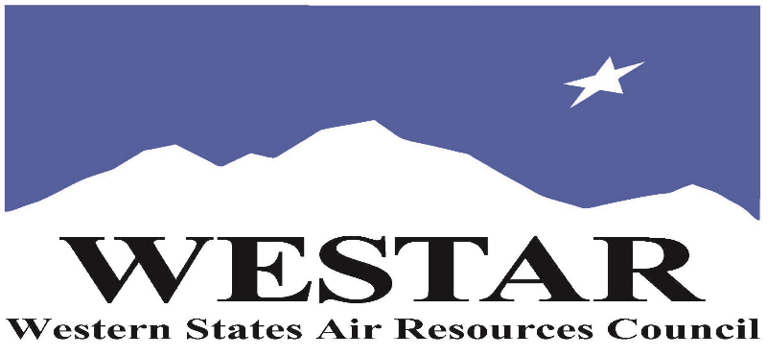

TO REGISTER
- Log onto EPA’s AirKnowledge and create a profile, or log onto your existing AirKnowledge account: EPA's AirKnowledge Website
- When you complete your profile, you will receive a confirmation e-mail to activate your new account. It may take several minutes before receiving the email.
- Once activated, log into your account.
- Click the “Instructor Lead Training Calendar” link under the “My Training” tab.
- Search the calendar for the training date(s). On the calendar you will see a course description. Hover over the text for additional information.
- To register click the course title link.
- In the lower righthand corner of the page you will see a “Request” button. Click it.
- WESTAR attempts to accommodate all requests but at times it may be necessary to prioritize attendees.

THURSAY, JUNE 18, 2026
PACIFIC TIMES
12:30 pm
DRAFT AGENDA
- Discussion of Pre-Session Work & Thought Exercises
- Ozone Chemistry Overview
  - Progression of Regulatory Efforts Over Time
  - Ozone Nonattainment Challenges in the West
- Ozone Classification Systems for Nonattainment Areas
  - Data Sources
- SIP Elements by Classification
- Stringency of Controls
- Recent Regulatory Proposals & Actions
2:30 pm
- Adjourn

Notes on workshop elements
Pre-session work and a pre-session thought exercise will be sent out to registered participants ~2 weeks prior to the session. Completion of the presession work is optional but highly encouraged.

Post-session work will be sent out to registered participants after the
session.

ABOUT THE TRAINING COURSE
COURSE DELIVERY: This is a virtual, instructor-led training course.

REGISTRATION FEES: There are no registration fees for state, local or tribal air quality agency staff.

ACCESSIBILTY
WESTAR strives to host inclusive, accessible training events that enable all individuals, including individuals with disabilities, to engage fully with the instructor and course content. To request an accommodation or for inquiries about accessibility, please contact Jeff Gabler at jgabler@westar.org or 503-744-0486 by Friday, May 29, 2026.

