WESTAR Council

Rule Writing for Air
Pollution Control Planners

June 24, 2026

8:30 – 11:00 am (Pacific)

VIRTUAL TRAINING

REGISTRATION DEADLINE
Friday, June 19, 2026

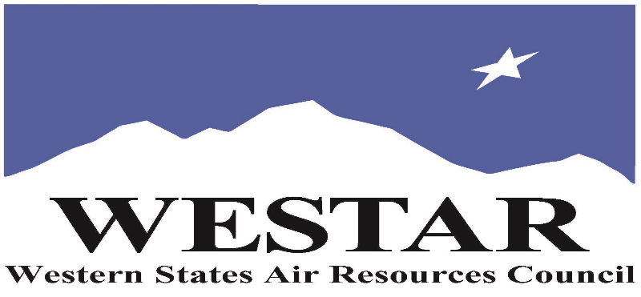

TO REGISTER
- Log onto EPA’s AirKnowledge and create a profile, or log onto your existing AirKnowledge account: EPA's AirKnowledge Website
- When you complete your profile, you will receive a confirmation e-mail to activate your new account. It may take several minutes before receiving the email.
- Once activated, log into your account.
- Click the “Instructor Lead Training Calendar” link under the “My Training” tab.
- Search the calendar for the training date(s). On the calendar you will see a course description. Hover over the text for additional information.
- To register click the course title link.
- In the lower righthand corner of the page you will see a “Request” button. Click it.
- WESTAR attempts to accommodate all requests but at times it may be necessary to prioritize attendees.

WEDNESDAY, JUNE 24, 2026
PACIFIC TIMES
8:30 am
DRAFT AGENDA
- Why Do We Need Air Pollution Control Rules and Regulations
- Foundations for Air Pollution Control Rules and Regulations
- Why Do Planners Need to Learn Rule Writing
- Regulation Development Process Overview
- Basic Elements of Rules
11:00 am
- Adjourn

OBJECTIVES
The focus of the Rule Writing training course is to present the purpose and history of air pollution control law and regulations while exploring the fundamentals of regulation development and structure. Participants are encouraged to share experiences and challenges faced.

ABOUT THE TRAINING COURSE
COURSE DELIVERY: This is a virtual, instructor-led training course.

REGISTRATION FEES: There are no registration fees for state, local or tribal air quality agency staff.

ACCESSIBILTY
WESTAR strives to host inclusive, accessible training events that enable all individuals, including individuals with disabilities, to engage fully with the instructor and course content. To request an accommodation or for inquiries about accessibility, please contact Jeff Gabler at jgabler@westar.org or 503-744-0486 by Friday, June 5bro, 2026.

