WESTAR Council

Principles of Ambient Air
Monitoring (AMBM 102)

November 17-18, 2026

VIRTUAL TRAINING

REGISTRATION DEADLINE
October 30, 2026

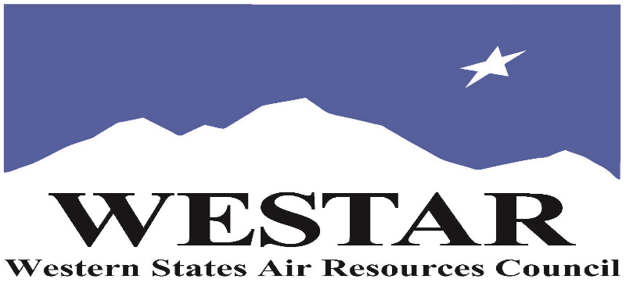

TO REGISTER
- Log onto EPA’s AirKnowledge and create a profile, or log onto your existing AirKnowledge account: EPA's AirKnowledge Website
- When you complete your profile, you will receive a confirmation e-mail to activate your new account. It may take several minutes before receiving the email.
- Once activated, log into your account.
- Click the “Instructor Lead Training Calendar” link under the “My Training” tab.
- Search the calendar for the training date(s). On the calendar you will see a course description. Hover over the text for additional information.
- To register click the course title link.
- In the lower righthand corner of the page you will see a “Request” button. Click it.
- At this point you have requested a seat in the training. Because demand for WESTAR sponsored training frequently exceeds availability all registrants are placed on a waitlist.
- You will receive an email from Jeff Gabler confirming your request.
- WESTAR attempts to accommodate all requests but at times it may be necessary to prioritize attendees.

AGENDA
WEDNESDAY, NOVEMBER 17, 2026
PACIFIC TIMES
9:00 am Introduction/Course Overview
9:15 am Regulations & Standards
10:15 am Break
10:25 am Monitoring Networks
11:15 am Break
12:15 pm Monitoring Networks (cont’d)
1:00 pm Break
1:10 pm Station Siting
1:50 pm Q&A
2:00 pm Adjourn for Day
THURSDAY, NOVEMBER 18, 2026
PACIFIC TIMES
9:00 am Review of Day 1
9:15 am Measurement Process
10:15 am Break
10:25 am Measurement Process (cont’d)
11:15 am Break
12:15 pm Data Handling & Documentation
12:50 pm Break
1:00 pm Quality Assurance/Quality Control
1:30 pm References & Resources
2:00 pm Adjourn

ABOUT THE TRAINING COURSE
COURSE DESCRIPTION: This is an introductory course in the general aspects and requirements for an ambient air monitoring network. The course will cover regulations and standards, types of monitoring networks, how to locate air monitoring stations, instrumentation (including sensors), required documentation, data handling, and quality assurance. After completion of this course, participants will be able to explain the general principles of ambient air monitoring for criteria pollutants and what is needed to operate a regulatory network.

COURSE DELIVERY: This is a virtual, instructor-led training course.

SPACE LIMITATION: Registration is limited to 40 attendees. Air quality staff from the fifteen western states receive registration preference.

REGISTRATION FEES: There are no registration fees for state, local or tribal air quality agency staff.

ACCESSIBILTY
WESTAR strives to host inclusive, accessible training events that enable all individuals, including individuals with disabilities, to engage fully with the instructor and course content. To request an accommodation or for inquiries about accessibility, please contact Jeff Gabler at jgabler@westar.org or 503-744-0486 by Friday, October 16, 2026.

INSTRUCTOR BIO
Gordon Pierce retired from the Colorado Department of Public Health and Environment, Air Pollution Control Division, in 2022 after 35 years of service. His last role was supervising the Technical Services Program, which covered ambient air monitoring, quality assurance, modeling, prescribed fire and forecasting. During this time, at CDPHE, he worked on a variety of air monitoring projects and was involved with a number of different groups, including the Western States Air Resources Council, the Western Regional Air Partnership, the NACAA National Air Monitoring Steering Committee and the IMPROVE Steering Committee. Currently, Gordon is working part-time for 2B Technologies, an air monitoring equipment manufacturer in Broomfield, Colorado and part-time for the US Forest Service in their Smoke Monitoring Cache in Lakewood, Colorado. Gordon has a BSc in Geological Engineering from the Colorado School of Mines and a MS in Environmental Science from the University of Colorado-Denver.

