WESTAR Council

Fabric Filters
(PERM241)

July 28, 2026

VIRTUAL TRAINING

REGISTRATION DEADLINE
Friday, July 10, 2026

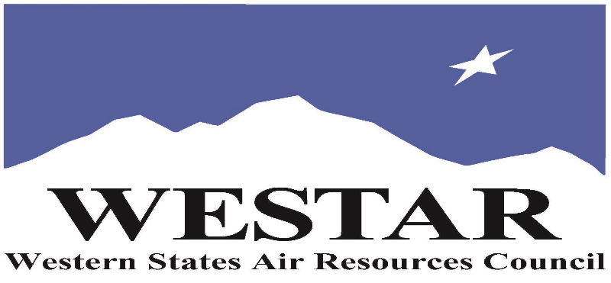

TO REGISTER
- Log onto EPA’s AirKnowledge and create a profile, or log onto your existing AirKnowledge account: EPA's AirKnowledge Website
- When you complete your profile, you will receive a confirmation e-mail to activate your new account. It may take several minutes before receiving the email.
- Once activated, log into your account.
- Click the “Instructor Lead Training Calendar” link under the “My Training” tab.
- Search the calendar for the training date(s). On the calendar you will see a course description. Hover over the text for additional information.
- To register click the course title link.
- In the lower righthand corner of the page you will see a “Request” button. Click it.
- At this point you have requested a seat in the training. Because demand for WESTAR sponsored training frequently exceeds availability all registrants are placed on a waitlist.
- You will receive an email from Jeff Gabler confirming your request.
- WESTAR attempts to accommodate all requests but at times it may be necessary to prioritize attendees.

AGENDA
TUESDAY, JULY 28, 2026
PACIFIC TIMES
9:00 am Introductions/Course Overview
9:30 am Baghouse Theory
10:00 am How does Fabric Filtration Work?
11:00 am Types of Baghouses
11:30 am Design & Operation of Baghouses
12:00 noon Lunch
1:00 pm Operation & Maintenance Problems
1:30 pm Inspecting a Baghouses
2:00 pm Review
3:00 pm Adjourn

ABOUT THE TRAINING COURSE
TARGET AUDIENCE: This course is intended for new, inexperienced state, local and tribal air quality professionals.
COURSE DESCRIPTION: This is a one-day course that presents the major uses for baghouses, operational theory and design, applicable regulations, permit conditions and inspection procedures. The course also includes a brief discussion of baghouse troubleshooting and maintenance. After completion of this one-day course, learners will be able to explain key aspects of baghouse operations, including:
• Fabric filtration
• Types of baghouses
• Design and operation of baghouses
• Operation and maintenance problems
• Baghouse inspection
COURSE DELIVERY: This is a virtual, instructor-led training course.

SPACE LIMITATION: Registration is limited to 40 attendees. Air quality staff from the fifteen western states receive registration preference.

REGISTRATION FEES: There are no registration fees for state, local or tribal air quality agency staff.

ACCESSIBILTY
WESTAR strives to host inclusive, accessible training events that enable all individuals, including individuals with disabilities, to engage fully with the instructor and course content. To request an accommodation or for inquiries about accessibility, please contact Jeff Gabler at jgabler@westar.org or 503-744-0486 by Friday, June 26, 2026.

