WESTAR Council

Effective Permit
Writing

July 14-16, 2026

VIRTUAL TRAINING

REGISTRATION DEADLINE
Friday, June 19, 2026

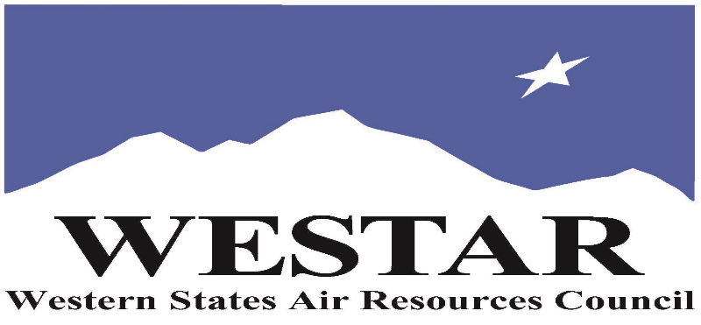

TO REGISTER
- Log onto EPA’s AirKnowledge and create a profile, or log onto your existing AirKnowledge account: EPA's AirKnowledge Website
- When you complete your profile, you will receive a confirmation e-mail to activate your new account. It may take several minutes before receiving the email.
- Once activated, log into your account.
- Click the “Instructor Lead Training Calendar” link under the “My Training” tab.
- Search the calendar for the training date(s). On the calendar you will see a course description. Hover over the text for additional information.
- To register click the course title link.
- In the lower righthand corner of the page you will see a “Request” button. Click it.
- At this point you have requested a seat in the training. Because demand for WESTAR sponsored training frequently exceeds availability all registrants are placed on a waitlist.
- You will receive an email from Jeff Gabler confirming your request.
- WESTAR attempts to accommodate all requests but at times it may be necessary to prioritize attendees.

AGENDA
TUESDAY, JULY 14, 2026
PACIFIC TIMES
9:00 am
- Welcome & Housekeeping
- Learning Objectives
- Course Introduction
- Sources of Authority that Govern Your Ability to do Your Job
- Permit Types & Application Forms
10:45 am
- Break
11:15 am
- Concepts of Potential to Emit & Enforceability
- Breakout Session 1 – Enforceable Permit Conditions
- Permit Application Completeness
- Breakout Session 2 – Application Completeness
12:45 noon
- Break

12:55 pm
- Translating the Application into a Permit
  - Define the Source
  - Determine Applicable Permit Type
  - Conduct Rule Assessment
1:45 pm
- Close Out & Homework
2:00 pm
- Adjourn for Day
WEDNESDAY, JULY 15, 2026
PACIFIC TIMES
9:00 am
- Welcome & Housekeeping
- Group Discussion: Homework Review
- Translating the Application into a Permit (cont’d)
- Make Discretionary Decisions
- Develop Permit Conditions
- Document Decisions
- Prepare for Public Participation
10:15 am
- Break
10:45 am
- Breakout Session 3 – Review of Standard Conditions
- Set Emissions Limits
- Breakout Session 4 – What Kinds of Regulations Create the Need for Emissions Limits
- Set Emission Limits (cont’d)
- Breakout Session 5 – Emission Limits & Permit Exercise
- Emission Limits (cont’d)
12:05 pm
- Break
12:15 pm
- Breakout Session 6 – Determine the Emissions Limits
- Monitoring
- Explain & Apply Title V Permits
- Close Out & Homework
2:00 pm
- Adjourn for Day
THURSDAY, JULY 16, 2026
PACIFIC TIMES
9:00 am
- Welcome, Housekeeping and Introduction
- Breakout Sessions 7.1 – 7.4 – Defective Permits
- Breakout Sessions 8.1 – 8.2 – Permit Drafting (including a 30 break)
- Report Out on Permit Drafting
- Post-Test & Course Evaluation
2:00 pm
- Adjourn

ABOUT THE TRAINING COURSE
COURSE DESCRIPTION: This course presents information on the major national programs in air pollution stationary source permitting. This course was designed to provide methods and procedures used to effectively draft and review permit conditions used with a variety of permit programs. This course is designed for personnel of state and local permitting agencies who are new to permit programs, managers of programs which are impacted by permits, and inspectors who must read and interpret permit conditions. Examples of the various types of permit conditions are presented along with practical exercises.

MAJOR TOPICS:
- Identification of the components required in a complete permit application evaluation,
- Explanation of the functions and purposes of each component of a complete permit application,
- Description of the characteristics of an effective permit,
- Explanation of the process, approaches that can be used to assure an effective permit is produced.

COURSE DELIVERY: This is a virtual, instructor-led training course.

SPACE LIMITATION: Registration is limited to 35 attendees. Air quality staff from the fifteen western states receive registration preference.

REGISTRATION FEES: There are no registration fees for state, local or tribal air quality agency staff.

ACCESSIBILTY
WESTAR strives to host inclusive, accessible training events that enable all individuals, including individuals with disabilities, to engage fully with the instructor and course content. To request an accommodation or for inquiries about accessibility, please contact Jeff Gabler at jgabler@westar.org or 503-744-0486 by Friday, JUNE 5, 2026.
INSTRUCTIONAL BIO
Matt Haber has been working on permits since 1980, when he began work at EPA preparing PSD permits, reviewing state and local permits, and reviewing the applicability of the PSD program to potential permit applicants. He was in the room during the development of the Title V permit program. He finished his EPA career in the headquarters enforcement office, where he was involved in several NSR enforcement initiatives. Since 2015, he has worked at ERG and has advised EPA, state, and local agencies about permit program development, implementation, and enforcement.

Liz Gorman recently joined ERG as an Environmental Engineer with over 15 years of air quality and environmental compliance experience. She has spent the majority of her career providing air quality consulting services to industrial clients in the oil and gas, refining, petroleum bulk terminal, chemical, and general manufacturing sectors. More recently, she provided on-site environmental compliance support to a DoD military installation. Liz assisted clients with compliance strategies for maintaining compliance with major and non-major construction and operating permits.

