WESTAR Council

Fugitive Volatile Organic
Compounds (TOXC 240)

May 21, 2026

VIRTUAL TRAINING

REGISTRATION DEADLINE
Friday, April 17, 2026

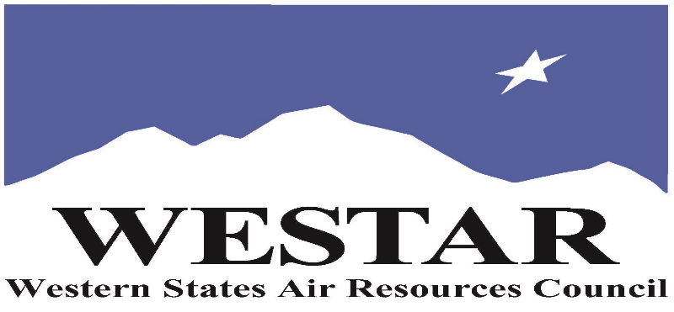

TO REGISTER
- Log onto EPA’s AirKnowledge and create a profile, or log onto your existing AirKnowledge account: EPA's AirKnowledge Website
- When you complete your profile, you will receive a confirmation e-mail to activate your new account. It may take several minutes before receiving the email.
- Once activated, log into your account.
- Click the “Instructor Lead Training Calendar” link under the “My Training” tab.
- Search the calendar for the training date(s). On the calendar you will see a course description. Hover over the text for additional information.
- To register click the course title link.
- In the lower righthand corner of the page you will see a “Request” button. Click it.
- At this point you have requested a seat in the training. Because demand for WESTAR sponsored training frequently exceeds availability all registrants are placed on a waitlist.
- You will receive an email from Jeff Gabler confirming your request.
- WESTAR attempts to accommodate all requests but at times it may be necessary to prioritize attendees.

AGENDA
THURSDAY, MAY 21, 2026
PACIFIC TIMES
9:00 am Welcome and Introduction
9:15 am Definitions & Affected Sources
9:30 am Facilities & Components Regulated
10:00 am Break
10:15 am Estimating Emissions & Test Methods
10:45 am LDAR & MRR Requirements
11:15 am Regulations & Standards
12:00 noon Lunch
1:00 pm Leak Detection Devices & Limitations
1:45 pm Field Inspections & Safety
2:30 pm Review
3:00 pm Adjourn

ABOUT THE TRAINING COURSE
WHO SHOULD ATTEND: This course is intended for new, entry-level as well as semi-experienced stationary source permit engineers, inspectors, regulatory agency staff, and environmental specialists in business and government. The course is designed to provide an overview of VOC leak inspections.

LEARNING OBJECTIVES: Those completing this course will gain a basic understanding of the general information associated with fugitive VOC emission inspections. Attendees will be able to perform regulatory reviews involving the following elements of fugitive emissions:
• Regulated Facilities
• Components
• Estimating Emissions
• Regulations and Standards
• Portable Hydrocarbon Analyzers
• Field Inspections

COURSE DELIVERY: This is a virtual, instructor-led training course.

SPACE LIMITATION: Registration is limited to 40 attendees. Air quality staff from the fifteen western states receive registration preference.

REGISTRATION FEES: There are no registration fees for state, local or tribal air quality agency staff.

ACCESSIBILTY
WESTAR strives to host inclusive, accessible training events that enable all individuals, including individuals with disabilities, to engage fully with the instructor and course content. To request an accommodation or for inquiries about accessibility, please contact Jeff Gabler at jgabler@westar.org or 503-744-0486 by Friday, April 17, 2026.

