WESTAR Council

NOx Control/Regulation

APRIL 21-23, 2026

VIRTUAL TRAINING

REGISTRATION DEADLINE
Friday, March 20, 2026

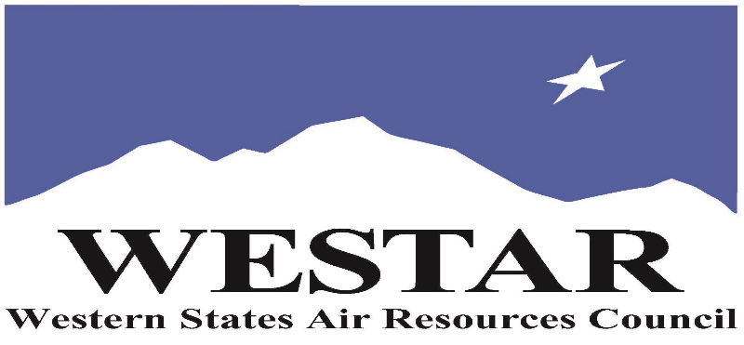

TO REGISTER
- Log onto EPA’s AirKnowledge and create a profile, or log onto your existing AirKnowledge account: EPA's AirKnowledge Website
- When you complete your profile, you will receive a confirmation e-mail to activate your new account. It may take several minutes before receiving the email.
- Once activated, log into your account.
- Click the “Instructor Lead Training Calendar” link under the “My Training” tab.
- Search the calendar for the training date(s). On the calendar you will see a course description. Hover over the text for additional information.
- To register click the course title link.
- In the lower righthand corner of the page you will see a “Request” button. Click it.
- At this point you have requested a seat in the training. Because demand for WESTAR sponsored training frequently exceeds availability all registrants are placed on a waitlist.
- You will receive an email from Jeff Gabler confirming your request.
- WESTAR attempts to accommodate all requests but at times it may be necessary to prioritize attendees.

AGENDA
TUESDAY, APRIL 21, 2026
PACIFIC TIMES
9:00 am
- Welcome & Introductions
- Learning Objectives
- Logistics
- Clean Air Act Structure: Focus on where control technology requirements exist, especially RACT/BACT/LEAR
- Why Control NOx?
- FTP Introduction
- Basics of NOx Formation
  - NOx Formation
  - Impact of Fuel Type on NOx
  - Major Combustion Sources

10:45 am
- Break

11:15 am
- Types of NOx Controls
- Calculating NOx Emissions & NOx Control
- Exercise: Accounting for NOx Control in PTE Calculations
- History & Definitions of RACT, BACT, & LAER, and when each is required
- RBLC: Uses & Caveats/Dangers, and how best to use it in analysis
1:00 pm
- Break
1:10 pm
- The Role of RACT in SIP Planning & the relationship between RACT and Reasonable Available Control Measure (RACM) requirements.
- RACT Review Process, Anti-Backsliding Provisions, and State/Local/Tribal Discretions
- Source Types Subject to NOx RACT and Status of Adoption of RACT Measures for Those Sources in States, Measures Adopted, State-to-State Consistency
- Brief Overview of Source Types Subject to VOC RACT
1:25 pm
- Break
1:35 pm (PACIFIC)
- Monitoring – Continuous Emission Monitoring (CEMs) and Converting Wet to Dry, X% Oxygen to Y% Oxygen
- Introduce - Homework Exercise
2:00 pm
- Adjourn for Day

WEDNESDAY, APRIL 22, 2026
PACIFIC TIMES
9:00 am
- Questions from Day 1, Learning Objectives
- Review of Homework Exercise
- Overview of Permit Types: PSD vs NNSR vs Minor Source
- BACT & LAER: How are they Determined, & Multi-Step BACT Process
- Example Determinations for Source Categories of Interest
10:25 am
- Break
10:55 am
- Exercise – BACT Analysis Review
- How do State Interpret BACT (e.g.; cost thresholds in BACT Determinations, considerations of new technologies & alternative production processes/sites/sizes)
- Enforceability Basic
12:00 noon
- Break
12:10 pm
- Multi-Step LAER Process
- Exercise – LAER Analysis Review
12:50 pm
- Break
1:00 pm
- NOx Controls for stationary source categories. Discuss NOx controls for boilers, engines, turbines, flares, incinerators, cement kilns, glass furnaces
- Introduce Homework Exercise
2:00 pm
- Adjourn for Day
THURSDAY, APRIL 23, 2026
PACIFIC TIMES
9:00 am
- Questions from Day 2, Review Homework Exercise
- Engine Control Exercise
- RACT Exercise IC Engines (Group)
10:10 am
- Break
10:40 am
- BACT Exercise for Engines
11:30 am
- Break
11:40 am
- NOx Control Trends & Case Studies
  - Provide Data on Actual NOx Controls Achieved in Practice
  - Review Several Real-World NOx Control Case Studies
- LAER Exercise for Boilers
- Post Test & Discussion of Answers
2:00 am
- Adjourn

ABOUT THE TRAINING COURSE
WHO SHOULD ATTEND: This course was designed to address the needs of tribal, state, and local air agency personnel involved in the permitting and compliance assessment of existing regulatory requirements as well as those personnel involved in the development of nitrogen oxide (NOx) control programs. This class is intended for new permit and compliance engineers and scientists who are responsible for permitting, compliance, and SIP planning activities.

ABOUT THE COURSE: This course presents fundamental information on NOx emissions from combustion sources such as industrial and utility boilers. The goal of this course is to present information that will help environmental professionals address present and future NOx control issues. The course introduces a broad range of control technology topics and identifies some of the sources for obtaining further information on these topics.

LEARNING OBJECTIVES: Those completing this course will gain an understanding of the mechanisms by which NOx is formed in the combustion process as well as sources of NOx emissions and the history related to regulating NOx emissions from these sources. Attendees will be able to perform regulatory reviews involving the types, applicability, capability, and limitations of available control techniques to suppress the formation of NOx emissions or to minimize NOx emissions.

COURSE DELIVERY: This is a virtual, instructor-led training.

SPACE LIMITATION: Registration is limited to 35 attendees. Air quality staff from the fifteen western states receive registration preference.

REGISTRATION FEES: There are no registration fees for state, local or tribal air quality agency staff.

ACCESSIBILTY
WESTAR strives to host inclusive, accessible training events that enable all individuals, including individuals with disabilities, to engage fully with the instructor and course content. To request an accommodation or for inquiries about accessibility, please contact Jeff Gabler at jgabler@westar.org or 503-744-0486 by Friday, March 20, 2026.
INSTRUCTIONAL STAFF
Matt Haber has been working on permits since 1980, when he began work at EPA preparing PSD permits, reviewing state and local permits, and reviewing the applicability of the PSD program to potential permit applicants. He was in the room during the development of the Title V permit program. He finished his EPA career in the headquarters enforcement office, where he was involved in several NSR enforcement initiatives. Since 2015, he has worked at ERG and has advised EPA, state, and local agencies about permit program development, implementation, and enforcement.

Liz Gorman recently joined ERG as an Environmental Engineer with over 15 years of air quality and environmental compliance experience. She has spent the majority of her career providing air quality consulting services to industrial clients in the oil and gas, refining, petroleum bulk terminal, chemical, and general manufacturing sectors. More recently, she provided on-site environmental compliance support to a DoD military installation. Liz assisted clients with compliance strategies for maintaining compliance with major and non-major construction and operating permits.

