NMED REGIONAL OZONE SOURCE APPORTIONMENT STUDY

INTRODUCTION

In 2025–2026, the New Mexico Environment Department (NMED) contracted with Ramboll to conduct a Regional Ozone Source Apportionment Study. The study is being conducted in two phases. Phase I was performed from April through June 2025 during Fiscal Year 2024–2025 (FY2024–2025). Phase I included 2022v1 base case and 2026v1 ozone source apportionment modeling using the EPA 2022v1 12 km modeling platform for the Comprehensive Air-quality Model with extensions (CAMx) photochemical grid model (PGM). Under Phase II (FY2025–2026), Ramboll developed a higher-resolution CAMx 2022v2 12/4 km modeling platform using EPA 2022v2 emissions and conducted CAMx 2022v2 and 2032v2 12/4 km base case and ozone source apportionment modeling. Ozone source apportionment modeling is being conducted and reported for the full 4 km modeling domain (Figure 1, left panel), which includes all of New Mexico and portions of adjacent states. Although results are obtained for the entire New Mexico 4 km domain, the focus is on ozone contributions within the New Mexico portion of the Permian Basin where the largest ozone increases have occurred in recent years.

Figure 1 displays the ozone monitoring sites in New Mexico and portions of adjacent states and the 2005–2024 trends in ozone Design Values (DVs) at the three ozone monitoring sites located in the New Mexico portion of the Permian Basin in southeastern New Mexico: Carlsbad City and Carlsbad Caverns in Eddy County, and Hobbs in Lea County. In August 2018, U.S. EPA designated ozone nonattainment areas for the 70 ppb 2015 ozone National Ambient Air Quality Standard (NAAQS) based on observed 2014–2016 ozone DVs, which at the Carlsbad City and Hobbs monitoring sites were 67 ppb and 66 ppb, respectively. This resulted in Eddy and Lea Counties being designated as attainment areas under the 2015 ozone NAAQS. Since 2017, ozone concentrations in the Permian Basin have increased, coincident with increases in oil and gas (O&G) production in the region. By 2018, ozone DVs in the New Mexico portion of the Permian Basin began exceeding the 2015 ozone NAAQS (Figure 1, right panel).

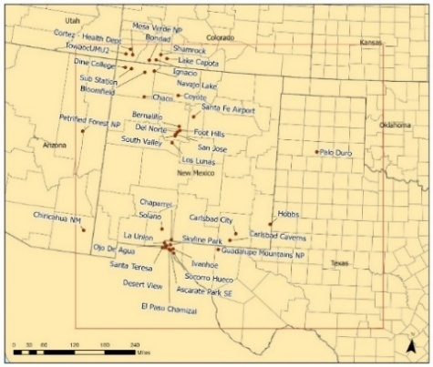 | 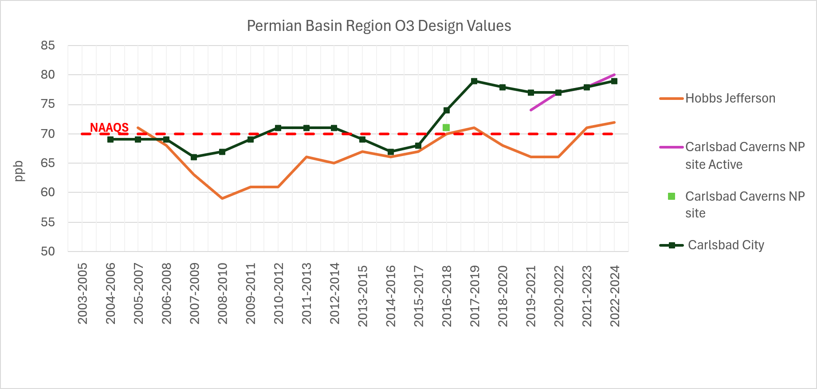
Figure 1. Locations of ozone monitoring sites within the New Mexico 4 km modeling domain (left) and trends in observed ozone Design Values at monitoring sites within the New Mexico portion of the Permian Basin (right)

NMED REGIONAL OZONE STUDY PHASE I FY2024-2025 RESULTS

Phase I of the NMED Regional Ozone Modeling Study was conducted during April to June 2025 and used the EPA CAMx 2022v1 12 km continental U.S. (12US2) modeling platform. A CAMx 2022v1 12 km based case was conducted and subjected to a model performance evaluation. Figure 2 displays the 12US2 12 km grid resolution domain used and the Maximum Daily Average 8-hour (MDA8) ozone Normalized Mean Bias (NMB) performance metric for sites in and adjacent to New Mexico. The MDA8 ozone met or nearly met the ozone bias Performance Criterion at all sites and met the bias Performance Goal at approximately half of the sites.

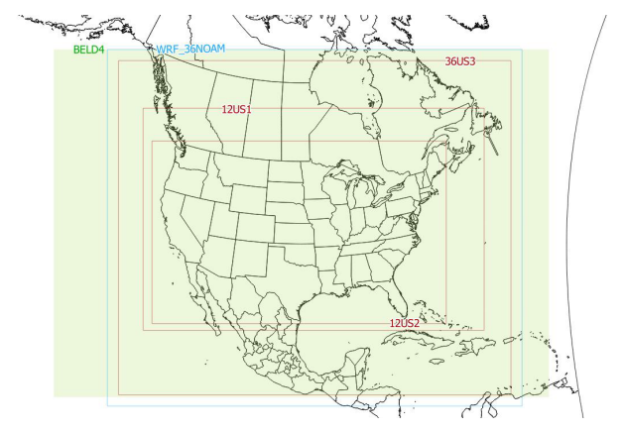 | 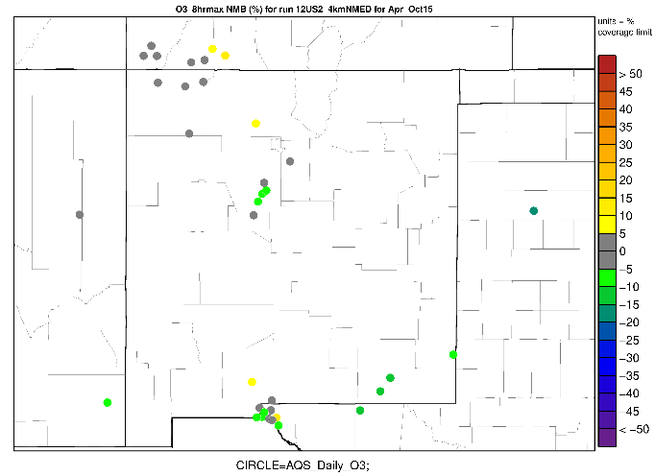
Figure 2. 12US2 12 km modeling domain (left) and CAMx 2022v1 12 km MDA8 ozone NMB performance metric (left) colored grey to show when the NMB meets the bias Performance Goal (≤±5%) and green (underestimation) or yellow (overestimation) when the NMB meets the bias Performance Criterion (≤±15%).

Scatter plots of the predicted and observed MDA8 ozone concentrations at the Carlsbad City and Hobbs southeast New Mexico sites in the Permian Basin O&G region are shown in Figure 3 with both sites showing that the CAMX 2022v1 12 km base case has a MDA8 ozone underestimation bias with more points below than above the 1:1 line of perfect agreement. The MDA8 ozone NMB at Hobbs (-5.3%) is at the ozone bias Performance Goal, whereas at Carlsbad City the MDA8 ozone NMB (-10.6%) has an underprediction tendency that falls between the bias Performance Goal and Criterion.

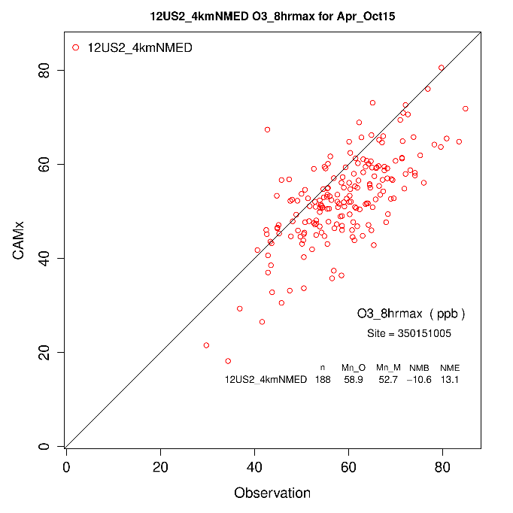 | 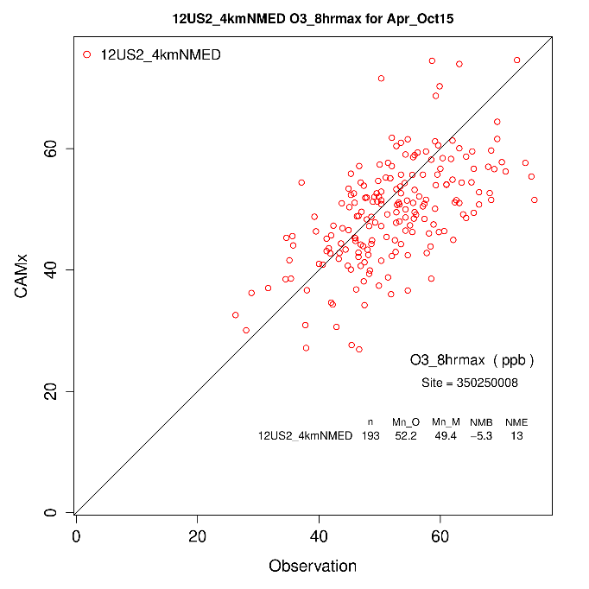
Figure 3. Scatter plots of predicted and observed MDA8 ozone concentrations and performance statistics at the Carlsbad City (left) and Hobbs (right) southwest New Mexico monitoring sites from the CAMx 2022v1 12 km base case simulation.

A CAMx 2026 emissions scenario was conducted using the EPA 2022v1 12 km modeling platform and the observed base year 2020-2024 ozone Design Values (DVB) projected to 2026 using the Software for the Modeled Attainment Test (SMAT). Figure 4 displays the spatial distribution of the interpolated observed 2020-2024 ozone DVBs and projected future year 2026 ozone Design Values (DVF). The area in southeast New Mexico with projected 2026 ozone DVFs exceeding the 70 ppb 2015 ozone NAAQS is smaller compared to the areas of the 2020-2024 ozone DVB; the observed 2020-2024 DVB at Carlsbad City (78.0 ppb) that exceeds the 75 ppb 2008 ozone NAAQS is reduced to 71.8 ppb that exceeds but is close to the 2015 ozone NAAQS.

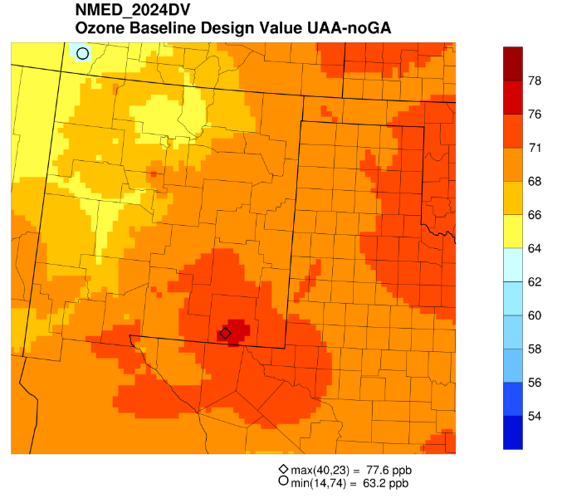 | 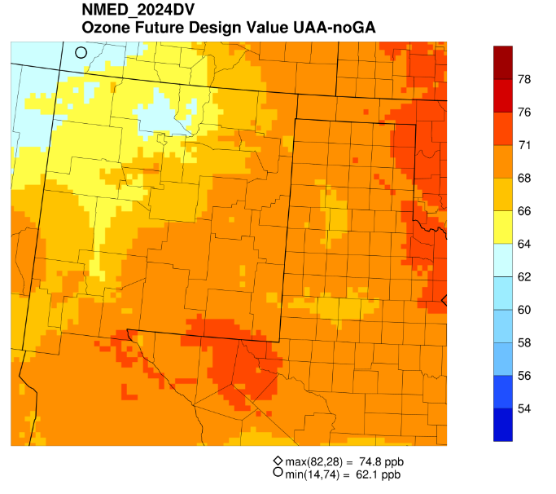
Figure 4. Spatial distribution of the 2020-2024 ozone DVB (left) and projected 2026 ozone DVF (right) from the 2022 and 2026 CAMx modeling using the EPA 2022v1 12 km modeling platform.

CAMx 2026 ozone source apportionment modeling was conducted using 6 Source Regions and 10 Source Categories. Figure 5 shows the spatial distribution of the New Mexico total anthropogenic emissions and New Mexico O&G emissions to the projected 2026 ozone DVF. The maximum contribution of New Mexico anthropogenic emissions to the projected 2026 ozone DVF is 9.0 ppb near Carlsbad City with 8.5 ppb of that contribution due to New Mexico O&G emissions.

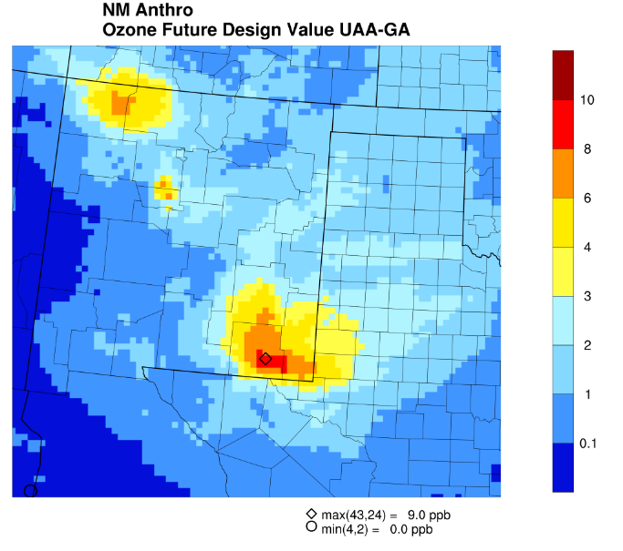 | 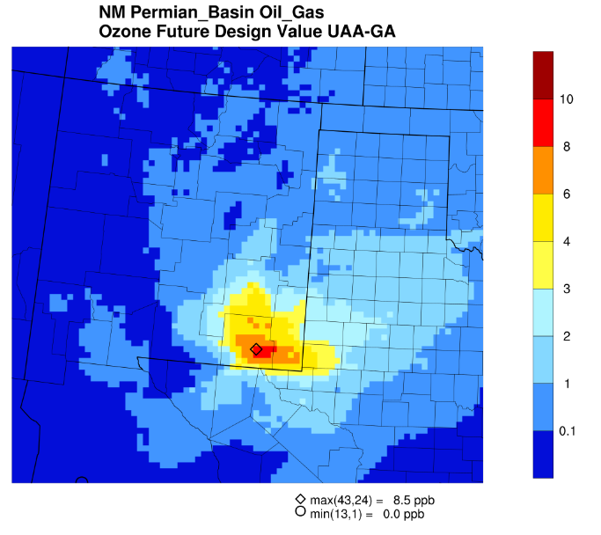
Figure 5. Contribution of New Mexico total anthropogenic emissions (left) and New Mexico O&G emissions (right) to the projected 2026 ozone DVF using the EPA 2022v1 12 km modeling platform.

The CAMx 2026 APCA ozone source apportionment contributions to MDA8 ozone were extracted at the monitoring sites and processed into Excel Dashboards so that the Source Groups ozone contributions to MDA8 ozone concentrations at the monitors can be displayed for a day or groups of days. The MDA8 ozone Dashboard allows the user to investigate into the Source Region and Source Category ozone contributions of interest to 2026 MDA8 ozone concentrations at all New Mexico sites. Three types of Excel Dashboards were developed:
- MDA8 Ozone Dashboard: Display MDA8 ozone contributions by Source Regions and Source Categories at a single user-selected ozone monitor and user-selected set of days.
- O3N/O3V Dashboard: Display MDA8 ozone contributions at a monitoring site that provides information on whether MDA8 ozone was formed under more NO_{X}-sensitive (O3N) or VOC-sensitivity (O3V) conditions.
- Ozone Efficiency Dashboard: Display ozone efficiency metrics of the ozone contribution (O3N and O3V) per mass of emissions (NO_{X} and VOC).

Figure 6 displays a screen shot of the MDA8 Ozone Dashboard for the Carlsbad City monitoring site and the 10 days used by SMAT to make 2026 ozone DVF projections for all Source Regions and Source Categories. The projected 2026 ozone DVF at Carlsbad City is 71.8 ppb and the 2026 modeled average across the 10 SMAT days is 66.99 ppb with Boundary Conditions (BC) contributing a majority (66%) of the average MDA8 ozone concentration.
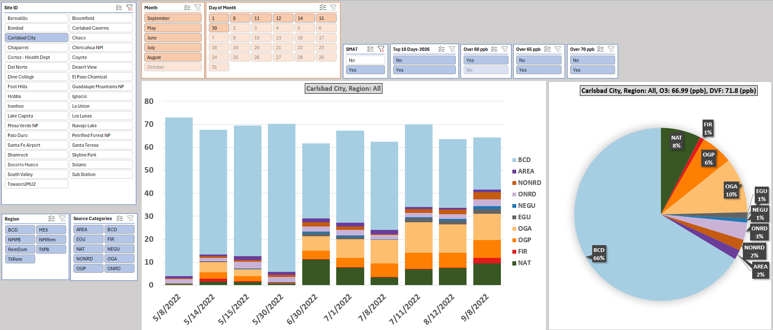
Figure 6. MDA8 Ozone Dashboard that displays Source Category and Source Region contributions to 2026 MDA8 ozone concentrations at Carlsbad City monitoring site on the 10 days used by SMAT to make 2026 ozone DVF projections.

Phase I of the NMED Regional Ozone Study Produced the following Deliverables:

- Report on CAMx 2022v1 12 km Base Case modeling, model performance evaluation and 2026v1 ozone source apportionment modeling.

- MDA8 Ozone Excel Dashboard

- O3N/O3V Excel Dashboard

- Ozone Efficiency Excel Dashboard

- Report on WRF 2022 12/4 km Meteorological Model Application/Evaluation

- Memorandum on Preliminary CAMx 2022v1 12/4 km Flexinest Evaluation

NMED REGIONAL OZONE STUDY PHASE II FY2025-2026 RESULTS

Under Phase II (FY2025-2026) of the NMED Regional Ozone Source Apportionment Study, Ramboll developed a Conceptual Model of ozone formation in New Mexico and a higher resolution CAMx 2022v2 12/4 km modeling platform using the WRF 2022 12/4 km meteorology developed in Phase I and EPA’s 2022v2 Emissions Modeling Platform (EMP). EPA’s 2022v2 12 km model-ready emissions were used and the 2022v2 emissions were processed by the Sparse Matrix Operator Kernel (SMOKE) emission model to generate the 2022v2 CAMx emission inputs for the New Mexico 4 km domain. Figure 7 displays pie charts of the New Mexico 2022v2 anthropogenic NO_{X} and VOC emissions that show O&G emissions are the largest contributor for both NO_{X} (60%) and VOC (85%). Figure 8 displays the CAMx 2022v2 12/4 modeling domains and the MDA8 NMB performance metric at sites in the New Mexico 4 km domain, which can be compared to the Phase I CAMx 2022v1 12 km NMB in Figure 2. The CAMx 2022v2 12/4 km has a larger ozone underestimation bias than the CAMx 2022v1 12 km simulation that is due to the 2022v1 emissions overstating NO_{X} emissions from O&G drilling and fracing engines by 74%.

Figure 7. Pie Charts showing the percent contributions of 2022v2 anthropogenic emission source sectors to total anthropogenic NO_{X} and VOC emissions in New Mexico.

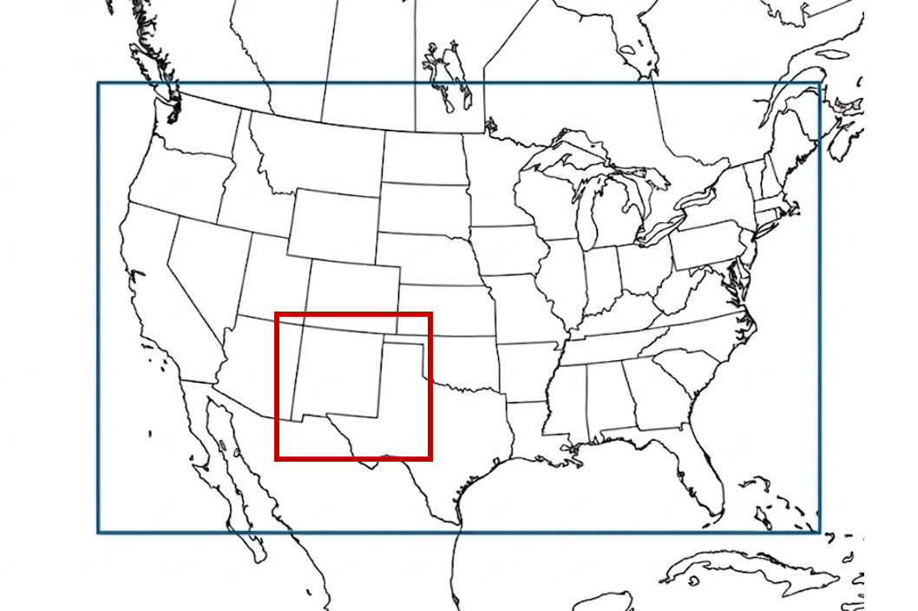 | 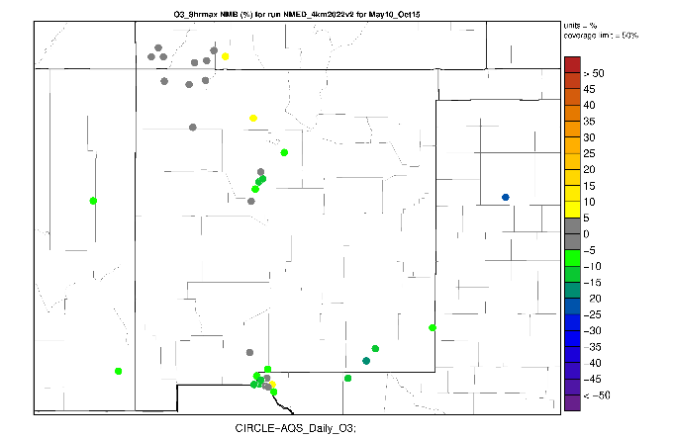
Figure 8. CAMx 2022v2 12 km (blue) and 4 km (red) modeling domains (left) and CAMx 2022v2 4 km MDA8 ozone NMB performance metric (right) colored to show when the NMB meets the bias Performance Goal (≤±5%; grey) or bias Performance Criteria (≤±15%; green and yellow).

Figure 9 displays scatter plots of predicted and observed MDA8 ozone concentrations at Carlsbad City for the Phase II CAMx 2022v2 12/4 km base case simulation, which can be compared to the Phase I CAMx 2022v1 12 km performance in Figure 3. There is a worsening on MDA8 ozone performance in the Phase II CAMx 2022v2 12/4 km results at these at these two Permian Basin sites compared to Phase I CAMx 2022v1 12 km simulation that is attributable to the aforementioned error in the 2022v1 O&G drill and fracing engine NO_{X} emissions that were 74% too high. The NMB degrades from -10.6% to -14.6% at Carlsbad City and from -5.3% to -9.5% at Hobbs going from the CAMx 2022v1 12 km to CAMx 2022v2 12/4 km base case simulations.

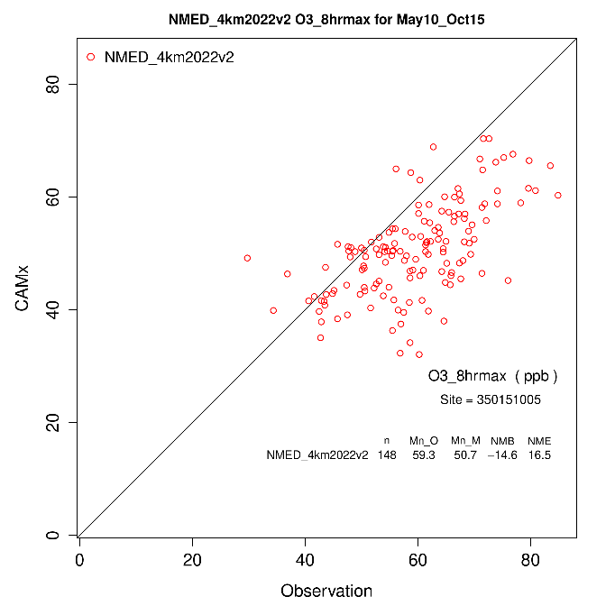 | 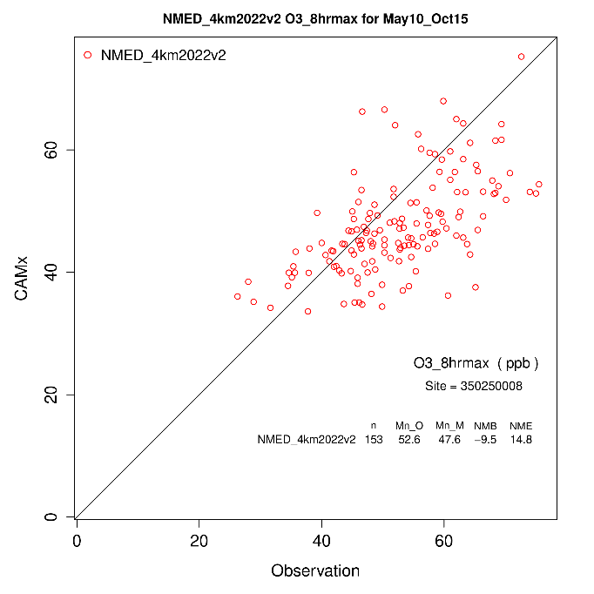
Figure 9. Scatter plots of predicted and observed MDA8 ozone concentrations and performance statistics at the Carlsbad City (left) and Hobbs (right) southwest New Mexico monitoring sites from the Phase II CAMx 2022v2 12/4 km km base case simulation.

The CAMx 2022v2 12/4 km base case simulation was also evaluated against surface VOC measurements and satellite observations. The satellite observations suggested that the model may understate the benefits of reducing VOC emissions in the Permian Basin for reducing ozone concentrations. Figure 10 shows an example of the VOC evaluation for ethane at the Carlsbad Caverns and Loving, New Mexico sites that are near Carlsbad City in the Permian Basin. Ethane (as well as propane) are underestimated by the CAMx 2022v2 12/4 km base case by approximately a factor of 5 at both sites. As ethane and propane are markers for O&G emissions, these results suggest that the 2022v2 emissions inventories understate O&G VOC emissions in the Permian Basin.

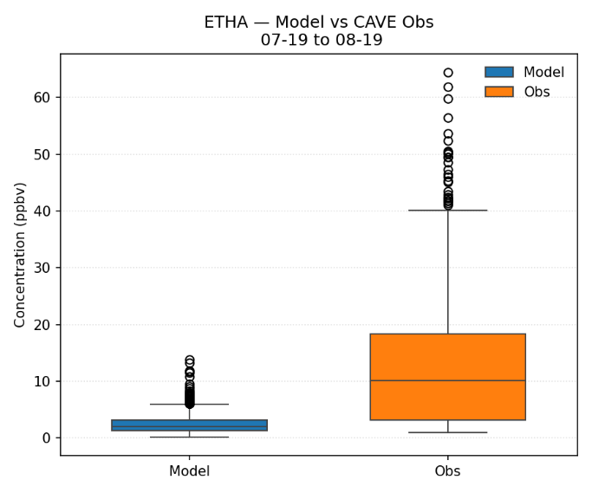 | 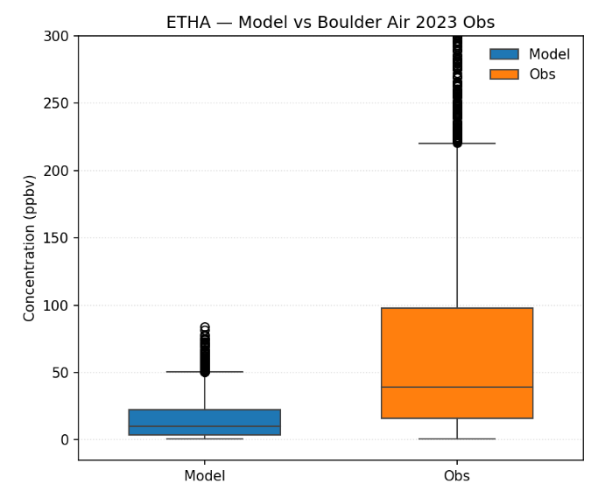
Figure 10. Ethane (ETHA) evaluation of the CAMx 2022v2 12/4 km base case simulation at the Carlsbad Caverns (left) and Loving, New Mexico (right) sites.

Seven (7) CAMx 2022v2 12/4 km sensitivity simulations were performed for the June 28 to July 17, 2022 20-day period related to alternative meteorology and emissions. Figure 11 show scatter plots of MDA8 ozone performance at the Carlsbad City site for the CAMx 2022v2 12/4 km base case and the CAMx 2022v2 12/4 km Sens5 scenario that increased New Mexico (NM) Permian Basin (PB) O&G NO_{X} and VOC emissions by a factor of 3. Whereas, all the MDA8 ozone points in the CAMx 2022v2 12/4 km base case are below the 1:1 line of perfect agreement with a NMB of -14.4% that barely achieves the bias Performance Criterion, when NM PB O&G emissions are increased by a factor of 3 the points are centered on the 1:1 line of perfect agreement and the NMB (-2.5%) achieves the bias Performance Goal. The CAMx Sens5 3 times NM PB O&G sensitivity test also greatly reduced the underestimation of the observed ethane and propane concentrations.

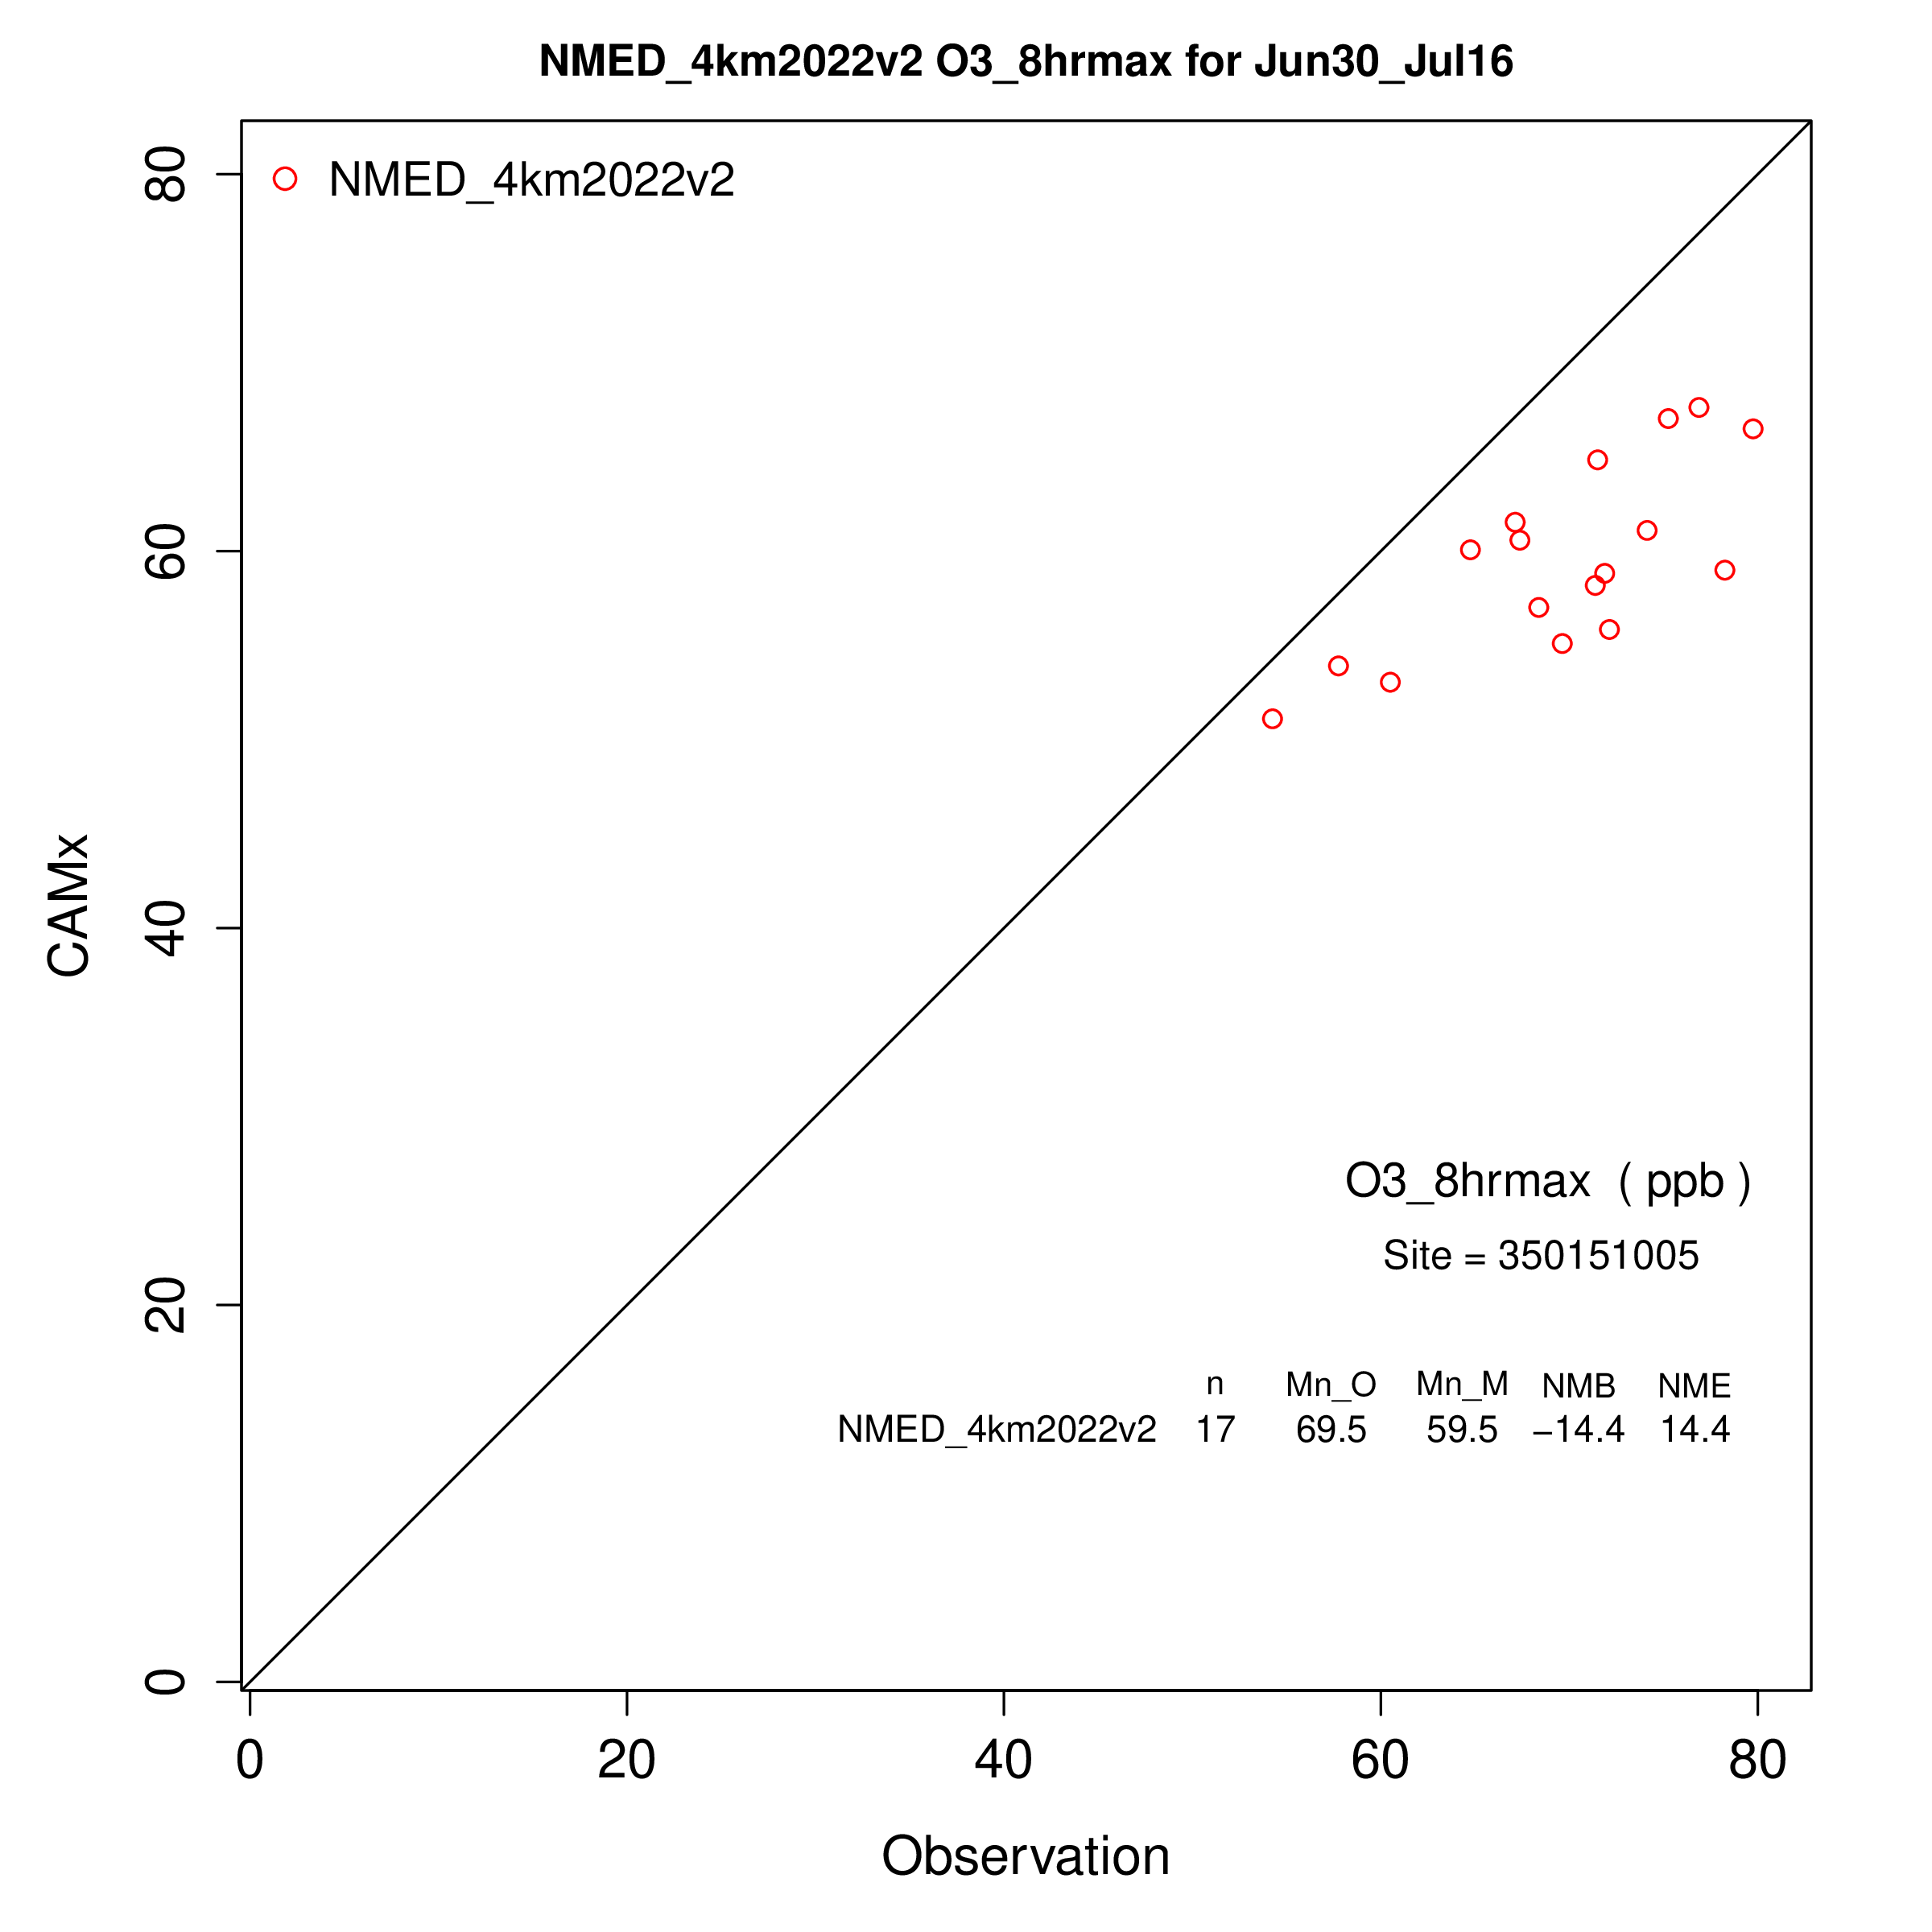 | 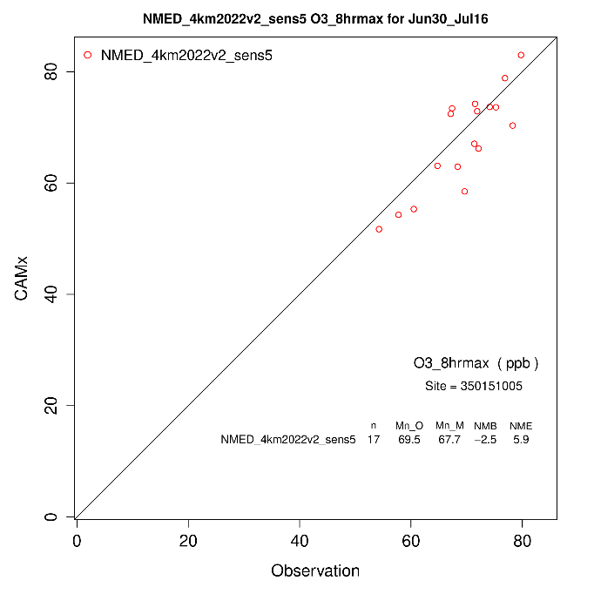
Figure 11. Scatter plots of predicted and observed MDA8 ozone concentrations at Carlsbad City for the CAMx 2022v2 12/4 km base case (left) and Sens5 3 times New Mexico Permian Basin O&G NO_{X} and VOC emissions sensitivity test (right).

A 2032 emissions scenario for the CAMx 2022v2 12/4 km modeling platform was developed by projecting 2022v2 O&G emissions to 2032 assuming On-the-Book (OTB) controls, developing 2032 On-Road Mobile source emissions using 2032 MOVES5 and 2022 12/4 meteorological, using 2022v1 platform 2026v1 emissions for some Source Sectors, and holding some Source Sector emissions constant at 2022v2 levels. Table 1 compares the New Mexico 2022v2 and 2032 anthropogenic emissions. There is a -8% and -6% reduction in New Mexico total anthropogenic NO_{X} and VOC emissions, respectively, which is driven primarily by reductions in On-Road and Non-Road Mobile sources. Total New Mexico O&G NO_{X} emissions increase by +8%, while New Mexico O&G VOC emissions decreased by -26% between 2022 and 2032.

Table 1. Comparison of New Mexico 2022v2 and 2032 NOX and VOC emissions by Source Sector (Source Sectors with a * are held constant at 2022v2 levels).
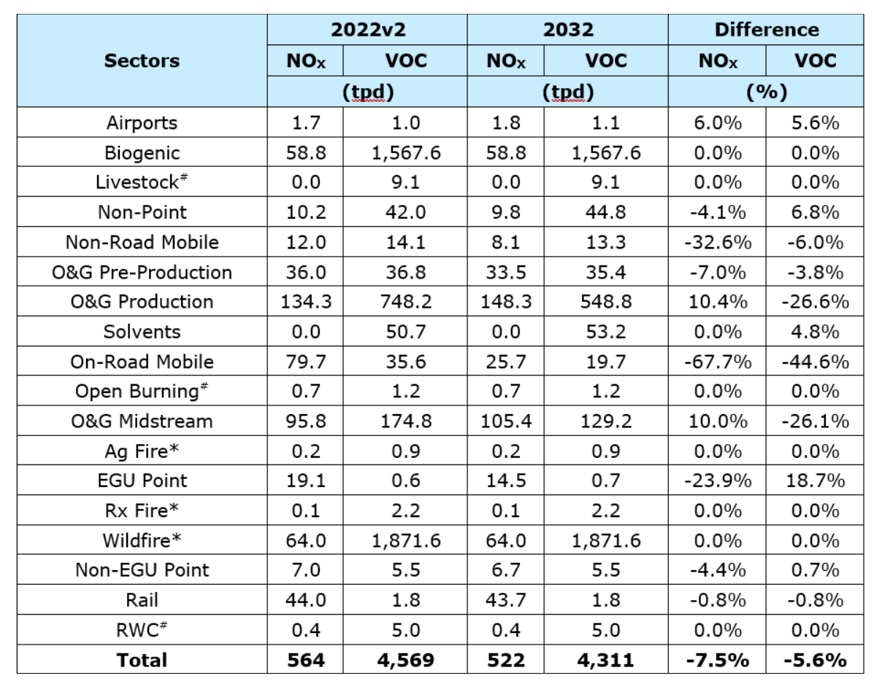

Two types of ozone source apportionment modeling are being conducted using the CAMx 2022v2 12/4 km modeling platform: (1) Local Source; and (2) State-Specific.

The CAMx 2022v2 12/4 km Local Source ozone source apportionment modeling will have the following attributes:
- APCA version of the CAMx ozone source apportionment Probing Tool.
- Two APCA simulations using the 2022v2 and 2032 emission scenarios.
- June 1 – August 15, 2022 modeling period.
- Four (4) Source Regions:
- New Mexico Permian Basin;
- Remainder New Mexico;
- Texas Permian Basin; and
- Remainder of 12/4 km Domains.
- Ten (10) Source Categories:
- Natural (Biogenic + LNOX);
- Fires;
- O&G Pre-Production;
- O&G Production;
- O&G Midstream;
- EGU Point;
- Non-EGU Point;
- On-Road Mobile;
- Non-Road Mobile; and
- Remainder Anthropogenic.

The CAMx 2022v2 12/4 km State-Specific ozone source apportionment modeling will have the following characteristics:
- APCA version of the CAMx ozone source apportionment Probing Tool.
- 2022v2 emissions scenario.
- May 1 – August 15, 2022 modeling period.
- Eleven (11) Source Regions:
- Arizona;
- California;
- Colorado;
- Kansas;
- Nevada;
- New Mexico;
- Oklahoma;
- Texas;
- Utah
- Mexico; and
- Remainder of 12/4 km Domains.
- Three (3) Source Categories:
- Biogenic;
- Fires + LNOx; and
- Anthropogenic.

At this writing (May 2026), the Phase II CAMx ozone source apportionment modeling and post-processing is ongoing. Phase II of the NMED Regional Ozone Study currently has the following deliverables posted:

- Conceptual Model of ozone formation in New Mexico with focus on the Permian Basin.

- PowerPoint of CAMx 2022v2 12/4 km base case model performance evaluation

- Report on CAMx 2022v2 12/4 km base case modeling and model performance evaluation.

