WESTAR Council

Monitoring Compliance Testing & Source Test Observation

October 26 - 30, 2026

VIRTUAL TRAINING

REGISTRATION DEADLINE
October 2, 2026

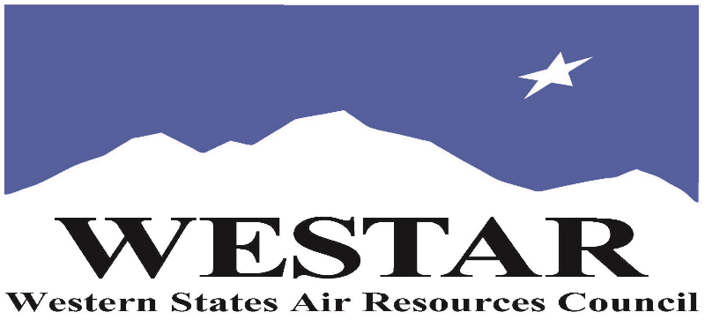

TO REGISTER
- Log onto EPA’s AirKnowledge and create a profile, or log onto your existing AirKnowledge account: EPA's AirKnowledge Website
- When you complete your profile, you will receive a confirmation e-mail to activate your new account. It may take several minutes before receiving the email.
- Once activated, log into your account.
- Click the “Instructor Lead Training Calendar” link under the “My Training” tab.
- Search the calendar for the training date(s). On the calendar you will see a course description. Hover over the text for additional information.
- To register click the course title link.
- In the lower righthand corner of the page you will see a “Request” button. Click it.
- At this point you have requested a seat in the training. Because demand for WESTAR sponsored training frequently exceeds availability all registrants are placed on a waitlist.
- You will receive an email from Jeff Gabler confirming your request.
- WESTAR attempts to accommodate all requests but at times it may be necessary to prioritize attendees.

AGENDA
MONDAY, OCTOBER 26, 2026
PACIFIC TIMES
9:00 am – 2:00 pm
- Introduction to/Sources of Methods
Topics Dealing with Source Testing Guidance
- EPA’s National Stack Test Gu EPA’s National Stack Test Guidance and Compliance Monitoring Strategy
• Introduction to Stack Testing and Gas Physics
  - Gas Physics
  - Boyle/Charles Laws
  - Correction to Standard Temperature and Pressure
Topics Dealing with FRM’s 1 Through 5
- Overview of Federal Reference Methods 1-5 (Video)
- Stack Testing Basics: Overview of Federal Reference Methods Federal Reference Methods 1-2
- Sampling Point Locations (IsoCalc Spreadsheet)
- Stack Gas Velocity (IsoCalc Spreadsheet)
- Cyclonic and Non-Parallel Flows & Port Locations
- Adjourn/Homework Problems Assignment

TUESDAY, OCTOBER 27, 2026
PACIFIC TIMES
9:00 am - 2:00 pm
- Homework Review
Topics Dealing with FRM’s 1 Through 5
- Agency Observer Checklists
- Stack Testing Basics: Federal Reference Methods 3-4
  - Stack Gas Molecular Weight (IsoCalc Spreadsheet)
  - Stack Gas Moisture (IsoCalc Spreadsheet)
  - Sampling Train Configuration
- Federal Reference Method 5 Operation/Associated Equations/Setting % Isokinetic Sampling Rate
- Agency Observer Checklist
- The Source Test
- Role of the Agency Inspector
- Homework
WEDNESDAY, OCTOBER 28, 2026
PACIFIC TIMES
9:00 am - 2:00 pm
- Homework Review
- F-Factors
- FRM 201/201A for PM-10, PM-2.5
- FRM 202 Condensable PM
- FRM 29/SW-846, Method 0060, Multi-Metals Sampling, FRM 12 for Inorganic Lead and FRM 306 for Chromium
- Federal Reference Method 26/26A/SW-846 Methods 0050/0051 (HCl/Cl2)
- Homework
THURSDAY, OCTOBER 29, 2026
PACIFIC TIMES
9:00 am - 2:00 pm
Topics Dealing with VOC Stack Testing
- Homework Review
- Introduction to VOCs/Selecting VOC Sampling and Analytical Methods (State of Pennsylvania Selection Process)
- Reporting VOC Emissions (in ppms? In #/Hr.? etc.) and Calculations (i.e., “As Carbon?”; “As VOCs?”; “As Organics?”; “As Propane?”)
- Overview of Stack Testing for VOCs Utilizing FRMs 18, 25, 25A,
- CTS 035 and SW-846 Methods
- Municipal Solid Waste Landfill Emissions and Sampling of VOC and
- HAP’s
- Federal Reference Method 18, 25, & 25A
- Weaknesses/Strengths of FRMs 18, 25, 25A
- Homework

FRIDAY, OCTOBER 30, 2026
PACIFIC TIMES
9:00 am -2:00 pm
- FRM Method 204 PTE/TTE Enclosures, Capture Efficiency/Calculations
- Stack Testing Special Topics
  - High Moisture Stacks
  - High Pressure Stacks
  - High VOC Concentration Stacks/Molecular Weight Determination
Topics Dealing with Stack Testing Gas Turbines, Acid Gas Monitoring and Other Topics
- Reciprocating Internal Combustion Engine (RICE) Sampling and Overview of CEMS for Engines and Gas Turbine Testing
  - Federal Reference Method 6C/7E/3A and 20
  - Fourier Transform Infrared (FTIR) Spectroscopy Technology
  - ASTM D6522-00 (Portable Analyzer Technology)
- RATA and CGAs
- FRM 205 (Gas Dilution System)
- FRM 320/ASTM D6348-03
- Safety on the Stack Test
- FRM 30 Mercury (Hg) Sampling
ABOUT THE TRAINING COURSE
WESTAR’s Training Center will host this training course for state, local and tribal air quality professional staff working, or planning to work, in source testing.
This lecture-based course is designed for state, local and tribal air quality professionals whose role is to observe source testing, evaluate source test methods, approve test protocols and review source test results as required under various federal and state regulations or as required by issued permits. This class is intended for compliance and field engineers, scientists and technicians who have responsibility for the above source testing tasks.
Those completing this course will gain a basic understanding of the general information associated with source testing and source test methods. This course develops the ability to plan, guide, evaluate, and (after experience on the job) perform source sampling measurements to determine rates of emissions from stationary sources. It clarifies EPA Reference Methods 1 to 4, and Method 5. The course develops knowledge of the equipment employed, understanding of why the prescribed methods are established, and ability to perform the calibrations and calculations which are a part of the reference methods.
To ensure that the source test methods utilized to demonstrate compliance are performed according to EPA guidelines, both agency and industrial personnel will be required to observe stack tests to document that compliance with the methodology is being achieved. This will mean that an observer must be intimately familiar with numerous stack test methods, each one with its own particular operation.
COURSE DELIVERY: This is a virtual, instructor-led training course.
SPACE LIMITATION: Registration is limited to 40 attendees. Air quality staff from the fifteen western states receive registration preference.
REGISTRATION FEES: There are no registration fees for state, local or tribal air quality agency staff.

ACCESSIBILTY
WESTAR strives to host inclusive, accessible training events that enable all individuals, including individuals with disabilities, to engage fully with the instructor and course content. To request an accommodation or for inquiries about accessibility, please contact Jeff Gabler at jgabler@westar.org or 503-744-0486 by Friday, September 25, 2026.

