WESTAR Council

Landfill Gas Control Facilities
(TOXC 229)

Wednesday, October 21, 2026

VIRTUAL TRAINING

REGISTRATION DEADLINE
October 9, 2026

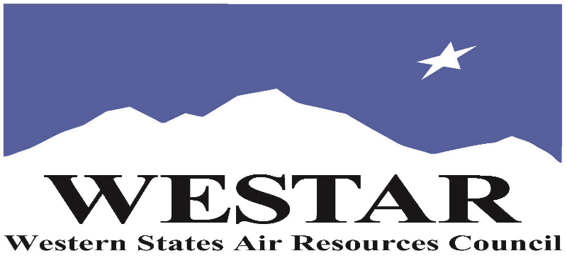

TO REGISTER
- Log onto EPA’s AirKnowledge and create a profile, or log onto your existing AirKnowledge account: EPA's AirKnowledge Website
- When you complete your profile, you will receive a confirmation e-mail to activate your new account. It may take several minutes before receiving the email.
- Once activated, log into your account.
- Click the “Instructor Lead Training Calendar” link under the “My Training” tab.
- Search the calendar for the training date(s). On the calendar you will see a course description. Hover over the text for additional information.
- To register click the course title link.
- In the lower righthand corner of the page you will see a “Request” button. Click it.
- At this point you have requested a seat in the training. Because demand for WESTAR sponsored training frequently exceeds availability all registrants are placed on a waitlist.
- You will receive an email from Jeff Gabler confirming your request.
- WESTAR attempts to accommodate all requests but at times it may be necessary to prioritize attendees.

AGENDA
WEDNESDAY, OCTOBER 21, 2026
PACIFIC TIMES
9:00 am Introductions
9:15 am Landfill Facts and Figures
9:30 am Primary Air Pollutants from Landfills
10:00 am Collection and Monitoring of Landfill Gases
10:30 am Break
10:45 am Landfill Gas Control Devices
11:15 am Secondary Air Pollutants
11:45 am Lunch
12:45 pm Monitoring Equipment
1:30 pm Rules, Regulations and Laws
2:00 pm Inspection of Landfill Gas Operations
3:00 pm Adjourn

ABOUT THE TRAINING COURSE
AUDIENCE: This course is intended for new, entry-level permit engineers, inspectors, regulatory agency staff, and environmental specialists in business and government. The course is designed to provide an overview of Landfill Gas Control Facilities.

LEARNING OBJECTIVES: Those completing this course will gain a basic understanding of the Landfill Gas control systems. The following topics will be covered in this course:
- Facts and figures regarding Landfills
- Primary and Secondary air pollutants at Landfills
- Methane monitoring equipment
- Inspections and safety tips
- Scientific principles behind landfill gas generation
- Landfill gas collection technologies and principles
- Landfill gas controls and energy uses
- Description of landfill gas monitoring equipment and proper use
- Regulatory Overview and Update on Green House Gas Regulations, CCR Title 17, Section 95460
- Inspection and Safety Tips

COURSE DESCRIPTION: This course provides an introduction to the operation of landfill gas collection, controls and gas-to-energy systems. Special emphasis is placed on inspection techniques. Students will be able to discuss and observe landfill operations/activities and landfill gas extraction control components.

COURSE DELIVERY: This is a virtual, instructor-led training course.

SPACE LIMITATION: Registration is limited to 40 attendees. Air quality staff from the fifteen western states receive registration preference.

REGISTRATION FEES: There are no registration fees for state, local or tribal air quality agency staff.

ACCESSIBILTY
WESTAR strives to host inclusive, accessible training events that enable all individuals, including individuals with disabilities, to engage fully with the instructor and course content. To request an accommodation or for inquiries about accessibility, please contact Jeff Gabler at jgabler@westar.org or 503-744-0486 by Friday, September 18, 2026.

