WESTAR Council

Industrial Boilers
(TOXC 226)

May 20, 2026

VIRTUAL TRAINING

REGISTRATION DEADLINE
Friday, April 17, 2026

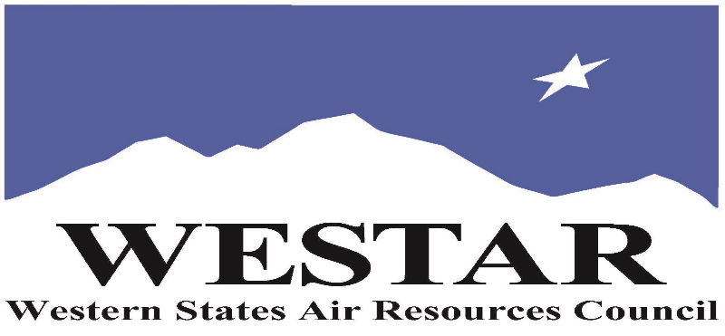

TO REGISTER
- Log onto EPA’s AirKnowledge and create a profile, or log onto your existing AirKnowledge account: EPA's AirKnowledge Website
- When you complete your profile, you will receive a confirmation e-mail to activate your new account. It may take several minutes before receiving the email.
- Once activated, log into your account.
- Click the “Instructor Lead Training Calendar” link under the “My Training” tab.
- Search the calendar for the training date(s). On the calendar you will see a course description. Hover over the text for additional information.
- To register click the course title link.
- In the lower righthand corner of the page you will see a “Request” button. Click it.
- At this point you have requested a seat in the training. Because demand for WESTAR sponsored training frequently exceeds availability all registrants are placed on a waitlist.
- You will receive an email from Jeff Gabler confirming your request.
- WESTAR attempts to accommodate all requests but at times it may be necessary to prioritize attendees.

AGENDA
WEDNESDAY, MAY 20, 2026
PACIFIC TIMES
9:00 am Introduction/Overview
9:15 am Terminology & Boiler Types
9:30 am Theory & Operation of Boilers
10:00 am Break
10:15 am Boiler Components & Designs
11:00 am Break
11:00 am Emissions and Control Techniques
12:00 noon Lunch
1:00 pm Boiler Regulations & Permits
2:00 pm Monitoring, Source Testing, Inspections, and Safety
3:30 pm Adjourn
ABOUT THE TRAINING COURSE
TARGET AUDIENCE: This course is intended for new, inexperienced state, local and tribal air quality professionals.
COURSE DESCRIPTION: Boilers are one of the most common emission sources and range in use from small fire tube boilers to large utility boilers associated with power plant facilities. The course discusses uses of boilers, heat transfer methods and fundamentals of operation of modern industrial and utility boilers including those fired by natural gas, biomass municipal waste and coal (circulating fluidized bed units). The course also discusses steam turbines and power generation. This is followed by a detailed discussion on emissions and control techniques such as Low-NOx burners, FGR, staged combustion, SCR and SNCR. New technologies such as Ultra Low-NOx 9 ppm burners, applicable federal and local BACT regulations, permitting requirements and agency inspection procedures and safety concerns are thoroughly discussed.
LEARNING OBJECTIVES: Those completing this course will gain a basic understanding of the general information associated with industrial boiler operations. Attendees will be able to perform regulatory reviews involving the following elements of industrial boilers:
- Air Pollution - Why
- Boiler Uses
- Boiler Theory and Operation
- Air Pollution Formation
- Air Pollution Control Devices
- Boiler Regulations
- Typical Permit Conditions
- Inspection Procedures
COURSE DELIVERY: This is a virtual, instructor-led training course.

SPACE LIMITATION: Registration is limited to 40 attendees. Air quality staff from the fifteen western states receive registration preference.

REGISTRATION FEES: There are no registration fees for state, local or tribal air quality agency staff.

ACCESSIBILTY
WESTAR strives to host inclusive, accessible training events that enable all individuals, including individuals with disabilities, to engage fully with the instructor and course content. To request an accommodation or for inquiries about accessibility, please contact Jeff Gabler at jgabler@westar.org or 503-744-0486 by Friday, April 17, 2026.

