WESTAR Council

Incinerators
(TOXC 222)

December 15, 2026

VIRTUAL TRAINING

REGISTRATION DEADLINE
December 1, 2026

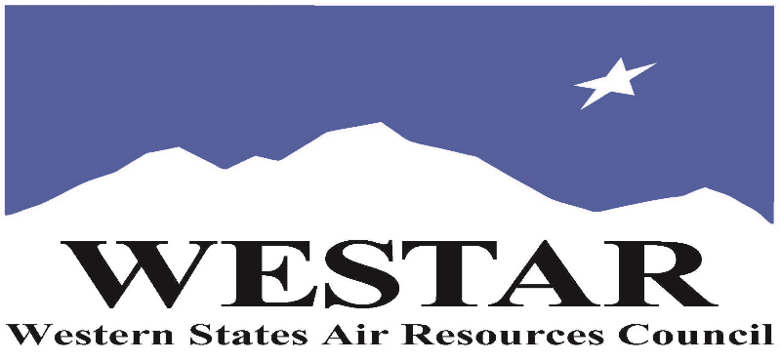

TO REGISTER
- Log onto EPA’s AirKnowledge and create a profile, or log onto your existing AirKnowledge account: EPA's AirKnowledge Website
- When you complete your profile, you will receive a confirmation e-mail to activate your new account. It may take several minutes before receiving the email.
- Once activated, log into your account.
- Click the “Instructor Lead Training Calendar” link under the “My Training” tab.
- Search the calendar for the training date(s). On the calendar you will see a course description. Hover over the text for additional information.
- To register click the course title link.
- In the lower righthand corner of the page you will see a “Request” button. Click it.
- At this point you have requested a seat in the training. Because demand for WESTAR sponsored training frequently exceeds availability all registrants are placed on a waitlist.
- You will receive an email from Jeff Gabler confirming your request.
- WESTAR attempts to accommodate all requests but at times it may be necessary to prioritize attendees.

AGENDA
TUESDAY, DECEMBER 15, 2026
PACIFIC TIMES
9:00 am Introduction/Overview
9:30 am Incinerator Theory
10:00 am Break
10:10 am Types of Incinerators
10:40 am Incinerator Operating Procedures
11:10 am Break
11:20 am Incinerator Emissions
11:35 am Incinerator Emissions Controls
12:15 pm Lunch Break
1:15 pm Incinerator Emissions Controls (cont’d)
1:40 pm Regulations Summary
2:10 pm Break
2:20 pm Incinerator Inspection
2:50 pm Inspector Safety
3:20 pm Adjourn
ABOUT THE TRAINING COURSE
AUDIENCE: This course is intended for new, inexperienced state, local and tribal air quality professionals.
COURSE DESCRIPTION: This course will focus on the process, emission control equipment and inspection procedures of small to medium sized solid waste incinerators. The types of incinerators include biomedical, pathological, crematories and commercial heat stripping ovens. This course does not address municipal waste combustors, biomass or hazardous waste incinerators.
LEARNING OBJECTIVES: Those completing this course will gain a basic understanding of the general information associated with incinerators operations. Attendees will be able to perform regulatory reviews involving the following elements of incinerators: The following topics will be covered in this course:
- 3 T’s of combustion
- Types of combustion
- Categories of Industrial Incinerators
- Typical Incinerator Operating Procedures
- Typical Operational Errors
- Incinerator Emissions & Control
- Incinerator Inspection
- Air Pollution Control Points of Inspection
COURSE DELIVERY: This is a virtual, instructor-led training.
SPACE LIMITATION: Air quality staff from the fifteen western states receive registration preference.

REGISTRATION FEES: There are no registration fees for state, local or tribal air quality agency staff.

ACCESSIBILTY
WESTAR strives to host inclusive, accessible training events that enable all individuals, including individuals with disabilities, to engage fully with the instructor and course content. To request an accommodation or for inquiries about accessibility, please contact Jeff Gabler at jgabler@westar.org or 503-744-0486 by Friday, November 13, 2026.

