WESTAR Council

Fugitive Volatile Organic
Compounds (TOXC 240)

May 21, 2026

VIRTUAL TRAINING

REGISTRATION DEADLINE
Friday, April 17, 2026

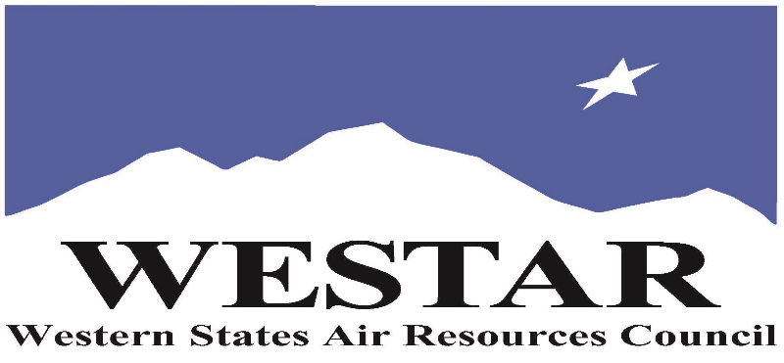

TO REGISTER
- Log onto EPA’s AirKnowledge and create a profile, or log onto your existing AirKnowledge account: EPA's AirKnowledge Website
- When you complete your profile, you will receive a confirmation e-mail to activate your new account. It may take several minutes before receiving the email.
- Once activated, log into your account.
- Click the “Instructor Lead Training Calendar” link under the “My Training” tab.
- Search the calendar for the training date(s). On the calendar you will see a course description. Hover over the text for additional information.
- To register click the course title link.
- In the lower righthand corner of the page you will see a “Request” button. Click it.
- At this point you have requested a seat in the training. Because demand for WESTAR sponsored training frequently exceeds availability all registrants are placed on a waitlist.
- You will receive an email from Jeff Gabler confirming your request.
- WESTAR attempts to accommodate all requests but at times it may be necessary to prioritize attendees.

AGENDA
THURSDAY, MAY 21, 2026
PACIFIC TIMES
9:00 am Welcome and Introduction
9:05 am Lesson I: Particulate Matter Primer
9:30 am Lesson II: Fugitive Dust Overview
9:50 am Lesson III: Rules and Regulations
10:15 am Break
10:30 am Lesson III continued
11:00 am Lesson IV: Methods to Determine Violations
12:00 noon Lunch
1:00 pm Lesson IV: Local Air District Rules
2:00 pm Lesson V: Dust Control Measures
2:30 pm Break
3:00 pm Lesson VI: Dust Control Plans
3:30 pm Lesson VII: Community Outreach
4:00 pm Jeopardy/Test/Wrap-up and Evaluations
5:00 pm Adjourn

ABOUT THE TRAINING COURSE
WHO SHOULD ATTEND: Planning and rulemaking staff who may be dealing with statewide or regional particulate matter rule development or attainment issues or who are developing responses to site-specific fugitive dust emissions. Also permit writers and inspectors dealing with operations that generate fugitive dust, such as construction activities, aggregate, concrete, cement, asphalt and mining operations and activities with vehicle traffic on unpaved surfaces.

COURSE DESCRIPTION: This course presents a comprehensive overview of fugitive dust emissions and controls. The course includes the how, what, where and health impacts of particulate matter and the problem that fugitive dust presents. The course also discusses the rules and regulations that have been adopted by some agencies to control fugitive dust and the methods that are used to determine compliance with and/or violations of these regulations.
LEARNING OBJECTIVES: After completion of this one-day course, learners will be able to understand how fugitive dust is determined and regulated and explain fugitive dust control in the context of the following topics:
• Health effects of particulate matter (PM10) pollution
• Fugitive dust sources
• Dust control measures
• Fugitive dust rules and regulations
• Dust control plans
• Visible dust emissions and test methods

COURSE DELIVERY: This is a virtual, instructor-led training course.

SPACE LIMITATION: Registration is limited to 40 attendees. Air quality staff from the fifteen western states receive registration preference.

REGISTRATION FEES: There are no registration fees for state, local or tribal air quality agency staff.

ACCESSIBILTY
WESTAR strives to host inclusive, accessible training events that enable all individuals, including individuals with disabilities, to engage fully with the instructor and course content. To request an accommodation or for inquiries about accessibility, please contact Jeff Gabler at jgabler@westar.org or 503-744-0486 by Friday, April 17, 2026.

