WESTAR Council

Flares for Air Emissions
Control

January 12-13, 2027

VIRTUAL TRAINING

REGISTRATION DEADLINE
December 18, 2026

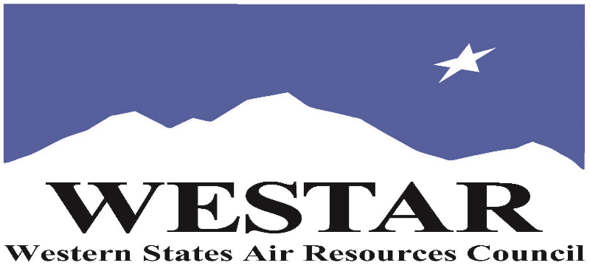

TO REGISTER
- Log onto EPA’s AirKnowledge and create a profile, or log onto your existing AirKnowledge account: EPA's AirKnowledge Website
- When you complete your profile, you will receive a confirmation e-mail to activate your new account. It may take several minutes before receiving the email.
- Once activated, log into your account.
- Click the “Instructor Lead Training Calendar” link under the “My Training” tab.
- Search the calendar for the training date(s). On the calendar you will see a course description. Hover over the text for additional information.
- To register click the course title link.
- In the lower righthand corner of the page you will see a “Request” button. Click it.
- At this point you have requested a seat in the training. Because demand for WESTAR sponsored training frequently exceeds availability all registrants are placed on a waitlist.
- You will receive an email from Jeff Gabler confirming your request.
- WESTAR attempts to accommodate all requests but at times it may be necessary to prioritize attendees.

AGENDA
TUESDAY, JANUARY 12, 2027
PACIFIC TIMES
9:00 am Introductions
9:10 am Flaring & Combustion Basics
10:30 am Break
10:45 am Flaring Types, System Components, & Environmental Impacts
12:00 noon Break
12:20 pm Flaring Discussion
1:00 pm Adjourn
WEDNESDAY, JANUARY 13, 2027
PACIFIC TIMES
9:00 am Flaring Regulations & Design
10:30 am Break
10:45 am Flare Monitoring & Inspection
12:00 noon Break
12:20 pm Troubleshooting Issues & Flare Minimization Plans
1:00 pm Adjourn
ABOUT THE TRAINING COURSE
COURSE DESCRIPTION: The course covers flare types, categories, uses, mechanism of work, components, design, operation, performance evaluation, factors that impact efficiency, monitoring, environmental and health impacts, monitoring, permitting, and regulations.
LEARNING OBJECTIVES: By the end of the course, the participants should be able to:
• Understand the basics of the combustion process and factors that can lead to incomplete combustion
• Identify flare types, their applications, and their mechanism of work
• Recognize the operational challenges of flares
• Explain the environmental impacts of flares
• Summarize the major regulatory requirement for flaring
• Describe the monitoring requirements and technologies for flares
• Evaluate permit applications to ensure that the flare design meets the regulatory standards
COURSE DELIVERY: This is a virtual, instructor-led training.
SPACE LIMITATION: Registration is limited to 40 attendees. Air quality staff from the fifteen western states receive registration preference.

REGISTRATION FEES: There are no registration fees for state, local or tribal air quality agency staff.

ACCESSIBILTY
WESTAR strives to host inclusive, accessible training events that enable all individuals, including individuals with disabilities, to engage fully with the instructor and course content. To request an accommodation or for inquiries about accessibility, please contact Jeff Gabler at jgabler@westar.org or 503-744-0486 by Friday, December 11, 2026.

INSTRUCTOR BIO
Dr. Amro El Badawy earned his Ph.D. in Environmental Engineering from the University of Cincinnati. His research investigates the environmental implications of nanotechnology, fate and transport of emerging contaminants, nanosensors for environmental monitoring, and membrane-based solutions for water desalination and reclamation. Dr. El Badawy teaches water and air quality engineering courses as well as environmental nanotechnology.

