WESTAR Council

Control of Gaseous
Emissions

December 1 - 3, 2026

VIRTUAL TRAINING

REGISTRATION DEADLINE
November 13, 2026

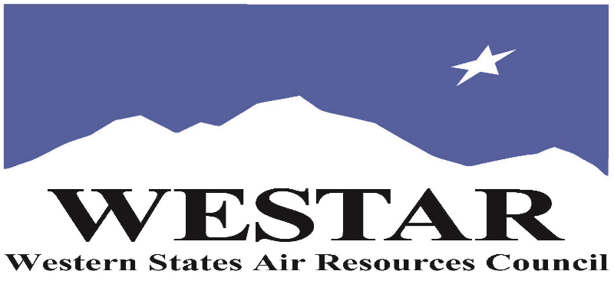

TO REGISTER
- Log onto EPA’s AirKnowledge and create a profile, or log onto your existing AirKnowledge account: EPA's AirKnowledge Website
- When you complete your profile, you will receive a confirmation e-mail to activate your new account. It may take several minutes before receiving the email.
- Once activated, log into your account.
- Click the “Instructor Lead Training Calendar” link under the “My Training” tab.
- Search the calendar for the training date(s). On the calendar you will see a course description. Hover over the text for additional information.
- To register click the course title link.
- In the lower righthand corner of the page you will see a “Request” button. Click it.
- At this point you have requested a seat in the training. Because demand for WESTAR sponsored training frequently exceeds availability all registrants are placed on a waitlist.
- You will receive an email from Jeff Gabler confirming your request.
- WESTAR attempts to accommodate all requests but at times it may be necessary to prioritize attendees.

AGENDA
TUESDAY, DECEMBER 1, 2026
PACIFIC TIMES
9:00 am – 3:30 pm
Introduction
- Basic Concepts
- Pollutants
Control – Bioreactors
Control – Oxidation
- Plume Burner
- Flare
- Recuperative Thermal Oxidizer
- Regenerative Thermal Oxidizer
- Catalytic Thermal Oxidizer
- Compliance Parameters
WEDNESDAY, DECEMBER 2, 2026
PACIFIC TIMES
9:00 am – 3:30 pm
Control – Absorption (Wet Scrubber)
- Oxidation / Reduction
- Mist Eliminator
- Compliance Parameters
Control – Adsorption (Dry Scrubber)
- Regeneration
- Fluidized Bed
- Compliance Parameters
Control – Condenser
- Surface Condenser
- Refrigerated Condenser
- Compliance Parameters

THURSDAY, DECEMBER 3, 2026
PACIFIC TIMES
9:00 am - 3:30 pm
Control – NOX
- Combustion
- Selective Non-Catalytic Reduction
- Selective Catalytic Reduction
- Non-Selective Catalytic Reduction
- Compliance Parameters
Control – SO2
- Flue Gas Desulfurization
- Low Sulfur Fuels
Control – Greenhouse Gases
- Carbon Capture & Storage

ABOUT THE TRAINING COURSE
AUDIENCE: This is an introductory course designed for agency inspectors, permit writers, and regulation developers who have responsibility for sources emitting carbon monoxide, carbon dioxide, nitrogen oxides, sulfur dioxide, and volatile organic compounds. The course will discuss the pollutants and associated air pollution controls.

LEARNING OBJECTIVES: This course is designed to give attendees a basic understanding of the controls for sources emitting carbon monoxide, carbon dioxide, nitrogen oxides, sulfur dioxide, and volatile organic compounds. Course topics include:
• Gaseous pollutants and their impacts
• Control devices for gaseous pollutants
• Compliance parameters

COURSE DELIVERY: This is a virtual, instructor-led training course.

SPACE LIMITATION: Air quality staff from the fifteen western states receive registration preference.

REGISTRATION FEES: There are no registration fees for state, local or tribal air quality agency staff.

ACCESSIBILTY
WESTAR strives to host inclusive, accessible training events that enable all individuals, including individuals with disabilities, to engage fully with the instructor and course content. To request an accommodation or for inquiries about accessibility, please contact Jeff Gabler at jgabler@westar.org or 503-744-0486 by Friday, October 16, 2026.

INSTRUCTOR BIO
Andrew D. Shroads, QEP has over 27 years of experience in air pollution control, working in the Weirton Steel Corporation Environmental Control Department, as an inspector for the Cleveland Division of Air Quality, and as a consultant for regulatory agencies and private clients. He helps local, state, tribal, and federal government agencies develop air pollution control requirements and helps industry comply with air pollution permit and regulatory requirements. He is currently working as a part-time environmental manager for two companies in Ohio, developing air pollution control requirements for the state of New Jersey, assisting tribes to develop air permitting programs, and assessing the environmental impacts from federal sites. He also develops and teaches air pollution training programs. In his spare time, he researches the history of air pollution control.

