WESTAR Council

Air Toxics & Regulating
Hazardous Air Pollutants

April 14-16, 2026

VIRTUAL TRAINING

REGISTRATION DEADLINE:
March 13, 2026

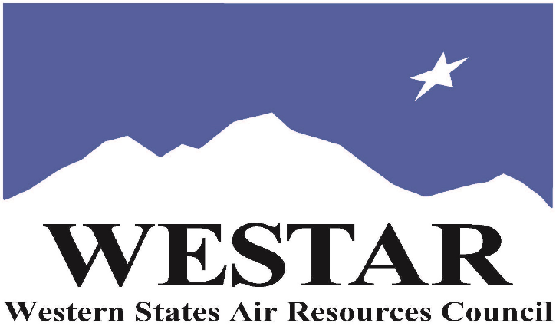

TO REGISTER
- Log onto EPA’s AirKnowledge and create a profile, or log onto your existing AirKnowledge account: EPA's AirKnowledge Website
- When you complete your profile, you will receive a confirmation e-mail to activate your new account. It may take several minutes before receiving the email.
- Once activated, log into your account.
- Click the “Instructor Lead Training Calendar” link under the “My Training” tab.
- Search the calendar for the training date(s). On the calendar you will see a course description. Hover over the text for additional information.
- To register click the course title link.
- In the lower righthand corner of the page you will see a “Request” button. Click it.
- At this point you have requested a seat in the training. Because demand for WESTAR sponsored training frequently exceeds availability all registrants are placed on a waitlist.
- You will receive an email from Jeff Gabler confirming your request.
- WESTAR attempts to accommodate all requests but at times it may be necessary to prioritize attendees.

TUESDAY, APRIL 14, 2026
PACIFIC TIMES
9:00 am Welcome, Introductions, and Course Objectives
9:05 am History of Air Toxics
9:30 am Types of Air Toxics
10:30 am Risk Assessment
11:30 am Lunch
12:30 pm Exposure Assessment
1:30 pm Toxicity Assessment
3:00 pm Adjourn for Day

WEDNESDAY, APRIL 15, 2026
PACIFIC TIMES
9:00 am Risk Characterization
10:45 am Human Exposure Modeling (HEM)
11:30 am Lunch
12:30 pm Federal Air Toxics Laws & Programs
2:00 pm Risk & Technology Reviews
3:00 pm Adjourn for Day

THURSDAY, APRIL 16, 2026
PACIFIC TIMES
9:00 am State Air Toxics Programs
10:00 am Individual vs Cumulative Exposure
10:30 am Permitting – Federal HAP Programs
11:00 am Compliance Assessment – Federal HAP Programs
11:30 am Lunch
12:30 pm Compliance Assessment – State Air Toxics Programs
1:30 pm Environmental Equity & Cumulative Risk
3:00 pm Adjourn
ABOUT THE TRAINING
DESCRIPTION: This three-day course provides an overview of air toxics emission sources that may be regulated under the Clean Air Act. The following topics will be covered:
• History and Types of Air Toxics
• Federal Air Toxic Laws and Programs
• State Air Toxics Programs
• Exposure and Toxicity Assessments
• Risk Characterization
• Compliance Assessment – Federal and State Programs
COURSE MATERIALS: Training course materials will only be available electronically. Attendees will receive an online document sharing link for access to materials. It is the attendee’s responsibility for downloading files and for providing the device or media on which to view materials. WESTAR will provide hard copies only for those needing accommodation.
SPACE LIMITATION: Registration is limited to 40 attendees. Air quality staff from the fifteen western states receive registration preference.
REGISTRATION FEES: There are no registration fees for state, local or tribal air quality agency staff.

ACCESSIBILITY
ACCESSIBILTY: WESTAR strives to host inclusive, accessible training events that enable all individuals, including individuals with disabilities, to engage fully with the instructor and course content. To request an accommodation or for inquiries about accessibility, please contact Jeff Gabler at jgabler@westar.org or 503-744-0486 by Friday, March 3, 2026.

