--Technical Steering Committee / Work Group Co-Chairs--

-- Monthly Coordination Meeting --

Agenda

Wednesday, May 27, 2026, 9:00–10:30 pm PT, 10:00–11:30 pm MT
Microsoft Teams meeting
Join on your computer or mobile app
Click here to join the meeting

Or call in (audio only)
+1 323-676-6261,, 915634309#
Phone Conference ID: 915 634 309#

WRAP TSC webpage / Call Materials available on the Committee Meetings tab

- Welcome, Roll Call, Agenda Review, Previous Meeting Notes (5 minutes) – Julie
  - Roll Call & Agenda Review
  - Notes for this call – Paul Corrigan, USFS
  - Review and approve notes from the March 25th meeting

  - WESTAR-WRAP Realignment Discussion (30-45 minutes) – Julie, Kristen, Rhonda, and Jay
  - Status of approvals (Tribal and Local Caucuses and WESTAR Council)
    - Will present to WRAP Board on June 10th
  - Visioning with the TSC, WESTAR Planning, and Technical co-chairs
    - Which groups would we want to keep?
    - Which groups would we sunset?
    - Discuss what would be the make-up of the new Coordinating Group
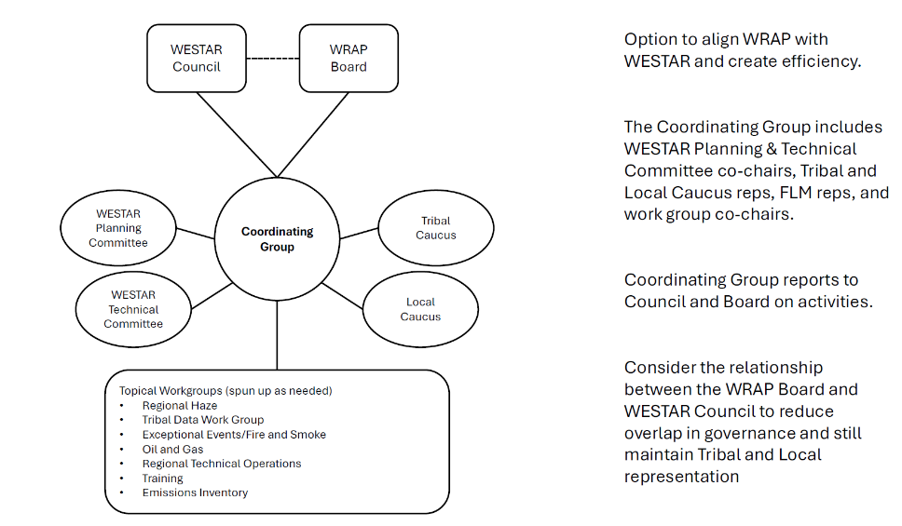
NOTES: This option includes the WESTAR Planning and Technical Committees. The Planning Committee has the important role of not only discussing external policy and planning, but internal strategy for the “network”…what are the important initiatives we need to plan for within our organization? Meets monthly. The Technical Committee serves as the “technical commons,” a cross-topic forum that may only meet quarterly, depending on activity in Topical Workgroups (avoid duplication between Technical Committee meetings and Topical Workgroup meetings). Representatives (WG, Committees, and Caucuses) make up the Coordinating Group (CG). The CG reports to the Board and Council (this may be duplicative right now, until we examine the relationship between Council and Board). The CG helps WGs stay in “information mode” and serves as the communication hub, making sure that if more than one WG/topic forum is interested in a topic, they are all invited. The CG can also pivot to “project management” mode when needed. The voice of the Planning Committee co-chairs is especially important in the CG because they can bring up future planning direction - are the topic forums appropriate for what we need? Do we need subgroups? Sunset other subgroups? Do we need to initiate “project management” mode? The Local and Tribal Caucuses are closely aligned with the Committees and report out to Board/Council at least twice a year.

- WESTAR-WRAP Updates (15 minutes) – Rhonda
  - Wildfire Smoke Preparedness in Community Buildings grant proposal submitted
  - 2026 Tiger Teams - HAQAST
- Meetings and Conferences (5 minutes) – Kristen
Upcoming:
  - 2026 Regional, State, and Local Dispersion Modelers’ Workshop, July 14-16, Minnesota Valley National Wildlife Refuge – Bloomington Education and Visitor Center, Bloomington, MN
  - 2026 Permitting, Enforcement, and Compliance (PEC) Workshop (MARAMA), June 23-25 (remote-only for non-MARAMA members)
  - 2026 National Air Quality Conference (NAQC), August 10-14, Hilton Omaha, Omaha, NE. Hotel room block ends July 15th, 2026. Draft agenda here. Registration forthcoming.
  - 2026 Rocky Mountain Wildfire Smoke Symposium, October 15-16, Denver, CO (hybrid)
  - CMAS Conference 2026, October 19-21, 2026, Chapel Hill, NC
  - WESTAR-WRAP Fall Business Meeting, October 28-29, 2026, Boise, ID
  - AWMA’s Atmospheric Optics: Aerosols, Visibility & Radiative Balance, November 10-13, 2026, Lake Junaluska, NC
Next Steps and Wrap up (5 minutes) – Kristen
  - Review next steps and action items from the call
    - Next call – Wednesday, July 29, 2026
    - Note taker – Tom Moore

Call Notetaking Schedule

Call Date | Time (PT) | Name | Agency | Representing | Geography
5/27/2026 | 11:30am – 1pm | Paul Corrigan | USFS | Fed | Utah
7/29/2026 | 11:30am – 1pm | Tom Moore | Colorado RAQC | Local | Colorado
9/30/2026 | 11:30am – 1pm | EPA Rep | EPA | Fed
11/25/2026 | 11:30am – 1pm | Bob Kotchenruther | EPA – Region 10 | Fed | Pacific NW
Dates in 2027 TBD
** | 11:30am – 1pm | Local Rep | Vacant Seat | Local
** | 11:30am – 1pm | Steve Miller | Idaho DEQ - Air Quality Bureau | State | Idaho
** | 11:30am – 1pm | Karl Seltzer | EPA OAQPS | Fed | National
** | 11:30am – 1pm | Phil Swartzendruber | Puget Sound Clean Air Agency | Local | Washington
** | 11:30am – 1pm | Danny Powers | Southern Ute Indian Tribe | Tribal | Utah/Idaho
** | 11:30am – 1pm | Jason Walker | NW Band, Shoshone Nation - Washakie Reservation | Tribal | 4 Corners
** | 11:30am – 1pm | Mike Barna | NPS | Fed | Intermountain
** | 11:30am – 1 pm | Jessica Hejny | NM Env. Dept. | State | New Mexico
** | 11:30am – 1pm | Charis Cooper | BLM | Fed | National

