--Technical Steering Committee / Work Group Co-Chairs--

-- Monthly Coordination Meeting --

Agenda

Wednesday, January 28, 2025, 12:00–1:00 pm PT, 1:00–2:00 pm MT
Microsoft Teams meeting
Join on your computer or mobile app
Click here to join the meeting

Or call in (audio only)
+1 323-676-6261,, 915634309#
Phone Conference ID: 915 634 309#

WRAP TSC webpage / Call Materials available on the Committee Meetings tab

- Welcome, Roll Call, Agenda Review, Previous Meeting Notes (5 minutes) – Julie
  - Roll Call & Agenda Review
  - Notes for this call – Jessica Hejny, NMED
  - Review and approve notes from the December 3rd meeting
    - Provide edits to meeting notes by Friday 1/30

  - TSC Informational Items (10 minutes) – Julie
  - Syndi Smallwood, Environmental Director for the Jamul Indian Village of California and new WRAP Board Tribal Representative
    - Announcement of Syndi, was consensus approved at last WRAP Board meeting
- Seeking consensus approval for Sarah Brown, WY DEQ Air Quality Program Manager, as new RHPWG Co-chair
    - Announcement of Sarah to replace Amber Potts
    - Need to go through consensus approval
    - Reading of Bio
- Still seeking a TSC local air agency member
    - Ask if folks have connections and have someone to recommend
- TSC meetings in 2026 – continue with bi-monthly schedule, but find a new 1.5 hr slot?
    - Rhonda: options: stick with bimonthly and find another slot OR go back to monthly and meet for an hour and stay 1-2 on the current day but not conflict with NACAA call
    - Rhonda will send out a Doodle poll for a 1.5hr slot and stay bimonthly

- WG Status Updates, Meetings, Topics, and Planning (15 minutes) – Kristen
  - Verbal updates from the WG co-chairs
    - Work group updates by raise of hand
    - David: Rhonda, Sarah, and David will meet to bring Sarah up to speed on all things RH
    - Lisa: no update from TDWG
    - Julie Hunter: update on Portola on Plumas Co has met the PM2.5 standard by changing out wood stoves, not sure where SIP is going to go, implemented a district rule that makes it more strict in a specific area (no burn during a curtailment day)
  - Participation and meeting overlap analysis
    - TSC Coordination Call Mini Attendance Analysis by Kristen and Rhonda
    - Who attends what meeting and where is there is overlap between 13 meetings and work groups, 2025 data
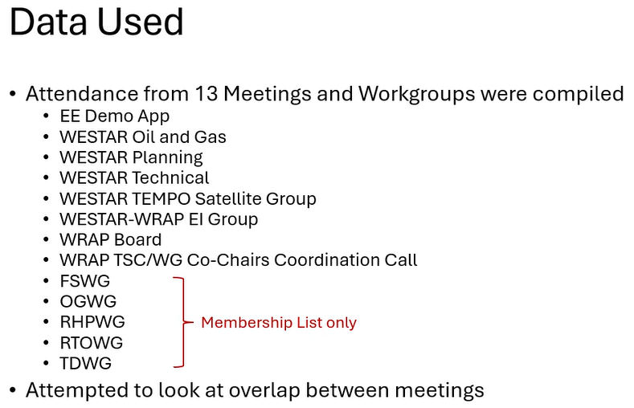
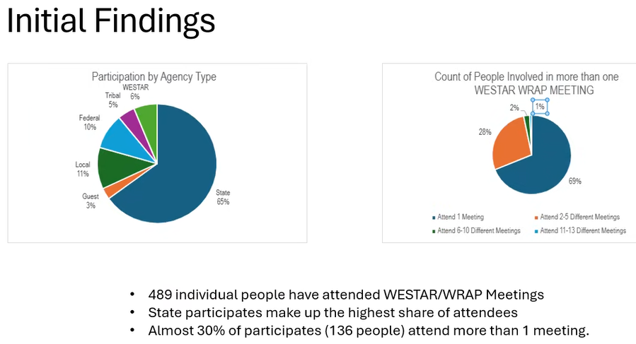
    - States are biggest attenders
    - Large amount of people attending these meetings, and almost 30% attended more than 1 meeting in 2025
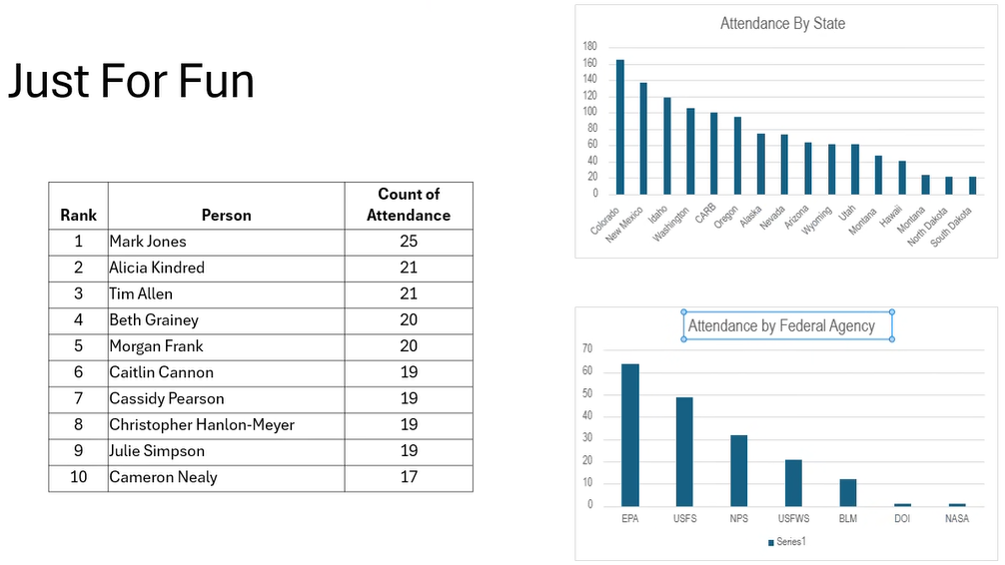
    - Colorado the most active, followed by NM
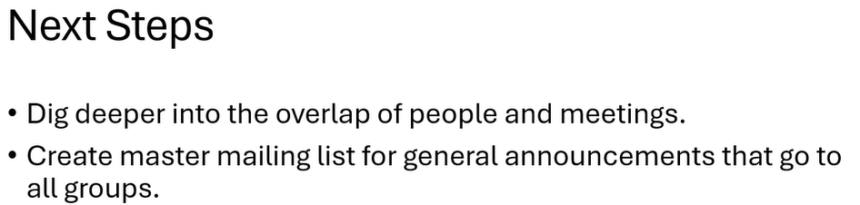
    - Now have a master attendance list with names, emails, and affiliations, which could be used for general announcements
    - Steve: are you looking to consolidate meetings? I appreciate this approach.
    - Rhonda: Yes, one of the goals is to curate meetings more. Also, Jay is going to reach out to Morgan at AAPCA to ask how they manage their mailing lists to avoid duplication in outreach. This was borne out of the idea of trying to align work groups and committees.
    - And give fun award for most active members
    - Rhonda: we are also looking at the roles between WESTAR-WRAP

  - Regulatory Update (15 minutes) - Rhonda
  - CO RH SIP for the 2nd Planning Period
    - Since we last met, EPA disapproved CO’s RH SIP
    - There was a prior partial approval/partial disapproval back in July of 2025, but now, EPA issued a full disapproval
    - Weston (CDPHE):
      - EPA did not like the closure dates in the SIP, which was responsible for the proposed partial disapproval last year
      - The utilities requested that these dates be included in the SIP
      - SIP was submitted in 2022 and prior administration did not act on it
      - This administration is uncomfortable with coal plant closure dates in the SIP
      - Nixon coal plant in CO Springs said they could not meet the 2029 date, so EPA said you are mandating unrequested closures on every plant, generates a takings issue, which could be illegal under state or federal law, but everything else is okay
      - EPA had wanted CO to modify the SIP to remove the closure dates and leave the rest the same
      - However, that was not possible quickly due to state processes, so EPA wanted us to voluntarily withdraw the whole SIP, CO said no, so they made a drastic turn and disapproved the whole SIP, despite state and other public comments arguing that it is not a takings issue
      - We have not officially decided how we are going to respond, either litigate or wait for EPA to develop a FIP because we know they don’t have the resources and no interest in doing so
      - All the modeling and EI was done at the WRAP, unclear how this could be redone
      - Trying to decide the best path forward now
      - On the MJO call on Monday, we got a comment from an EPA Region 6 person who agreed with the assertion in the CAA that requires/allows EPA to do anything about failure to remedy a disapproved SIP, so if CO doesn’t do anything, what are the consequences?
    - Jay: is there consideration of suing EPA?
    - Weston: yes, it’s being considered by the Governor’s office level
    - Weston: we got a lot of support from other states and MJOs
    - Jay: could have big implications for EPA too, like response to MACT rule
    - Rhonda: Weston, you had raised the question on another call: what was the justification that EPA gave for disapproving the other pieces of the SIP
    - Weston: there is nothing that we saw in the record from coal facilities that support EPA’s position of disapproving the whole SIP
    - Julie Hunter: there are some folks in CA dealing with the same issue, do you want to be connected with them?
    - Weston: yes
    - Rhonda: who is the lead?
    - Weston: I have been transitioning to taking on more of the utility work, Rick’s group is looking at RH and PM (anything other than ozone), but bc I did the four factor analysis for this round, I am still involved
  - RH 3rd Planning Period Deadline Extension
    - Extending to July 31, 2031
    - Does not impact the 10-year planning period to 2028
    - The progress reports are still due 2033

- Introduce Sarah, who is now on the call
    - Sarah is excited to be involved
    - Julie recapped the consensus-approval process
    - Hearing no objections, now approved, and it will go to the WRAP Board for consensus approval

- WESTAR-WRAP Updates (15 minutes) – Rhonda
  - Outline for WESTAR-WRAP Spring Business meeting and additional planning
    - Still working on getting the sessions filled
    - We went to the Council and asked what they want to hear more about
    - We always have talks on wildfire and air quality, Shawn Urbanski will be joining, and Elliot Gall on indoor air quality and smoke
    - Session on AI use in agencies
    - Will talk about data centers and data center permitting
    - IMPROVE updates and update on EPA unified platform
    - Is there anything you want to discuss?
    - Suggest topics for breakfast meeting
    - April 8-9 in Denver
  - 2022 EMP
    - Linked more info from projections group
    - Ongoing efforts in the 2022 EMP Projections Group
      - De minimis projections draft white paper hoping to have done by end of Feb.
      - 2022v2 EMP projections proposal spreadsheet
    - Main news is that EPA is considering developing the 2032 analytic year. If so, it could be available in 2027
    - Karl: wheels are turning on this, but not solidified
- Meetings and Conferences (5 minutes) – Kristen
Upcoming:
  - WESTAR TEMPO & Satellite Data Applications Group – met yesterday (January 27th). Contact Mary to be on the email list!
  - NOAA Satellite Applications Symposium Series: Fire, February 18, 2026, 7:30 am - 3:30 pm PT (In-person in Boise, ID, and virtual (In-person seating is limited and by invitation only))
  - 4th International Smoke Symposium, March 23-27, 2026, Tallahassee, FL (hybrid)
  - AWMA Data Center Insights and Innovation Conference, March 24-26, 2026, Dulles Technology Corridor, VA
  - AAPCA Spring Business Meeting, April 8-10, 2026, Atlanta, GA
  - WESTAR-WRAP Spring Business Meeting, April 8-9, 2026, Denver, CO
  - National Tribal Forum on Air Quality (NTFAQ), April 27-30, 2026, Pacific NW
  - UC Davis Air Sensors International Conference, May 4-8, 2026, Los Angeles, CA
  - 2026 Regional, State, and Local Dispersion Modelers’ Workshop, July 14-16, Location in the Midwest (more information to come)
  - NACAA 2026 Spring Membership Meeting, May 12-13, 2026, St. Louis, MO
  - NASA Health & Air Quality Applied Sciences Team (HAQAST), May 13-14, 2026, Madison, Wisconsin
  - National Atmospheric Deposition Program (NADP) Spring Meeting & Scientific Symposium, June 9-12, 2026, Madison, WI (hybrid)
  - National Ambient Air Monitoring Conference, Planning for August 2026. Location TBD
  - WESTAR-WRAP Fall Business Meeting, October 28-29, 2026, Boise, ID
  - CMAS Conference 2026, October 19-21, 2026, Chapel Hill, NC
  - AWMA’s Atmospheric Optics: Aerosols, Visibility & Radiative Balance, November 10-13, 2026, Lake Junaluska, NC
  - 2026 National Air Quality Conference – later this year, more information to come!
    - Question: heard that they were not doing the Ambient Air Monitoring conference, and how does the 2026 National Air Quality Conference differ?
    - Rhonda: latter is more focused on policy
    - Mary: joint venture by NACAA and AAPCA for the National Air Quality Conference because EPA is not doing it this year, they are wanting to make this conference with a lot of different tracks, so it may be different than what is was when EPA ran it
    - Unclear what is going on with the National Ambient Air Monitoring Conference
    - The only EPA conference happening for sure is the RSL modeling conference

Next Steps and Wrap up (5 minutes) – Kristen
  - Review next steps and action items from the call
    - Next call – Wednesday, March 25th, 2026
    - Note taker – Charis Cooper, BLM
- Only action item is Doodle poll on call day/time

Call Notetaking Schedule

Call Date | Time (PT) | Name | Agency | Representing | Geography
3/25/2026 | 11:30am – 1pm | Charis Cooper | BLM | Fed | National
5/27/2026 | 11:30am – 1pm | Paul Corrigan | USFS | Fed | Utah
7/29/2026 | 11:30am – 1pm | EPA Rep | EPA | Fed
9/30/2026 | 11:30am – 1pm | Tom Moore | Colorado RAQC | Local | Colorado
11/25/2026 | 11:30am – 1pm | Bob Kotchenruther | EPA – Region 10 | Fed | Pacific NW
Dates in 2027 TBD
** | 11:30am – 1pm | Local Rep | Vacant Seat | Local
** | 11:30am – 1pm | Steve Miller | Idaho DEQ - Air Quality Bureau | State | Idaho
** | 11:30am – 1pm | Karl Seltzer | EPA OAQPS | Fed | National
** | 11:30am – 1pm | Phil Swartzendruber | Puget Sound Clean Air Agency | Local | Washington
** | 11:30am – 1pm | Danny Powers | Southern Ute Indian Tribe | Tribal | Utah/Idaho
** | 11:30am – 1pm | Jason Walker | NW Band, Shoshone Nation - Washakie Reservation | Tribal | 4 Corners
** | 11:30am – 1pm | Mike Barna | NPS | Fed | Intermountain
** | 11:30am – 1 pm | Jessica Hejny | NM Env. Dept. | State | New Mexico

