WESTAR Council

Best Available Control
Technology (BACT)
Determination

August 19-21, 2025

IN-PERSON TRAINING

REGISTRATION DEADLINE:
Friday, August 1, 2025

State of Montana DEQ
Colonial Building
2401 Colonial Drive
Helana, MT 59601

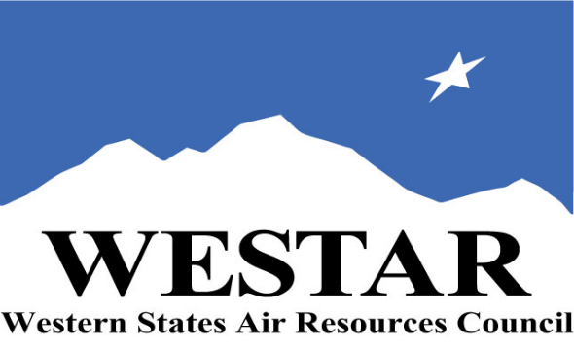

TO REGISTER

- Log onto EPA’s AirKnowledge and create a profile, or log onto your existing AirKnowledge account: https://airknowledge.csod.com/login/render.aspx?id=airknowledge
- When you complete your profile, you will receive a confirmation e-mail to activate your new account. It may take several minutes before receiving the email.
- Once activated, log into your account.
- Click the “Instructor Lead Training Calendar” link under the “My Training” tab.
- Search the calendar for the training date(s). On the calendar you will see a course description. Hover over the text for additional information.
- To register click the course title link.
- In the lower righthand corner of the page you will see a “Request” button. Click it.
- At this point you have requested a seat in the training. Because demand for WESTAR sponsored training frequently exceeds availability, all registrants are placed on a waitlist.
- You will receive an email from Jeff Gabler confirming your request.
- WESTAR attempts to accommodate all requests but at times it may be necessary to prioritize attendees.

TUESDAY, AUGUST 19, 2025
8:30 am Welcome, Introductions & Course Objectives
9:30 am BACT Background
10:15 am Break
10:30 am BACT Applicability
11:00 am BACT Determinations: Top-Down Step 1 (Identify Control Options)
12:00 noon Lunch (on your own)
1:00 pm BACT Determinations: Top-Down Step 2 (Technical Feasibility)
3:30 pm Break
3:45 pm BACT Determinations: Top-Down Step 3 (Ranking of Control
Options)
5:00 pm Adjourn for Day

WEDNESDAY, AUGUST 20, 2025
8:30 am BACT Determinations: Energy & Environmental Impacts Step 4
10:00 am Break
10:15 am BACT Determinations: Economic Impacts
12:00 noon Lunch (on your own)
1:00 pm BACT Determinations: Economic Impacts
3:00 pm Break
3:15 pm BACT Determinations: Top-Down Step 5 (Setting BACT Limits)
5:00 pm Adjourn for Day

THURSDAY, AUGUST 21, 2025
8:30 am BACT Determinations: Top-Down Step 5 (cont’d)
10:00 am Break
10:15 am History of Top-Down Procedure
12:00 noon Lunch (on your own)
1:00 pm Consideration of Precedent in Case-by-Case BACT Determinations
3:00 pm Responding to BACT Legal Challenges
3:30 pm Adjourn

ABOUT THE TRAINING
WESTAR’s Training Center will host this in-person training course for state, local and tribal air quality professional staff working, or planning to work, in major source permitting.
BACT is determined on a case-by-case basis, consisting of the following five steps:
- Step 1 – Identify each emission unit and all available control options
- Step 2 – Evaluate the technical feasibility of each control option. Eliminate control options that are not technically feasible based on physical, chemical, and engineering principles.
- Step 3 – Rank remaining control options on the basis of control efficiency, the top ranked control alternative is the first selection of BACT.
- Step 4 – Eliminate control options based on evaluation of economic, environmental and energy impacts.
- Step 5 – Select the most effective option as BACT.
This training will examine the framework for a consistent approach to determining BACT. The emphasis is on the types of data which should be required in a pre-construction permit application and how the data should be used in order to determine BACT, and the technological question of whether the emission control system proposed in the permit application represents BACT or whether a more stringent level of emission control is appropriate considering available technology and economic, energy, and environmental impacts.
COURSE MATERIALS: Training course materials will only be available electronically. Attendees will receive an online document sharing link for access to materials. It is the attendee’s responsibility for downloading files and for providing the device or media on which to view materials. WESTAR will provide hard copies only for those needing accommodation.
SPACE LIMITATION: Registration is limited to 35 attendees. Air quality staff from the fifteen western states receive registration preference.
REGISTRATION FEES:
There are no registration fees for state, local or tribal air quality agency staff. For federal agency staff a $1,200 registration fee will be charged.
ACCESSIBILITY
ACCESSIBILTY: WESTAR strives to host inclusive, accessible training events that enable all individuals, including individuals with disabilities, to engage fully with the instructor and course content. To request an accommodation or for inquiries about accessibility, please contact Jeff Gabler at jgabler@westar.org or 503-744-0486 by Friday, July 18, 2025.
TRAINING LOCATION
State of Montana DEQ
Colonial Building
2401 Colonial Drive
Helana, MT 59601

