WESTAR Council

Theory & Application
Of Common
Air Pollution Control Devices

August 12-14, 2025

ONLINE

REGISTRATION DEADLINE
Friday, June20, 2025

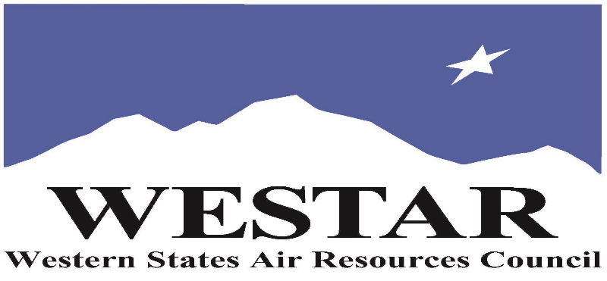

TO REGISTER
- Log onto EPA’s AirKnowledge and create a profile, or log onto your existing AirKnowledge account
Click Here - EPA AirKnowledge
- When you complete your profile, you will receive a confirmation e-mail to activate your new account. It may take several minutes before receiving the email.
- Once activated, log into your account.
- Click the “Instructor Lead Training Calendar” link under the “My Training” tab.
- Search the calendar for the training date(s). On the calendar you will see a course description. Hover over the text for additional information.
- To register click the course title link.
- In the lower righthand corner of the page you will see a “Request” button. Click it.
- At this point you have requested a seat in the training. Because demand for WESTAR sponsored training frequently exceeds availability all registrants are placed on a waitlist.
- You will receive an email from Jeff Gabler confirming your request.
- WESTAR attempts to accommodate all requests but at times it may be necessary to prioritize attendees.

AGENDA
TUESDAY, AUGUST 12, 2025
9:00 am (PACIFIC)
- Course Introduction
- Basic Concepts
- Capture & Control
- Introduction to Particulate Matter
- Separators
12:00 noon (PA CIFIC)
- Lunch Break
1:00 pm (PACIFIC)
- Baghouses
- Wet Scrubbers
3:30 pm (PACIFIC)
- Adjourn for the Day

WEDNESDAY, AUGUST 13, 2025
9:00 am (PACIFIC)
- Review of Day 1/Question
- Electrostatic Precipitators
- Introduction to Volatile Organic Compounds (VOC)
- Flares
- Thermal Oxidizer
12:00 noon (PACIFIC)
- Lunch Break
1:00 pm (PACIFIC)
- Refrigerated Condenser
- Absorption
- Adsoprtion
3:30 pm (PACIFIC)
- Adjourn for the Day
THURSDAY, AUGUST 14, 2025
9:00 am (PACIFIC)
- Review of Day 2/Questions
- Introduction to Carbon Monoxide
- Cabon Monoxide Controls
- Introduction to Sulfur Oxides and Nitrogen Oxides
- Acid Gas
12:00 noon (PACIFIC)
- Lunch Break
1:00 pm (PACIFIC)
- Parametric Monitoring
- Group Exercise/Test Review
3:30 pm (PACIFIC)
- Adjourn

ABOUT THE TRAINING COURSE
Who Should Attend
This is an introductory course designed for agency inspectors, permit writers, and regulation developers who have the responsibility to review air pollution control devices.
Learning Objectives
This course is designed to give attendees a basic understanding of the different types and operating characteristics of air pollution control devices that are available for particulate matter, volatile organic compounds, carbon monoxide, acid gases, and hazardous air pollutants. Course topics include:
- Background on ideal gas law and capture and control of air pollutants.
- Particulate controls, including separators, fabric filters, scrubbers, and electrostatic precipitators.
- Volatile organic compound controls, including minimization, oxidation, condensation, adsorption, and absorption.
- Carbon monoxide controls, including minimization, catalysts, and oxidation.
- Acid gas controls, including prevention, absorption, and adsorption; and
- Parametric monitoring of air pollution control equipment.

Course Delivery: This is a virtual, instructor-led training course.

Space Limitation: Registration is limited to 45 attendees. Air quality staff from the fifteen western states receive registration preference.

Registration Fees: There are no registration fees for state, local or tribal air quality agency staff.

ACCESSIBILTY
WESTAR strives to host inclusive, accessible training events that enable all individuals, including individuals with disabilities, to engage fully with the instructor and course content. To request an accommodation or for inquiries about accessibility, please contact Jeff Gabler at jgabler@westar.org or 503-744-0486 by Monday, July 14, 2025.
INSTRUCTIONAL STAFF
Instructor Bio:
Andrew D. Shroads, QEP has over 26 years of experience in air pollution control, working in the Weirton Steel Corporation Environmental Control Department, as an inspector for the Cleveland Division of Air Quality, and as a consultant for regulatory agencies and private clients. He helps local, state, tribal, and federal government agencies develop air pollution control requirements and helps industry comply with air pollution permit and regulatory requirements. He is currently working as the interim environmental manager for a manufacturing facility in Ohio, developing air pollution control requirements for the state of New Jersey, and assessing the air quality impacts from a federal site in New Mexico. He also develops and teaches air pollution control training programs to private clients and government agencies. In his spare time, he researches the history of air pollution control.

