NOTES
WESTAR Planning Committee Conference Call
June 6, 2024

11:00 AM HST; 12:00 PM AKST; 1:00 PM PST; 2:00 PM MST; 3:00 PM CST
Microsoft Teams meeting: Click here to join the meeting on your computer or mobile app
Or call in (audio only) (323) 676-6261 Access Code: 524 677 789#
Participants (attendance is marked by bolding)
States: AK, AZ, CA, CO, HI, ID, MT, ND, NM, NV, OR, SD, UT, WA, WY
Local Air Agencies: Clark County, Albuquerque, Solano
Tribal Air Agencies:
Federal Land Mangers: BLM, FWS, NPS, USFS
WESTAR:

- Call to Order- Chelsea Cancino (UT) and Laura Ballard (WY)
  - Notes for this call: Colorado
- Discussion Items
  - Climate Pollution Reduction Grant (CPRG) Update on Phase I Submission and Phase II Scoping
    - Background:
      - Climate Pollution Reduction Grants (CPRG) are a program included the 2022 Inflation Reduction Act
      - Phase I provides (noncompetitive) formula planning grant funding for states ($3M each), metropolitan areas ($1M to each of the 67 largest areas), territories ($2M set-aside), and tribes ($25M set-aside) to develop plans to reduce greenhouse gas emissions.
        - Planning grantees received awards in Summer/Fall 2023
        - Priority Climate Action Plan (PCAP) - due by 3/1/2024 for States and MSAs and by 4/1/2024 for Tribes and Territories.
          - Awardees of Implementation Grants must use them to implement measures included in the PCAP.
        - Comprehensive Climate Action Plans - due two years after planning grant awards. This corresponds to about mid-2025 for States and MSAs and the close of the grant period for Tribes and Territories.
          - Applications for Implementation Grants – due 4/1/2024
        - States and MSAs must submit a Status Report at the end of the 4-year grant period (around mid-2027)
      - Phase II will provide $4.6B nationwide in competitive implementation grant funding for government entities participating in Phase I.
        - $4.3 Billion competition for funding for States and MSAs.
          - Awards are split into 5 Tiers (Tiers A-E) based on grant size, as shown below.
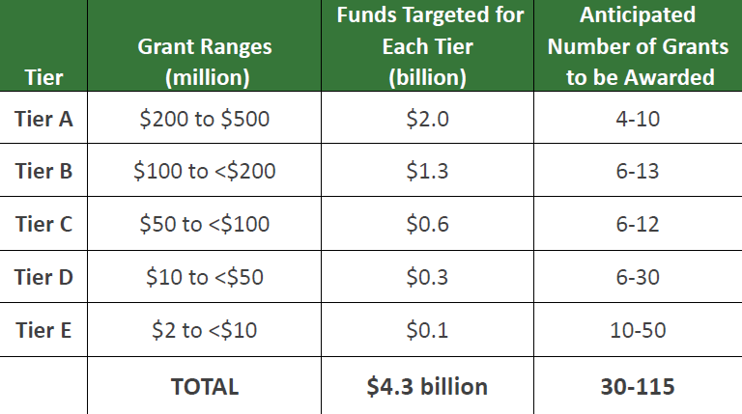
        - $300 Million competition for funding for Tribes and Territories.
        - EPA intends to notify winners of implementation grants in Summer 2024 (around July 2024) and award implementation grants in Fall 2024 ( around October 2024)
    - Glade Sowards (UT)
      - UT DEQ is lead agency for CPRG development for the state
        - PCAP known as the “Beehive Emission Reduction Plan”
      - DEQ received around 130 suggestions for GHG reduction measures; needed to prioritize and narrow down list.
        - Factors included: CPRG program requirements eligibility, CPRG Phase II grant scoring system, LIDAC (low-income disproportionately impacted communities), total Phase II funding availability (keep it realistic to avoid competing with large states like CA and NY), other funding sources, interactions with existing programs in UT
      - Selected 14 measures (high-level groupings of ideas) including 32 example projects
      - Utah PCAP Items:
        - Statewide Omnibus application, $75 Million (Tier C), UDAQ
        - Utah Trails application, 50 million (Tier C), UDOT
        - Multi-state coalition Resilient Local Energy, $500 Million total for all states (Tier A), 32 Million for UT
      - Salt Lake MSA PCAP Items:
        - Multi-family Buildings application, (Tier E), Salt Lake County
        - UT Renewable Communities application, $49 Million (Tier D), SLCGreen Dept.
        - Tree Planting and Municipal Fleet EV Charging application, (Tier E), SLC Public Services
        - Water Reclamation Facility application, (Tier D?), SLC Public Utilities Dept.
      - Awards Announced: July 2024
      - Funding Available: October 2024
      - Comprehensive Plan: ongoing development, due Summer 2025
    - Dina Geiszler (WA)
      - WA Dept of Commerce is lead agency for CPRG for the state
      - Puget Sound Clean Air Agency is lead agency for Seattle-Tacoma-Bellevue MSA
      - State PCAP focused on Measures in 5 Sectors
        - Buildings
          - Refrigerant Management in grocery stores
            - Focus on replacing high GWP refrigeration equipment in grocery stores, prioritize DI communities
            - Another program may focus on residential HVAC refirgerants
          - Decarbonize campus energy systems
        - Waste Management
          - Organics Management
        - Transportation
          - Scrap and replace fossil-fuel powered commercial vehicles
          - Marine terminal electrification
          - Ensure walkable/bikeable streets provide access to transit
          - Reduce fleet emissions for rural and special needs transit
          - Enable rail decarbonization
          - Electrify municipal and tribal fleets, including expanded charging infrastructure
          - Shift transport from trucking to water to reduce VMT
        - Electric Power
          - Support tribal energy sovereignty through Tribal Clean Energy Grants
        - Agriculture
          - Fund anaerobic digesters
      - Statewide PCAP measures include:
        - Total of around $470 million for measures implemented by Dept. of Ecology and Dept. of Transportation
        - Total of about $82 million for measures implemented by 8 tribes, one local government, and Dept. of Commerce
    - Aislinn Johns (ID)
      - ID DEQ is lead agency for CPRG development for the state
        - PCAP known as the “Gem State Air Quality Initiative”
      - Agriculture is largest GHG source (40%), Transportation is 2nd largest GHG source (30%)
      - Agriculture measures include:
        - Climate Smart Agriculture practices
          - Soil health
          - Nitrogen management
          - Manure and feed management
          - Energy efficiency,
          - On-farm energy production
      - Transportation measures include:
        - Sustainable Transportation Networks
          - Public Transit
          - Active Transportation
            - Biking and Pedestrian infrastructure
            - Biking as alternative transportation method
          - Traffic Flow Improvements
        - Transition to Sustainable, Cleaner Fuels
          - Biodiesel
          - Electricity
          - Ethanol
          - Hydrogen
          - Natural Gas
          - Propane
        - Truck-to-Rail Transload facility in SE Idaho
    - Morgan Schafer (OR)
      - OR DEQ is lead agency for CPRG development for the state
      - Transportation is largest GHG source (35% +), Residential & Commercial Buildings is 2nd largest GHG source (34%), Waste & Materials Management was 3rd focus
      - Transportation measures include:
        - Light-duty vehicle and charging incentive, focus on low-, moderate-income, and DI communities
        - Medium- and Heavy-duty vehicle and infrastructure incentives
      - Residential and Commercial Building measures include:
        - Incentives to build more efficient housing (residential)
        - Incentives for early/voluntary adoption of Building Performance Standard (BPS) requirements (commercial)
        - Incentives for residential heat pumps (residential)
        - Weatherization assistance (residential)
        - Building reuse and space-efficient housing
      - Materials and Waste Management
        - GHG reductions in lifecycle of food
          - Avoiding food waste
          - Upgraded/new composting facilities
          - Community composting grants
        - Capture of landfill gas
    - Q/A and Group Discussion
      - Q/A during each presentation, not much time left for additional Q/A or group discussion
- Actions/Updates
  - Any new actions for discussion or awareness?
  - EPA Rx Fire and Smoke Management Planning Webinar
    - May 15, 2024 1-2 PM MST
  - WESTAR Planning Committee Contact Spreadsheet
    - Please add your/your group members’ roles for future contact reference.
  - Topic Suggestion Google Form
    - Please use this form to submit any topic suggestions you would like us to cover in future meetings.
- Next Call
  - June 6, 2024, 2:00 PM MST Notes – Hawaii

