AGENDA
WESTAR Planning Committee Conference Call
March 7, 2024
11:00 AM HST; 12:00 PM AKST; 1:00 PM PST; 2:00 PM MST; 3:00 PM CST
Microsoft Teams meeting: Click here to join the meeting on your computer or mobile app Or call in (audio only) (323) 676-6261 Access Code: 524 677 789#

Participants (attendance is marked by bolding) States: AK, AZ, CA, CO, HI, ID, MT, ND, NM, NV, OR, SD, UT, WA, WY
Local Air Agencies: Clark County, Albuquerque, Solano , , Pima County, Denver Metro/North Front Range RAQC
Tribal Air Agencies:
Federal Land Mangers: BLM, FWS, NPS, USFS WESTAR:
- Call to Order- Laura Ballard (WY)
  - Notes for this call: Arizona

Discussion Items
  - National Exceptional Events Workshop Recap and Round Table
    - Introduction – Jay Baker
      - Exceptional event workshop was in St. Louis.
    - State Perspectives - Main Takeaways
      - Utah – Mark Sghiatti
- Main points/key takeaways:
  - Utah agency, and other agencies, had questions regarding the new PM_{2.5} NAAQS and exceptional event demonstration timeline. One key thing was that the new PM_{2.5} NAAQS, states will generally have to worry about 2022-2024 that EPA will base the final designation on based on the design values for those years.
  - Good and bad news/don’t have to worry about 2021, which might be good news—it tended to be a smoky year in the West. Bad news is we don’t know what 2024 data will look like.
  - Leaves some constraints on the timeline to determine which exceptional events are needed to remove from the data to get under the NAAQS for the final designation
  - Because we are missing 75% of 2024 data, what are other state agencies doing to be proactive
  - Conference touched on this— using different tools and data analysis developed by states or EPA to screen and flag potential days that might be considered for exceptional events in the future.
  - Tools related to determine the regulatory significance of days to help easily exclude or include days that will easily re-calculate the design value
- Jay added timing of the demonstrations might be one of the bigger issues.
  - Data for 2024 will be certified in May 2025. This would mean about 2 months to submit any 2024 exceptional event demonstrations
  - States may have additional 2022 and 2023 exceptional event demonstrations based on the outcome of 2024.
  - EPA was unsure how it would handle these issues
  - It was unclear if states need to hedge bets to submit additional demonstrations.

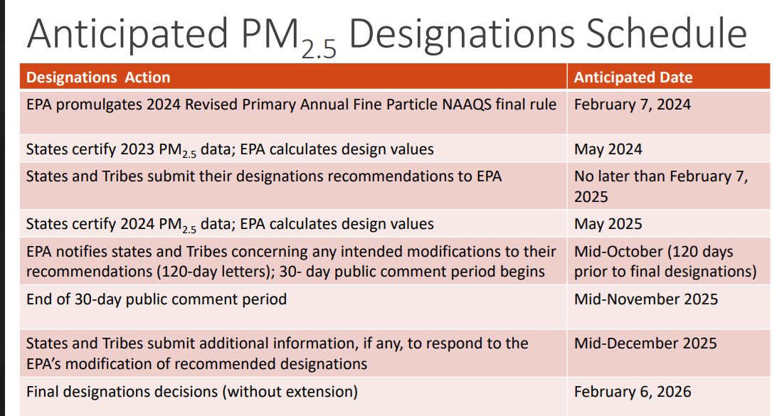
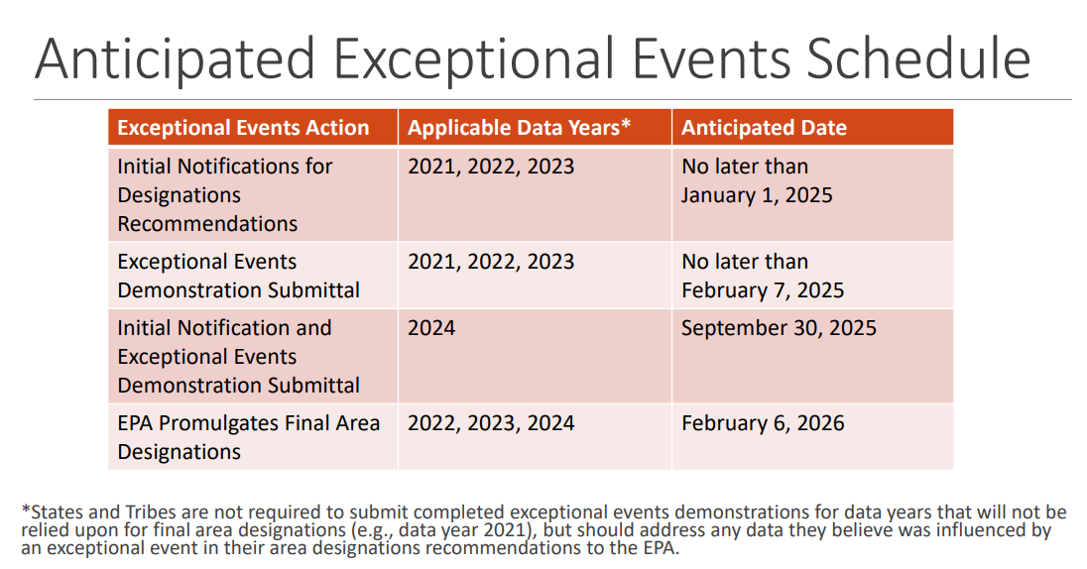
- Rebekka Fine (CARB) State recommendations will need to include 2021
- Won’t require a full demonstration, will likely have to include a discussion about why not considering 2021.
- Exceptional event demonstration
- Rebekka shared the image below
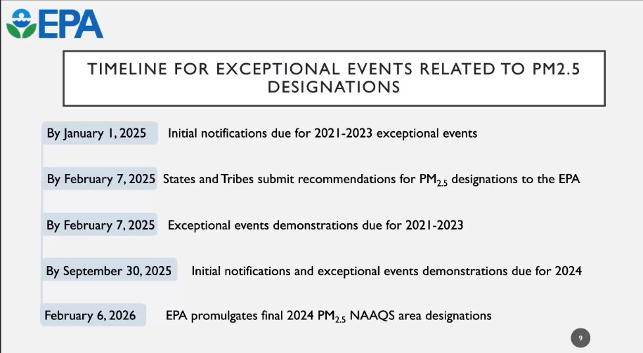

EPA mentioned that states should consider including a paragraph explaining the reason for not considering 2021 (due to period of data will shift from 2021-2023 to 2022-2024).

      - Nevada – Elizabeth Grainey
- Data visualization was for 2018-2022, will move to 2019-2023 on April 1st.
- SIPs are the regulatory significant reason to submit exceptional event demonstration.
- If there is an ARA (air resource advisor) on prior exceptional event demonstrations, you can request their smoke outlooks and other files
    - Only pull data for a single standard.
    - Can include videos in demonstrations
- Yousaf (Clark County) – Data flagging for the new PM_{2.5} standard. Clark county is starting to think about this process/wanted to know if any agency had decided on the process
    - Wyoming (Amber Potts) – a lot of states may have experience with transport piece of this
      - If all western states could have a similar methodology, it might help upwind states for transport.
- Mary Uhl: In the small group breakouts, a lot of people discussed and expressed interest in a Tier 0, where it would be obvious to exclude (smoke in the air column/smoke at the monitor)—something simpler than Tier 1.
    - Georgia had anticipated 50-60 demonstrations/year for prescribed fires
- Mark Sghiatti, Utah developed a flagging/screening tool—threshold set at 1 standard definition above the mean, and the site is touching an HMS derived smoke polygon, that day is marked as a potentially smoke impacted day for ozone or PM_{2.5}. QA/QC team is informed to flag the specific dates. I-flag is put on those dates to follow up on.
- Amber asked if Mark could provide a demonstration. Mark agreed if there was interest.
    - Group Discussion
      - What is your state’s approach to area designation recommendations for the new PM2.5 NAAQS?
- Already discussed this item in the prior agenda item.
      - How many exceptional event demonstrations is your state expecting to prepare as part of your recommendation?
- Amber: Wyoming is looking for to contract for that. Major fire year was 2021, with 60-100s of exceptional events and continue that work for 2024.
- Aislinn Johns: For 2022, looking at about 83 days across monitors (doing that work in house)
- Rebekka Fine: CA doesn’t have a set number of days, but meeting with local air districts monthly
  - Rather CA was looking at picking days that would be important to make a difference 5 out of the 35 air districts will prepare designations. However, the numbers are still being worked out.
      - Do any states have recommendations for the timing of designations and exceptional event demonstrations?
- Aislinn Johns: How are states having discussions about making these documents more readable for the public? Are other states having this challenge with this particular issue because it is so technical?
    - Sylvia Vanderspek—have not had that concern come up, but it will be a concern especially given the volume. Regional office has not brought it up, nor have public comments.
    - Farah Fatemi from DEQ in Oregon—conversation was that EPA is the primary audience, but maybe consider putting together fact sheet, summary, or other document for the public
      - It was in Sara Strachan’s presentation.
      - All the recordings and presentations (except for a few) are available on Westar’s website. – on the Exceptional events page.

Actions/Updates
  - Any new actions for discussion or awareness?
  - April 16-18, 2024: WESTAR Spring Business Meeting (Riverside, CA)
    - Submit questions or comments for EPA here – goal is to submit questions in the next 2 weeks (to be able to pass the questions on to EPA so they can answer the questions in the presentation)
  - WESTAR Planning Committee Contact Spreadsheet
    - AT the business meeting, there will also be a tour of CARB's mobile sources testing lab at the new Riverside Headquarters campus: https://ww2.arb.ca.gov/southern-california-headquarters-mary-d-nichols-campus
  - Link to Register:
    - Please add your/your group members roles for future contact reference.
      - Add information to help keep this as a resource for others.
  - Topic Suggestion Google Form
    - Please use this form to submit any topic suggestions you would like us to cover in future meetings.

Next Call
  - April 4, 2024, 2:00 PM MST Notes – California

Note Taking Schedule – 2024

March | Arizona
April | California
May | Colorado

June | Hawaii
July | Idaho
August | Montana
September | North Dakota
October | New Mexico
November | Nevada
December | Oregon

