WESTAR Planning Committee Conference Call Notes
September 7, 2023

Participants (attendance is marked by bolding): AK; AZ; CA; CO; HI; ID; MT; ND; NM; NV; OR; SD; UT; WA; WY; WESTAR; NPS; USFS; FWS; Albuquerque, NM; Clark County, NV; Spokane Clean Air; Nez Perce Tribe; Denver Metro / North Front Range RAQC, Pima County, AZ

1. CALL TO ORDER - Rebekka Fine (CA) and Chelsea Cancino (UT)
a. Notes for this call: North Dakota
b. Review notes
! No comments on the previous notes.

2. DISCUSSION ITEMS (All States and Agencies)
- EPA’s Advance Program for PM (Shawn Sweetapple, ID)

Cliff notes
What is it?
- For attainment areas approaching non-attainment and help keep it out of non-attainment, PM and Ozone focus (preemptively address coming issues)
- Local leadership needed
- Not regulatory = highly flexible approach
Benefits?
- Depends on the area and local buy-in, buy-in is critical.
  - No funding (at least not directly)
Eligible
- States/tribal/local goverments
- Areas of in attainment approaching nonattainment
- Need to participate in NEI reporting
How to join and timeline
- Local lead governmental organization
- Completed NEI report
- Stakeholder meetings and develop plan
- Submit path forward (plan) for the area in consultation w/ EPA
- Annual Advance plan revision

- Committed for 5years one you join the program

Shawn covered slides which provided an overview of the issues/situation and cities in ID that are participating in Advance
- Each areas and cities have unique challenges and can have many parties (state/local/federal) involved
- Challenges can be seasonal and/or area specific
Successes:
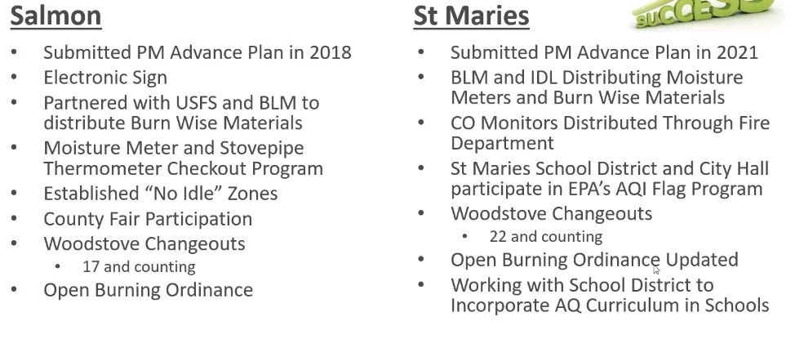
Challenges:
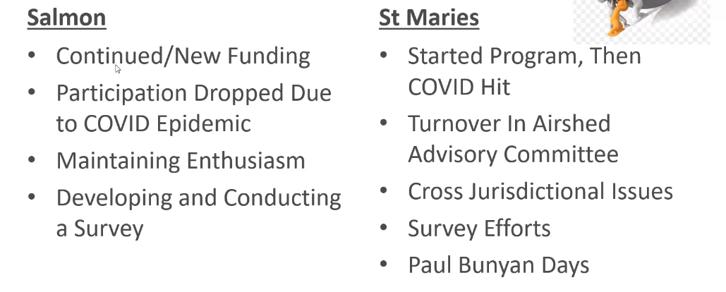

Q&A
City of Albuquerque: Is this program applicable to Ozone (to be in the PM Advance program)?
Shawn: Unsure because he hasn’t attempted, but seems like there are options to be at least looked into

Rebekka Fine (CA): what is a typical make-up of the group/program?
Shawn: local government, citizens – variety is key. Shawn stressed the local involvement is critical again. Need the local people with influence to be part of it (You have to find the “in”).
ID drove/pushed for this in one area, environmental advocacy groups pushed in another area.

Rebekka Fine (CA): Were/are additional monitors needed?
Shawn: No stationary monitoring, handheld monitoring has been utilized situationally. Monitor discussions are being had. Purple air monitors are used to show ‘bigger’ picture (not official, but helpful)
- SIP Minute: General Conformity (Jeff Sorkin, USFS)

Cliff notes:
General conformity
- Ensures federal agencies do not interfere with state plans to attain standards

USFS project types
- PM and Ozone are of the most concern. Other items such as oil and gas – have impacts but not likely to have conformity issues
- Many issues are irreverent to conformity
  - USFS projects are not like airports – or other large – projects
  - Very few USFW projects trigger conformity

Applicable analysis:
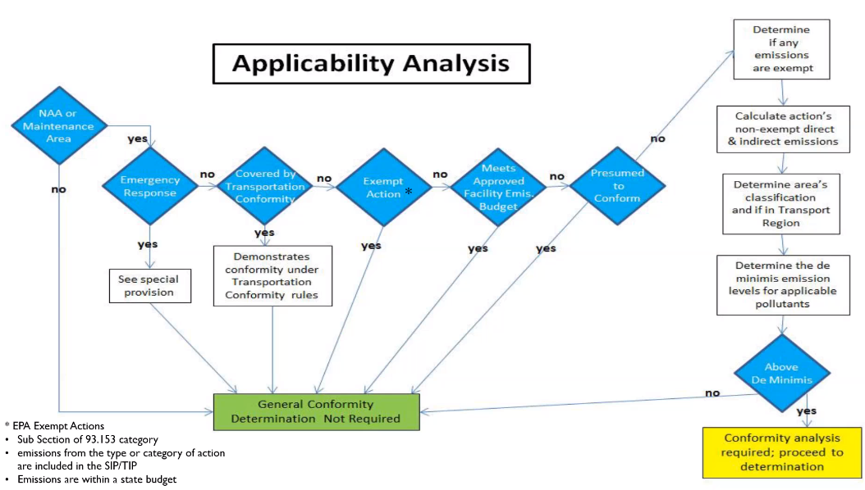

- Jeff has gone through this twice, but it showed de-minims emissions prior to moving through the full conformity analysis
- It takes a big project to trigger general conformity analysis
  - Such as major oil and gas development in certain areas

NEPA
- Conformity is folded into NEPA analysis to remove duplicative efforts
  - See EPA general conformity training manual 1.3.4.2
  - https://www.epa.gov/sites/default/files/2016-03/documents/general_conformity_training_manual.pdf
Prescribed fire and general conformity
- Projects must occur in areas designated non-attainment/maintenance for this to occur
- Pertinent, especially with regard to PM2.5 standard coming

Q&A
Aislinn Johns: what tools are available for use that can be shared with smaller groups? Such as detailed calcs/tables.
What about HUD projects? ID had some issues (large emissions) with this and calculation of PM from small projects.
Jeff Sorkin: EPA lays out a procedure to do this. USFS contracts out emissions inventory quantification – especially for larger projects.
HUD response – high emissions from the nature of the project seem to be calculated incorrectly. Recommend looking at the manual for guidance

3. ACTIONS / UPDATES
a. Any updates?

b. Upcoming Trainings/Workshops/Meetings:

- October 3-4: WESTAR Fall Business Meeting (Anchorage, AK) Details and registration are available online

- October 17-18: IMPROVE Steering Committee Meeting (Kalispell, MT) Contact Jay Baker or Scott Copeland for details

- October 19-20: HAQAST Public Meeting (Salt Lake City, UT) Details including registration, travel funding, and draft agenda are available online

- November 14-15: State Implementation Plan Development Training (Portland, OR) Details are available on the WESTAR Training webpage

4. NEXT CALL
a. November 2, 2023, 1:00 - 2:00 pm (Pacific), Notes – Oregon

NOTE TAKING SCHEDULE – 2023

January | Alaska
February | Arizona
March | Hawaii
April | Idaho
May | Montana
June | Nevada
July | New Mexico
August | Combined meeting w/ tech. committee
September | North Dakota
October | CANCELED
November | Oregon
December | South Dakota
January 2024 | Utah
February 2024 | Washington

