--Technical Steering Committee / Work Group Co-Chairs--

-- Monthly Coordination Meeting --

Agenda

Wednesday, September 25, 2024, 11:30 am–1:00 pm PT, 12:30–2:00 pm MT
Microsoft Teams meeting
Join on your computer or mobile app
Click here to join the meeting

Or call in (audio only)
+1 323-676-6261,, 912102369#
Phone Conference ID: 912 102 369#

WRAP TSC webpage / Call Materials available on the Committee Meetings tab

- Welcome, Roll Call, Agenda Review, Previous Meeting Notes (10 minutes) – Julie
  - Roll Call & Agenda Review
  - Notes for this call – Karl Seltzer
  - Review and approve notes from the June 26 meeting
    - No Comments
    - Please send any comment/edits to Rhonda, Julie & Kristen by COB Friday. Any changes will be incorporated, and the meeting notes will be made final next week and posted to the TSC website.

- WG Status Updates & Membership List Updates - (30 minutes) - Kristen
  - WG Co-Chairs – FSWG, OGWG, RHPWG, RTOWG, TDWG (oral updates)
    - FSWG
      - Recent meeting: discussed how fire season has progressed. Presentation by Pete Lahm of USFS on ARA season update. The Exceptional Events sub-group met and got an update on the WESTAR/SCAQMD app. The group also discussed using the app to create “Atypical” or “EE-lite” demonstrations that agencies can use in SIP development – to conduct trend analyses, figure out base-year concentrations, and examine representative years. Still brainstorming on what that might look like. Meetings have been recorded and will be posted.
    - OGWG
      - Last meeting was in May. May plan another meeting soon, need to follow-up on email from Rhonda. No other updates.
    - RHPWG
      - Need to wait and see the landscape of regulatory priorities before we begin planning for R3. The group of RH state and local planners met yesterday to talk about R3 and they all said it was not a priority at this time. The group also talked about EPA actions on R2 SIPs and R2 progress reports. Most states plan to send progress report to FLMs for review in the next few weeks. Last meeting was in June with RTOWG.
    - RTOWG
      - Not a lot to report on. Some things are occurring related to the 2022v1 EMP. In an upcoming meeting; would like EPA to give an overview of the current state of emissions with emphasis on Western US. Karl S will be presenting this type of material at the CMAS conference (in person meeting, only) and said he’d share that presentation with the TSC.
    - TDWG
      - New members, general discussion. Next meeting Oct. 8.
  - WG Membership List Updates – TSC Approval (as needed) – changes approved
    - FSWG: Remove Liz Ulrich, Rebekka Fine, Peter Brewer, Coleen Campbell, David Mueller. Add Jennifer Horton, Ron Sharron, Elyna Grapstein. Correct Matt Mavko’s email.
    - OGWG: Remove Liz Ulrich.
    - RHPWG: Add Ken McIntyre, Cassidy Pearson, Caitlyn Roehmholdt. Remove Liz Ulrich, Rebekka Fine, Chelsea Cancino, Laura Ballard, and Vangie Lund.
    - RTOWG: Remove Rebekka Fine and Chelsea Cancino.
    - TDWG: Add Saul Bobtail Bear and Lisa Gover. Remove Michael Baca. Correct email for Joe Hostler, Yurok Tribe.

- TSC Administrative and Informational Items (30 minutes) – Julie
  - Regional Haze R3 Planning Discussion
    - Had a meeting on 9/24, waiting to hear if EPA extends R3 deadline, can impact SIP deadlines.
  - TSC State and Local Vacancies – still looking for reps!
    - Rhonda is working to get a State rep. from NM – NM thinks they’ll have staff available in a couple of months after new staff are onboarded. Kristen is working to get a Local rep., possibly from Lane County Regional Air Protection Agency (LRAPA)
  - Analytic year work for the 2022 Platform Update (Rhonda, Tom, Karl)
    - Rhonda: Analytic year data review began – not all sectors are available but should be available by October 1. Agencies are encouraged to look at the data via the Data Retrieval Tool and the control, projection, and closure packets on the ftp site. For “larger” comments to incorporate into v2, EPA encourages folks to start those discussions with EPA now. Will eventually have the 2022 platform available on the ADMS as well. Looking to do a v1 debrief to inform v2. Fed/State meeting will include modeling presentations on how agencies are planning to use the 2022 EMP, will see impacts of various boundary conditions (Oct. 28th).
  - Request for topics EPA can cover in their OAQPS update at WESTAR/WRAP Fall Business meeting
    - What is going on with the Regional Haze Rule?
    - High bias in UV photometric ozone analyzers due to smoke influence.
    - Emissions reductions to be expected in 2026/32/38 projections as a result of OOOO guidance and reg.
    - Estimates of criteria emission reductions to be expected from CPRG awards by 2032/38.
  - Future meeting planning for TSC
    - Considering going to every 2 months, meeting the week before the WRAP Board meets. Quarterly is likely too long between meetings. Decided on next meeting December 4th at same time 11:30-1:00PT.
- Upcoming Meetings and Conferences (10 minutes) – Kristen
  - Fed/State Technical Work Collaboration Group call – Thursday, October 24, 2024. We will discuss the application of the 2022v1 EMP.
  - Keep up with EPA’s Office of Research and Development:
https://www.epa.gov/aboutepa/about-air-climate-and-energy-research-program
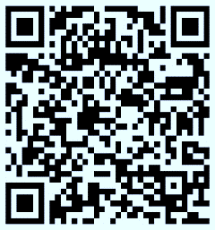
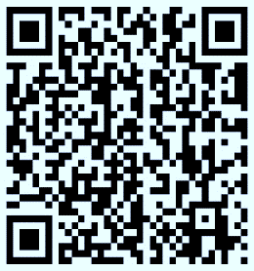
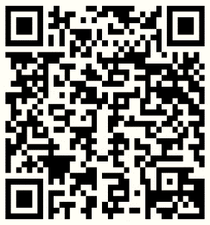
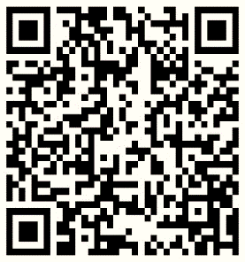
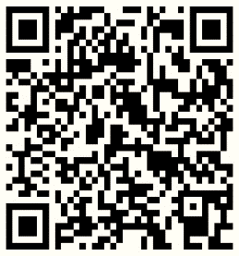

Air, Climate, & Energy Research Webinar Series (Quarterly)
Air Research News (Less than once per month)
Wildland Fire Science News (Less than once per month)
Air Sensor Community Science News (Less than once per month)
Science Matters Newsletter (Biweekly)
  - 2024 Rocky Mountain Wildfire Smoke Symposium (RMWSS), October 17-18, Missoula, MT
  - NADP 2024 Fall Meeting and Scientific Symposium - “Protecting the health of communities and ecosystems in a changing climate", November 4-8, Duluth, MN (hybrid)
  - NACAA Fall Membership Meeting, October 8-9, Alexandria, VA (in person only)
  - WESTAR/WRAP Fall Business Meeting, November 13-14, Reno, NV (hybrid)
- Next Steps and Wrap up (10 minutes) – Julie
  - Review next steps and action items from call: Post updated, approve member lists to website. Meet in 2 months. Review June meeting notes by COB 9/27.
  - Next call –
    - Wednesday, December 4, 11:30 PT / 12:30 MT
    - Note taker – Phil Swartzendruber – Confirmed availability.

Call Notetaking Schedule

Call Date | Time (PT) | Name | Agency | Representing | Geography
9/25/2024 | 11:30am – 1pm | Karl Seltzer | EPA OAQPS | Fed | National
12/4/2024 | 11:30am – 1pm | Phil Swartzendruber | Puget Sound Clean Air Agency | Local | Washington
11/27/2024 | 11:30am – 1pm | Jason Walker | NW Band, Shoshone Nation - Washakie Reservation | Tribal | Utah/Idaho
12/25/2024 | 11:30am – 1pm | Danny Powers | Southern Ute Indian Tribe | Tribal | 4 Corners
1/29/2025 (date may change) | 11:30am – 1pm | Tim Allen | FWS | Fed | National
2/26/2025 | 11:30am – 1pm | Mike Barna | NPS | Fed | Intermountain
3/26/2025 | 11:30am – 1 pm | State Rep | Vacant Seat | State
4/30/2025 | 11:30am – 1pm | Charis Cooper | BLM | Fed | National
5/28/2025 | 11:30am – 1pm | Paul Corrigan | USFS | Fed | Utah
6/25/2025 | 11:30am – 1pm | Gail Tonnesen | EPA - Region 8 | Fed | Intermountain
7/30/2025 | 11:30am – 1pm | Tom Moore | RAQC | Local | Colorado
8/27/2025 | 11:30am – 1pm | Bob Kotchenruther | EPA – Region 10 | Fed | Pacific NW
9/24 /2025 | 11:30am – 1pm | Local Rep | Vacant Seat | Local
10/22/2025 | 11:30am – 1pm | Steve Miller | Idaho DEQ - Air Quality Bureau | State | Idaho

