WESTAR Council

Intermediate Permitting

September 23-26, 2024

IN-PERSON TRAINING

Clark County – Division Air Quality
4701 West Russell Road, Suite 200
Las Vegas, Nevada 89118

Registration Deadline: Friday, August 23, 2024

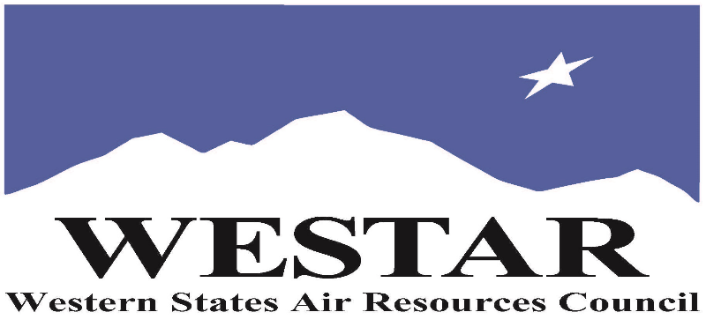

TO REGISTER
- Log onto EPA’s AirKnowledge and create a profile, or log onto your existing AirKnowledge account.
- https://epaapti.csod.com/client/epaapti/default.aspx
- When you complete your profile, you will receive a confirmation e-mail to activate your new account. It may take several minutes before receiving the email.
- Once activated, log into your account.
- Click the “Instructor Lead Training Calendar” link under the “My Training” tab.
- Search the calendar for the training date(s). On the calendar you will see a course description. Hover over the text for additional information.
- To register click the course title link.
- In the lower righthand corner of the page you will see a “Request” button. Click it.
- At this point you have requested a seat in the training. Because demand for WESTAR sponsored training frequently exceeds availability all registrants are placed on a waitlist.
- You will receive an email from Jeff Gabler confirming your request.
- WESTAR attempts to accommodate all requests but at times it may be necessary to prioritize attendees.

MONDAY, SEPTEMBER 23, 2024
8:30 am Welcomes & Introductions
8:45 am New Source Review (NSR) Program – Background &
History
9:15 am Prevention of Significant Deterioration (PSD) Applicability
9:45 am Break
10:00 am PSD Applicability (cont’d)
11:30 am Lunch (on your own)
12:45 pm PSD Applicability (cont’d)
2:30 pm Break
2:45 pm PSD Applicability (cont’d)
4:30 pm Adjourn for Day

TUESDAY, SEPTEMBER 24, 2024
8:30 am PSD Applicability (cont’d)
9:45 am Break
10:00 am PSD Applicability (cont’d)
11:30 am Lunch (on your own)
12:45 pm PSD Applicability (cont’d)
2:45 pm Break
2:45 pm PSD Requirements – BACT Determination
4:30 pm Adjourn for Day

WEDNESDAY, SEPTEMBER 25, 2024
8:30 am PSD Requirements – NAAQS Analysis
9:45 am Break
10:00 am PSD Requirements – Increment and Other Analyses
11:30 am Lunch (on your own)
12:45 pm Nonattainment Area Applicability & Requirements
2:45 pm Break
3:00 pm Nonattainment Area Applicability & Requirements
4:30 PM Adjourn for Day
THURSDAY, SEPTEMBER 26, 2024
8:30 am Nonattainment Area Applicability & Requirements
9:45 am Break
10:00 am Operating Permits/Title V/Permit Drafting and Analysis
11:30 am Lunch (on your own)
12:45 pm Source Monitoring/Comp & Enf./Alternative Approaches
2:45 pm Break
3:00 pm Recordkeeping & Resources
4:30 PM Adjourn

COURSE DESCRIPTION
WESTAR’s Training Program will host this 4-day Intermediate Permitting training course for agency personnel who have, or will have, permitting responsibilities for major sources. The objectives of the course are to provide with a high-level understanding of permitting elements, regulatory requirements, and policies pertaining to the major permitting programs, and provide attendees with the knowledge, skills, and abilities to identify pertinent regulatory and policy materials, and the ability to apply these to day-to-day responsibilities and activities.

Major Topics Include:
- New Source Review and Prevention of Significant Deterioration Programs – Background and History
- Definitions
- Applicability
- Requirements
- BACT
- NAAQS Analysis
- Netting Analysis
- Increment and Other Analyses
- NSR Reform
- Relationship between NSR and other programs
- Effective Use of Exclusions and Permit Procedures
- Pre-Application Monitoring Waivers
- Nonattainment Area Applicability and Requirements
- Operating Permits

ABOUT THE TRAINING COURSE
ACCESSIBILTY: WESTAR strives to host inclusive, accessible training events that enable all individuals, including individuals with disabilities, to engage fully with the instructor and course content. To request an accommodation or for inquiries about accessibility, please contact Jeff Gabler at jgabler@westar.org or 503-744-0486 by Friday, August 23, 2024.

COURSE MATERIALS: Training course materials will only be available electronically. Attendees will receive an online document sharing link for access to materials. It is the attendee’s responsibility for downloading files and for providing the device or media on which to view materials. WESTAR will provide hard copies for those needing accommodation.
SPACE LIMITATION: Registration is limited to 40 attendees. Air quality staff from the fifteen western states receive registration preference.
REGISTRATION FEES: There are no registration fees for state, local or tribal air quality agency staff. For federal employees the registration fees are $1,200.
TRAINING LOCATION

Clark County – Division Air Quality
4701 West Russell Road, Suite 200
Las Vegas, Nevada 89118

HOTEL INFORMATION
Attendees and speakers are responsible for making their hotel reservations. There are no hotels within a short walking distance of Clark County – Air Quality Division.

