WESTAR Council

Introduction to Continuous Monitoring Systems
(SRCE 103)

November 19-21, 2024

IN-PERSON TRAINING

TRAINING LOCATION:
CalEPA Headquarters Building
1001 I Street
Klamath Room (Second Floor)
Sacramento, CA 95814

REGISTRATION DEADLINE:
October 18, 2024

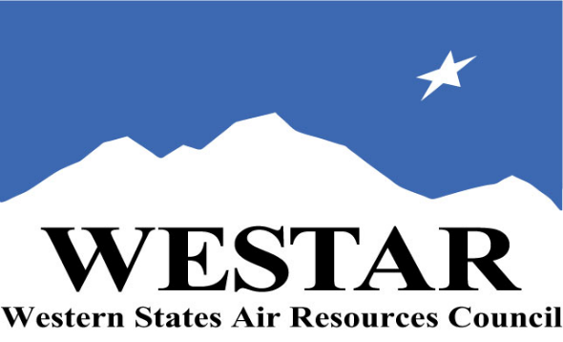
COURSE REGISTRATION
- Log onto EPA’s AirKnowledge and create a profile, or log onto your existing AirKnowledge account.
https://epaapti.csod.com/client/epaapti/default.aspx
- When you complete your profile, you will receive a confirmation e-mail to activate your new account. It may take several minutes before receiving the email.
- Once activated, log into your account.
- Click the “Instructor Lead Training Calendar” link under the “My Training” tab.
- Search the calendar for the training date(s). On the calendar you will see a course description. Hover over the text for additional information.
- To register click the course title link.
- In the lower righthand corner of the page you will see a “Request” button. Click it.
- At this point you have requested a seat in the training. Because demand for WESTAR sponsored training frequently exceeds availability, all registrants are placed on a waitlist.
- You will receive an email from Jeff Gabler confirming your request.
- WESTAR attempts to accommodate all requests but at times it may be necessary to prioritize attendees.

TUESDAY, NOVEMBER 19, 2024
8:30 am Welcome & Introduction
9:00 am Module 1: Introduction to Continuous Monitoring Systems (CMS)
10:00 am Break
10:30 am Module 1: Introduction to Continuous Monitoring Systems (CMS)
12:00 noon Lunch (on your own)
1:00 pm Module 1: Introduction to Continuous Monitoring Systems (CMS)
1:30 pm Module 2: Overview of CMS, and CMS Design and Components
2:00 pm Break
2:30 pm Module 2: Overview of CMS, and CMS Design and Components
4:30 pm Adjourn for Day
WEDNESDAY, NOVEMBER 20, 2024
8:30 am Module 3: Performance Specifications, Quality Assurance, and Commonly Used Technologies
9:30 am Break
10:00 am Module 3: Performance Specifications, Quality Assurance, and Commonly Used Technologies
12:00 noon Lunch (on your own)
1:00 pm Module 3: Performance Specifications, Quality Assurance, and Commonly Used Technologies
2:00 pm Break
2:30 pm Module 3: Performance Specifications, Quality Assurance, and Commonly Used Technologies
4:30 pm Adjourn for Day
THURSDAY, NOVEMBER 21, 2024
8:30 am Module 3: Performance Specifications, Quality Assurance, and Commonly Used Technologies
9:30 am Break
10:00 am Module 4: Audits/Inspections and Enforcement
12:00 noon Lunch (own your own)
1:00 pm Module 4: Audits/Inspections and Enforcement
2:00 pm Break
2:30 pm Module 4: Audits/Inspections and Enforcement
4:00 pm Course Wrap-Up
4:30 pm Adjourn

COURSE DESCRIPTION
The Continuous Monitoring Systems (CMS) training course is 3 days and in-person. It provides participants with a basic understanding of CMS including an overview of how to perform regulatory reviews and includes key concepts, terminology, techniques, and information on CMS, including types, regulations, analytical techniques, systems design and components, performance specifications (PS), quality assurance (QA) requirements, commonly used technologies, audits/inspections, and enforcement procedures. In addition to the instructor presentation and lecture, participants have opportunities to apply their knowledge through practical exercises, facilitated discussions, and knowledge check games.

There are four modules in this course and an introductory module:
- Course Introduction
- Module 1: Introduction to CMS
- Module 2: Overview of CMS and CMS Design and Components
- Module 3: Performance Specifications, Quality Assurance, and Commonly Used Technologies

M ACCESSIBILTY/MATERIALS
ACCESSIBILTY: WESTAR strives to host inclusive, accessible training events that enable all individuals, including individuals with disabilities, to engage fully with the instructor and course content. To request an accommodation or for inquiries about accessibility, please contact Jeff Gabler at jgabler@westar.org or 503-744-0486 by Friday, October 18, 2024.

COURSE MATERIALS: Training course materials will only be available electronically. Attendees will receive an online document sharing link for access to materials. It is the attendee’s responsibility for downloading files and for providing the device or media on which to view materials. WESTAR will provide hard copies for those needing accommodation.
SPACE LIMITATION: Registration is limited to 40 attendees. Air quality staff from the fifteen western states receive registration preference.
REGISTRATION FEES: There are no registration fees for state, local or tribal air quality agency staff. For federal employees the registration fee is $500.

TARGET AUDIENCE
This course is intended for a broad audience and could include participants with non-technical backgrounds (e.g., a basic degree in science) as well as technical backgrounds (e.g., a chemical engineering degree). No prior knowledge of CMS is presumed. This course is intended primarily for new hires or any participants who need an understanding of CMS in their job responsibilities.

Staff who could benefit from the course include, but are not limited to the following:
- Staff who are inspection and/or enforcement personnel
- Staff who observe stack test and CMS certifications
- Staff who are reviewing audit reports
- Staff who work on permits

TRAINING LOCATION
CalEPA Headquarters Building
1001 I Street
Klamath Room (Second Floor)
Sacramento, CA 95814

HOTEL INFORMATION
Attendees and speakers are responsible for making their hotel reservations. Below is a list of potential hotels in Sacramento. The listed hotels are 0.5 – ~1 miles from the training location. WESTAR DOES NOT have room blocks at these hotels. Please ask for the government rate.

The Citizen Hotel - Sacramento
926 J Street
Sacramento, CA 95814
916-447-2700

Best Western Plus Shutter House
1100 H Street
Sacramento, California 95814
916-441-1314

The Sterling Hotel
1300 H Street
Sacramento CA 95814
916-448-1300

Kimpton Sawyer Hotel
500 J Street
Sacramento, CA 95814
916-545-7100

Holiday Inn Sacramento Downtown
300 J Street
Sacramento, CA 95814
916-446-0100

Embassy Suites – Riverfront
100 Capitol Mall
Sacramento, CA 95814
916-326-5000

