WESTAR Council

Who Are These People & Why Do They Hate Me? (Re)Building
Trust in Government

May 14-15, 2024

IN-PERSON TRAINING

Kimpton Hotel Monaco Denver
1717 Champa Street
Denver, CO 80201
WESTAR Leadership Room Block

Registration Deadline: Saturday, April 13, 2024

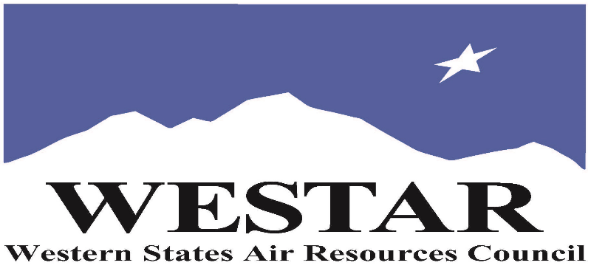

TO REGISTER
- Log onto EPA’s AirKnowledge and create a profile, or log onto your existing AirKnowledge account.
https://epaapti.csod.com/client/epaapti/default.aspx
- When you complete your profile, you will receive a confirmation e-mail to activate your new account. It may take several minutes before receiving the email.
- Once activated, log into your account.
- Click the “Instructor Lead Training Calendar” link under the “My Training” tab.
- Search the calendar for the training date(s). On the calendar you will see a course description. Hover over the text for additional information.
- To register click the course title link.
- In the lower righthand corner of the page you will see a “Request” button. Click it.
- At this point you have requested a seat in the training. Because demand for WESTAR sponsored training frequently exceeds availability all registrants are placed on a waitlist.
- You will receive an email from Jeff Gabler confirming your request.
- WESTAR attempts to accommodate all requests but at times it may be necessary to prioritize attendees.

TUESDAY, MAY 14, 2024
8:00 am – 5:00 pm
- Welcomes & Introductions
- Loss of Institutional Trust and Opposition to Expertise
- Fact vs Perception
- Twelve Factors of Human Anger, Why People Get So Upset
- Risk Assessment vs Risk Communication
- Types of Risk Communication
- Basics of Authentic and Effective Public Participation
- Strategies & Behaviors for Reducing Public Anger

WEDNESDAY, MAY 15, 2024
8:00 am – 5:00 pm
- Recap of Day One
- Strategies for Reducing Public Anger (cont.)
- Small Group Case Study Work
- Understanding Outrage, Self Interest and Ego
- Active, Intentional Listening
- Technobabble, Jargon and Plain Language
- Strategic Communication Objectives and Key Message Construction
- Emotional Reality and Building Trust
- Influencing People
- Empathy vs Sympathy
- Factors that Inspire Trust and Credibility – the Secrete Sauce
- Mega Case Study
- Class Wrap-Up

COURSE DESCRIPTION
WESTAR’s Training Program will host this 2-day leadership training on building trust in government for agency personnel in leadership positions at an agency.

Quantifiable polls, research and empirical evidence in the United States shows that people are increasingly suspicious and distrustful of government, science and expertise, particularly those public interest initiatives that are perceived to disrupt and change people’s lives.
Community opposition and protest can derail the best plans and intentions. Angry, cynical and emotional people don’t represent their interests very well, and simply ignoring or dismissing their skepticism isn’t a productive or effective option.

Managing public projects and policy requires an understanding of why people feel and react the way they do, and learning how to better prevent and handle that public emotion and opposition, to build relationships and rebuild public trust.

This course is a highly researched, time tested, effective approach for dealing with public anger, emotion, fear and opposition associated with public engagement and public information programs.

The class builds on proven, recognized global best practices in public participation and consensus building as well as continually updated and practical research from experts in public outrage, risk communication and behavioral science. The course helps managers and staff understand and manage authentic public involvement, and to deal with citizen anger in decision-making and public policy. This is a hands-on, customized, dynamic 2- day in person mix of interactive, large group discussions, videotape, small group problem solving with timely, real-world scenarios and exercises that gives people the understanding, tools and confidence to manage the tough public issues that they face.

ACCESSIBILTY/REG INFO
ACCESSIBILTY: WESTAR strives to host inclusive, accessible training events that enable all individuals, including individuals with disabilities, to engage fully with the instructor and course content. To request an accommodation or for inquiries about accessibility, please contact Jeff Gabler at jgabler@westar.org or 503-744-0486 by Friday, April 12, 2024.
SPACE LIMITATION: Registration is limited to 30 attendees. Air quality staff from the fifteen western states receive registration preference.

REGISTRATION FEES: There are no registration fees for state, local or tribal air quality agency staff.

INSTRUCTOR
John Godec is an expert in tough, contentious public communication and public engagement issues. He’s an IAF Certified™ Professional Facilitator, a training course developer and original master trainer for the International Association for Public Participation (IAP2). Godec is one of the first people ever designated as a Master Certified Public Participation Professional (MCP3). He’s trained thousands of students, facilitated thousands of meetings and workshops and managed hundreds of complex and controversial public communication and engagement projects in the U.S., Canada, Mexico, Europe, Africa, Australasia and the Middle East. Godec helped design a U.S. nationwide risk communication protocol for the National Governor’s Association (NGA) and has developed health risk communication training for the Centers for Disease Control and Prevention (CDC). He is an adjunct professor at the Indiana University School of Public and Environmental Affairs (SPEA) and lectures at Arizona State University, the Universities of Texas, Arizona and Denver, and the Queensland University of Technology in Brisbane. Godec is the past Communications Director of the Arizona Department of Environmental Quality and the former Director of Issues and Crisis Management for Motorola Corporation. He is President of Godec, Randall & Associates Inc. and a founding Partner of The Participation Company LLC.
HOTEL/TRAINING LOCATION

Kimpton Hotel Monaco Denver
1717 Champa Street
Denver, CO 80201
WESTAR Leadership Room Block

Attendees and speakers are responsible for making their hotel reservations. WESTAR’s room block expires on Saturday, April 13, 2024. Please be aware that:
- Reservations made using the Leadership Block link are defaulted to arriving on Monday, May 13th, and departing on Thursday, May 16th. If you need to adjust check-in or check-out date, click on “change search” to do so.
- If you would like to arrive earlier or extend your stay (outside the above dates) please reach out directly to:
Elise Kaslander, Group Sales Manager, Kimpton Hotel
elise.kaslander@monaco-denver.com
303.294.3008
- The Guest Amenity Fee/Service Charge is waived for WESTAR’s meeting. Unfortunately, the charge will show up on the reservation. At check-in, this charge should be waived.

